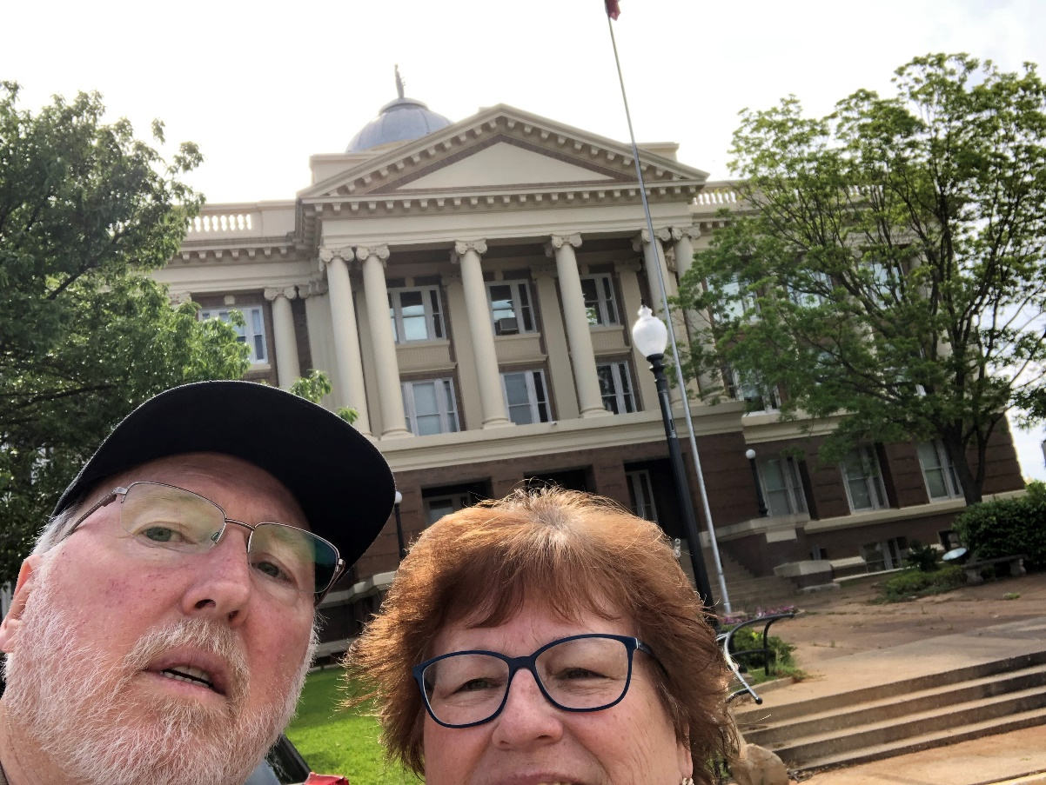
47 – Anderson County – Palestine, TX
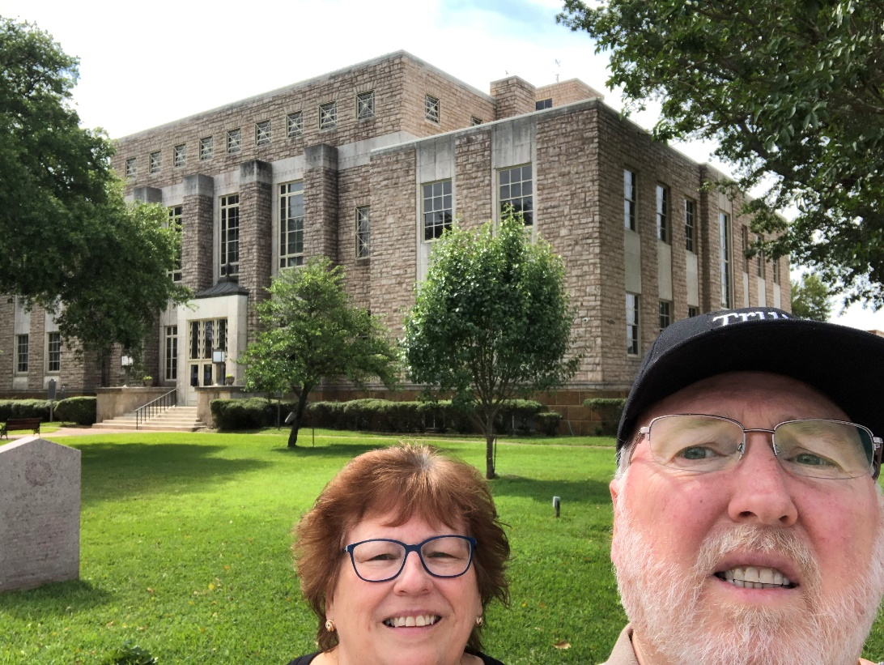
48 – Cherokee County – Rusk, TX
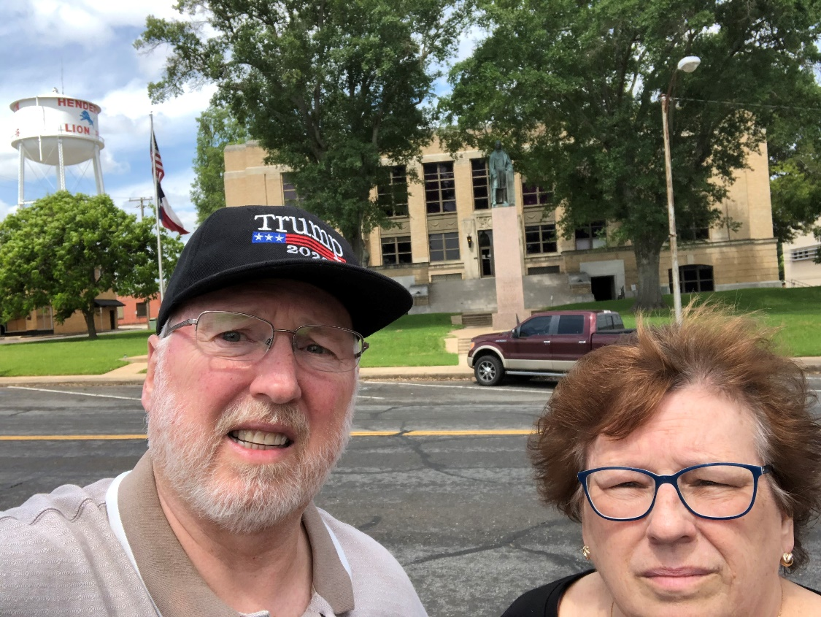
49 – Rusk County – Henderson, TX
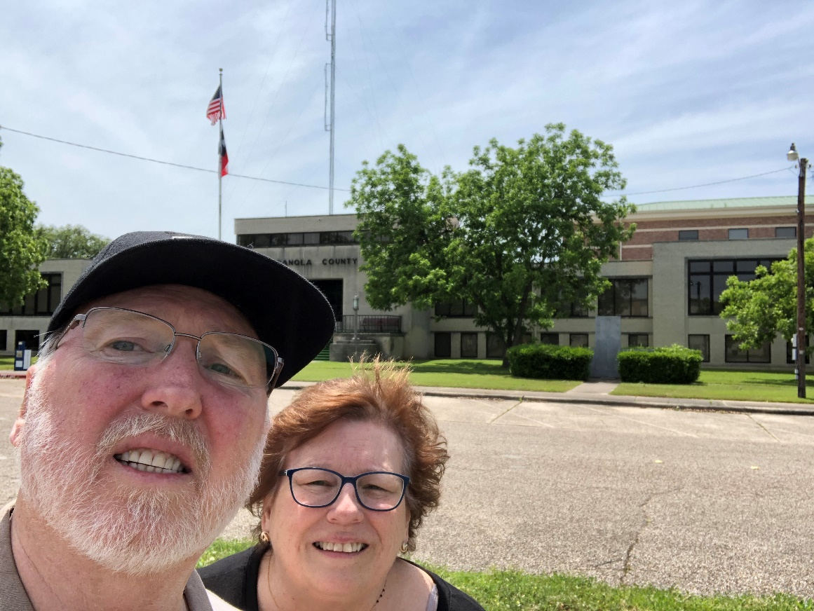
50 – Panola County – Carthage, TX

51 – Shelby County – Center, TX
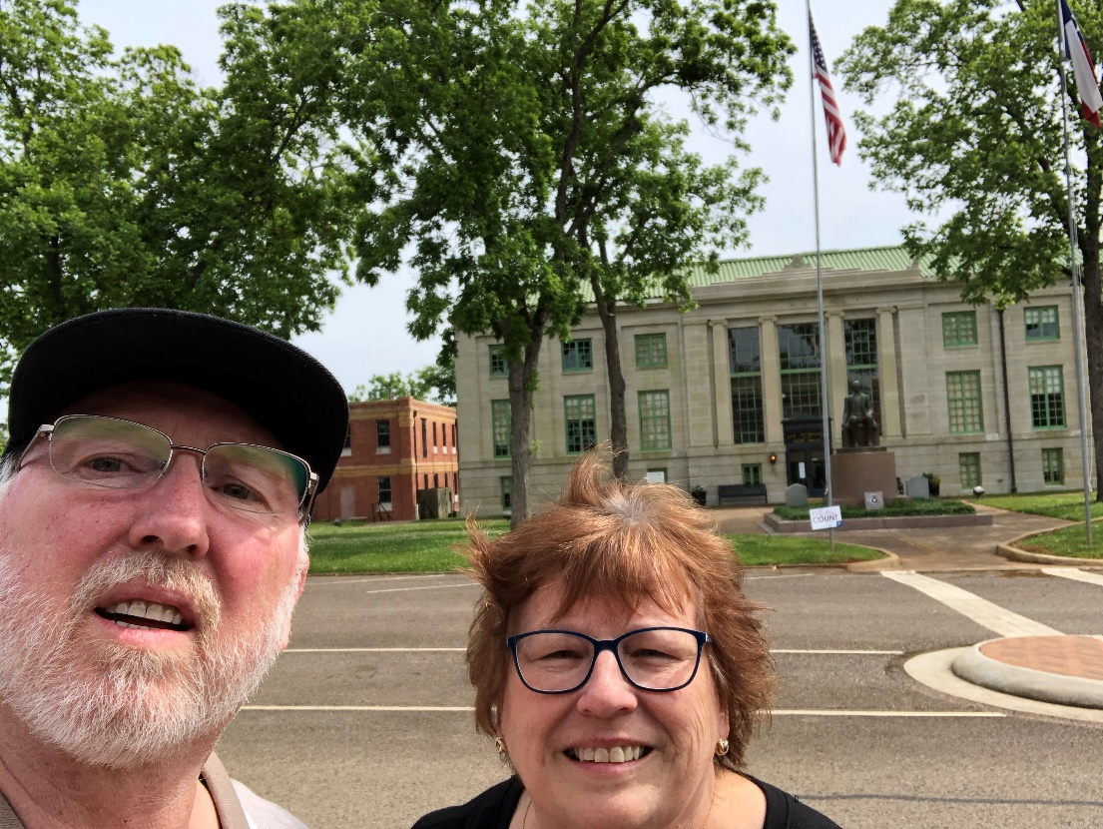
52– San Augustine County–San Augustine, TX
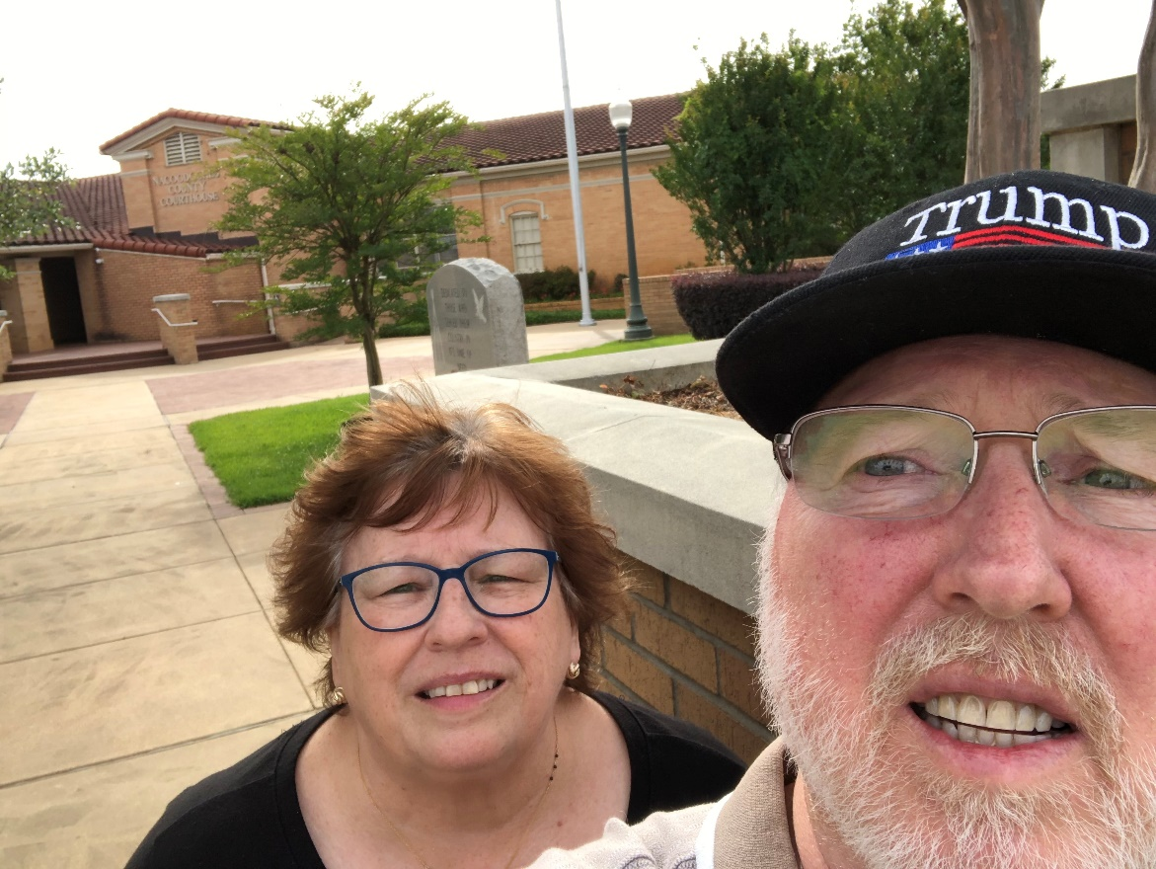
53 – Nacogdoches County – Nacogdoches, TX
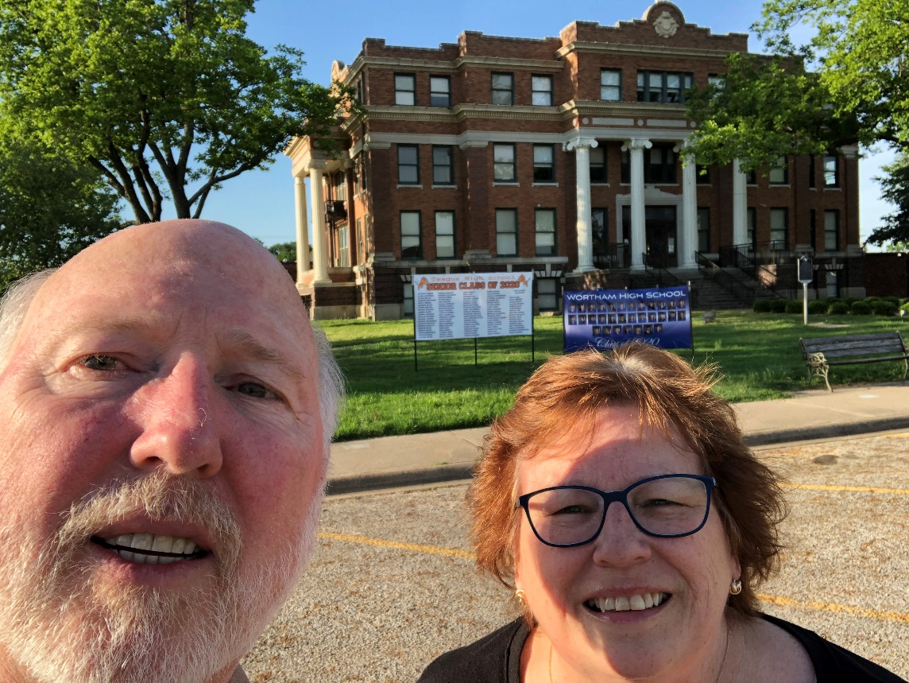
54 – Freestone County – Fairfield, TX

End of Trip

