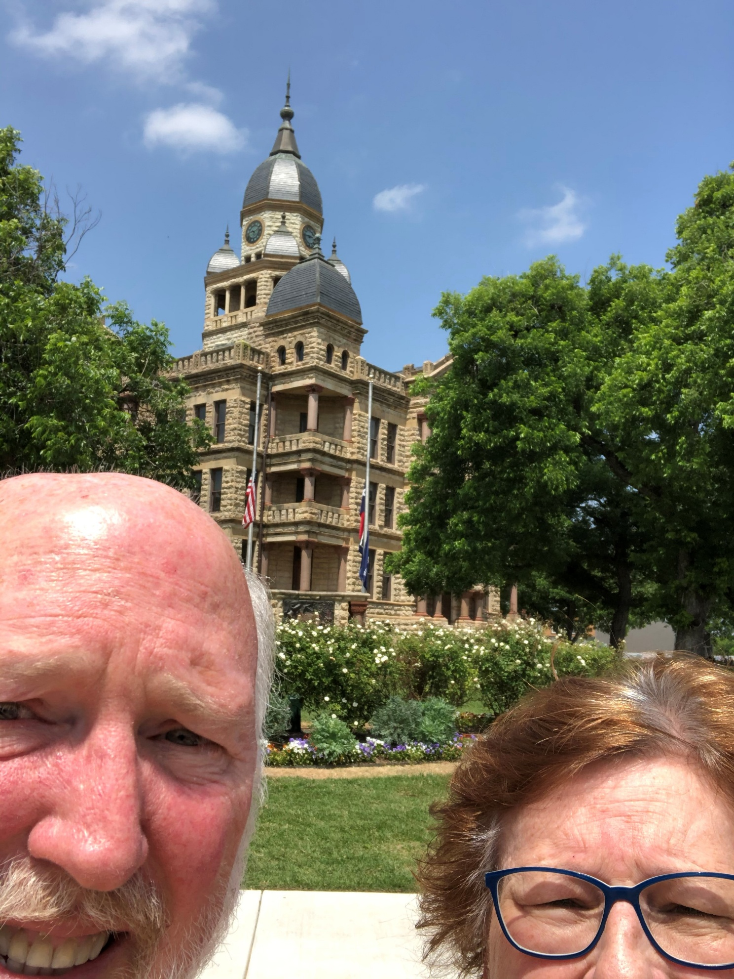
60 – Denton County – Denton, TX
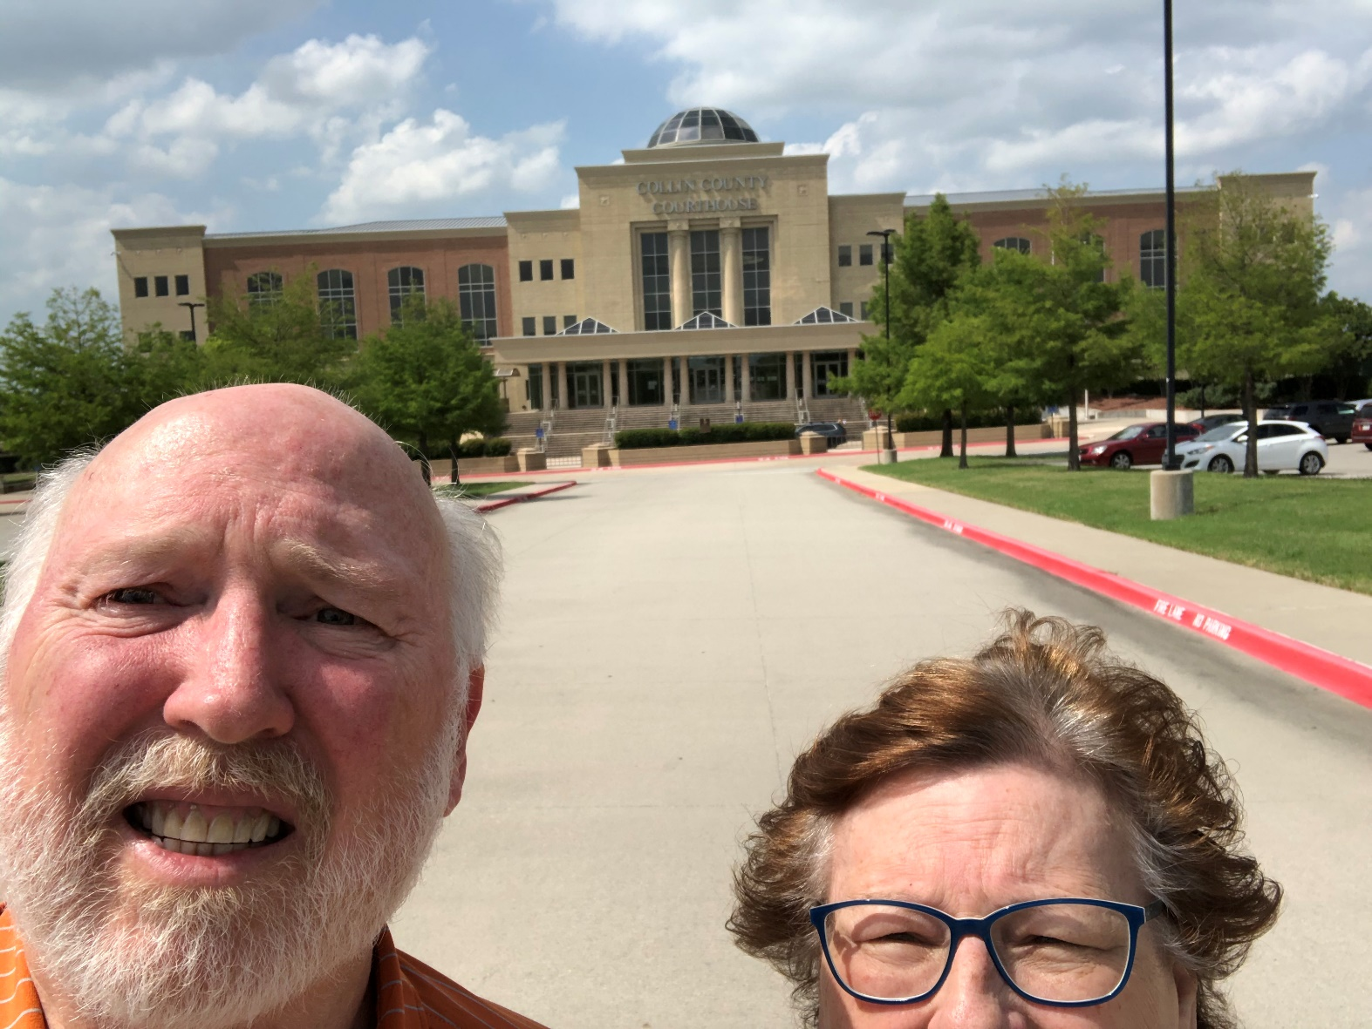
61 – Collin County – McKinney, TX
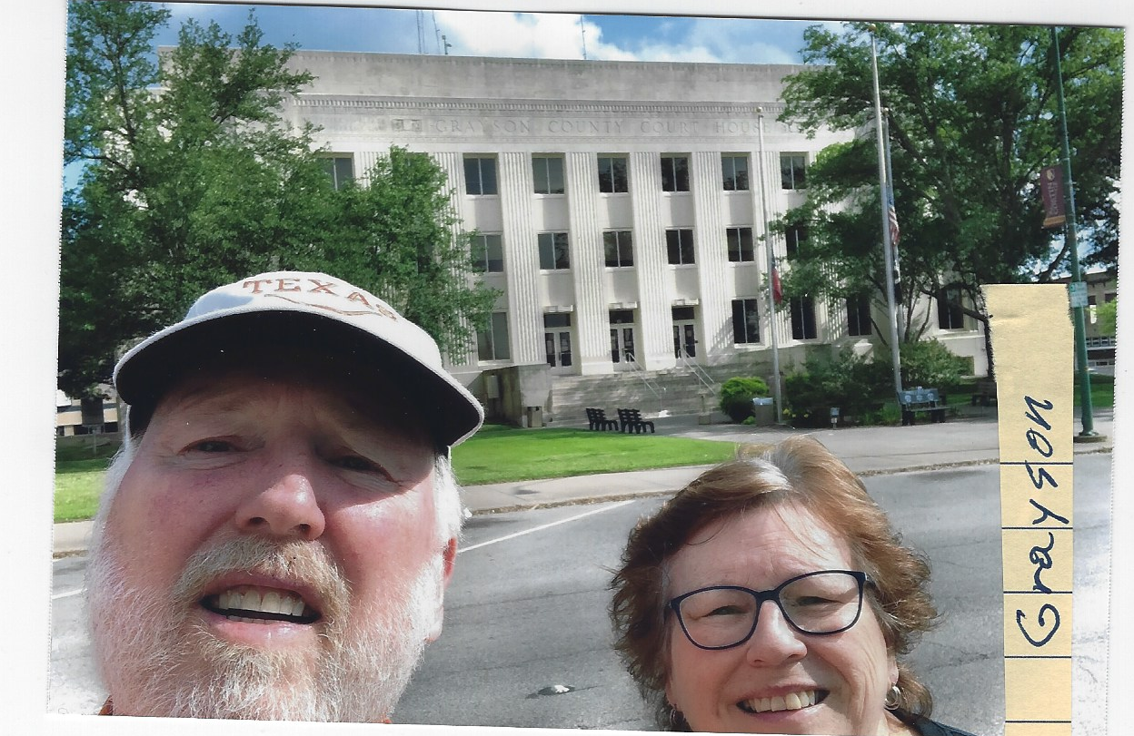
62 – Grayson County - Sherman, TX

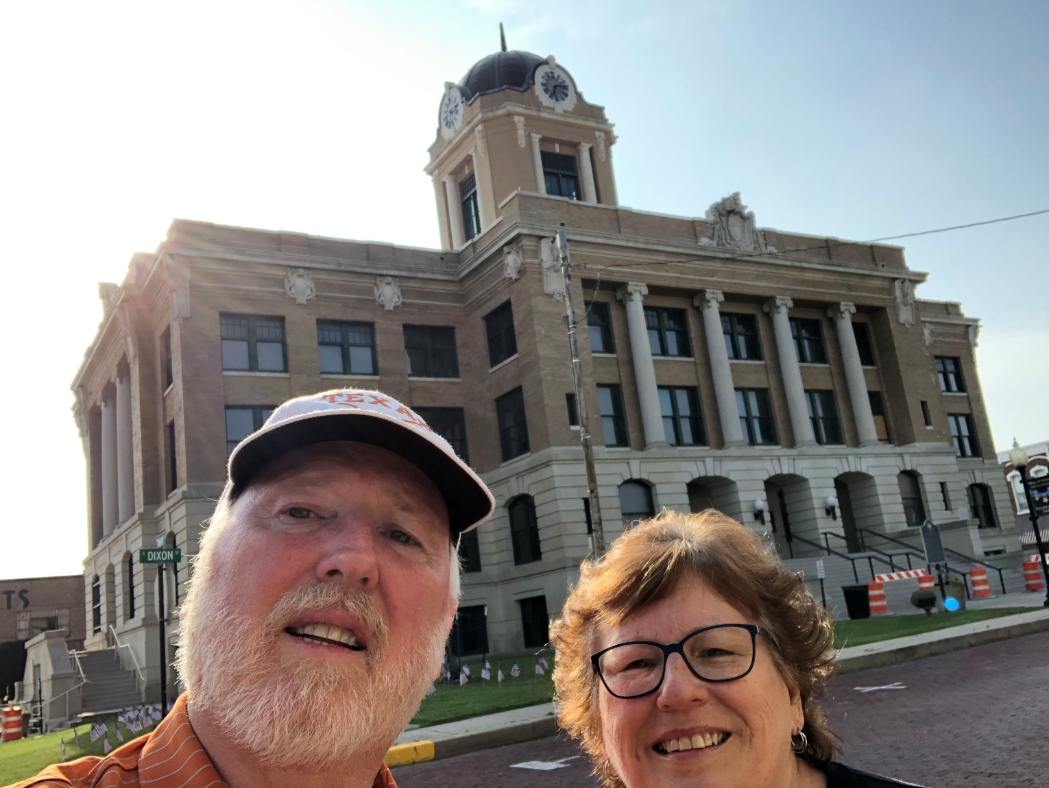

63 – Cooke County – Gainsville, TX
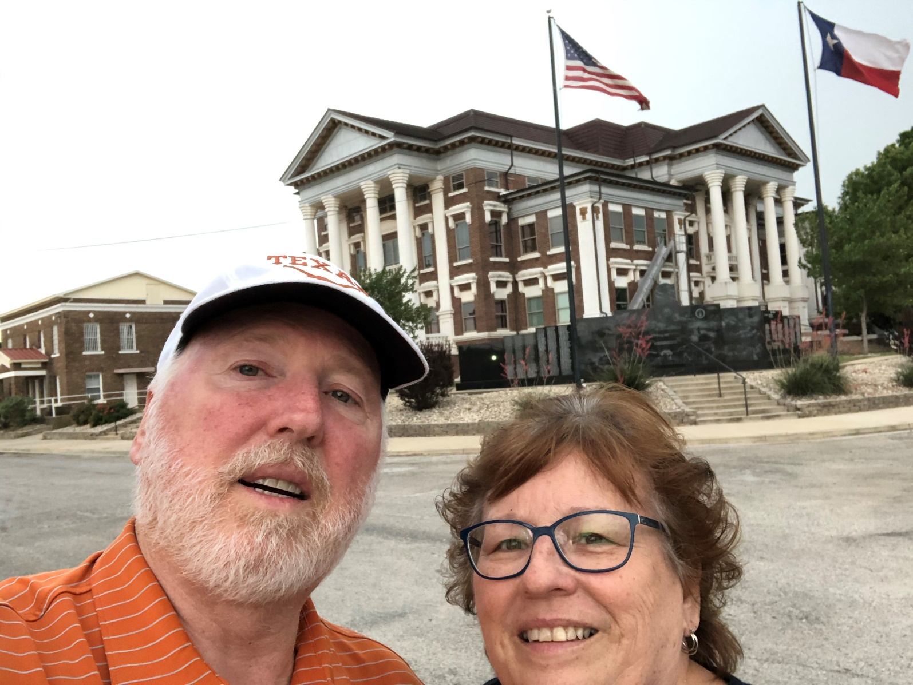
64 – Montague County – Montague, TX
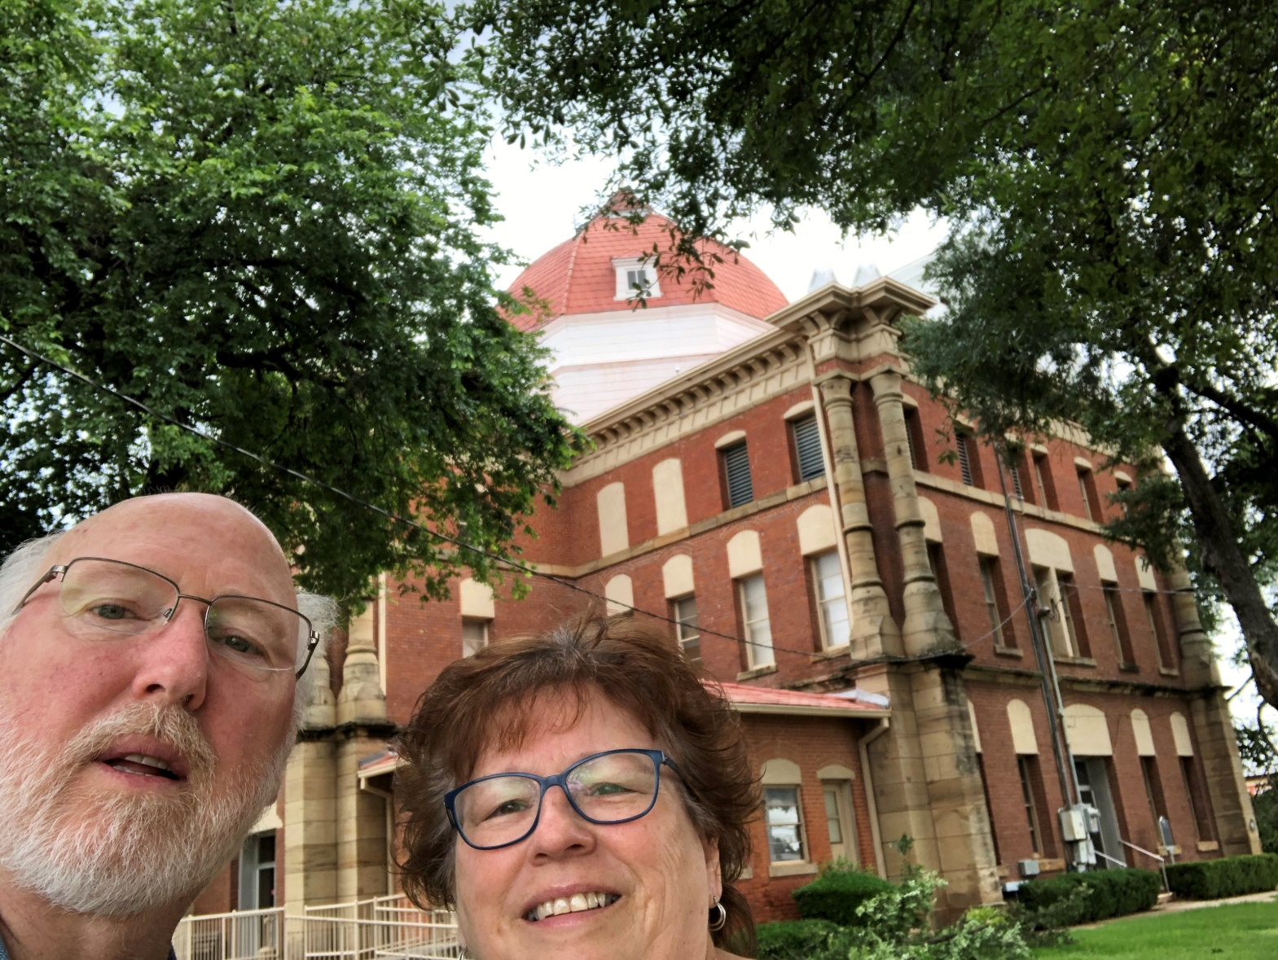
65 – Clay County – Henrietta, TX

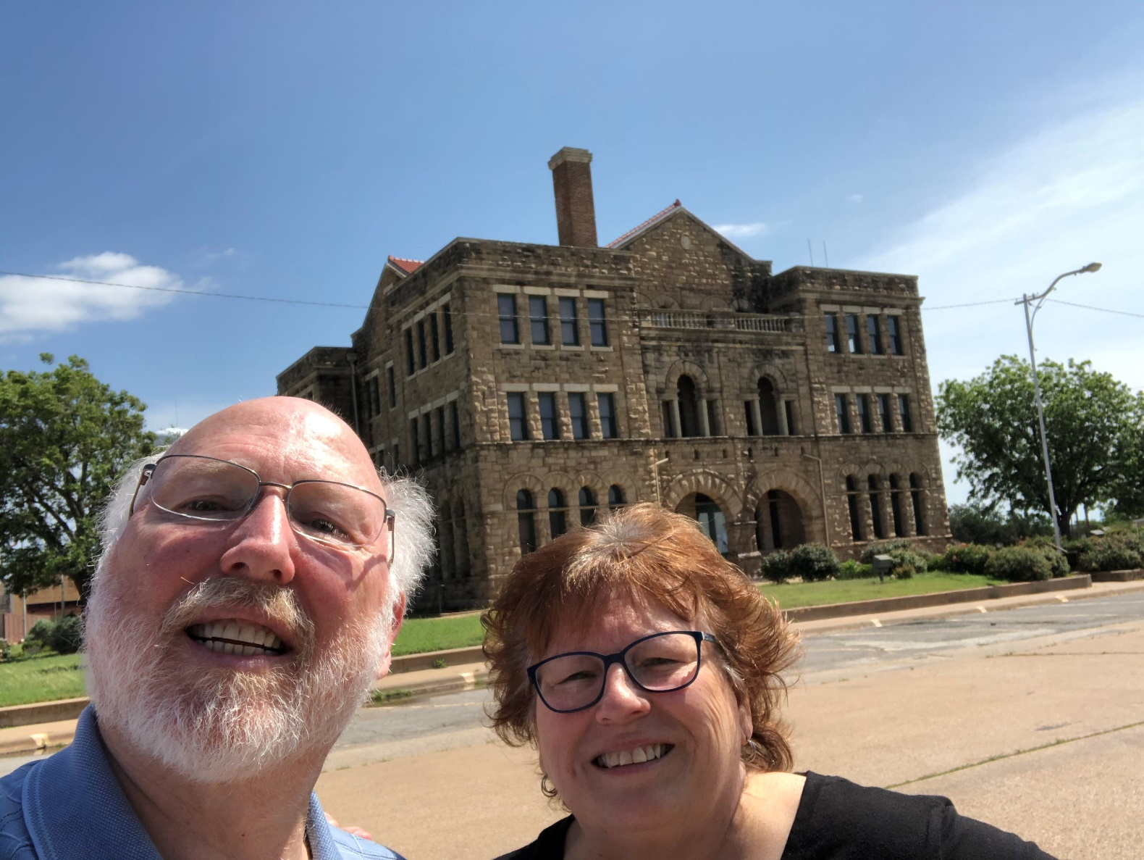
66 – Archer County – Archer City, TX

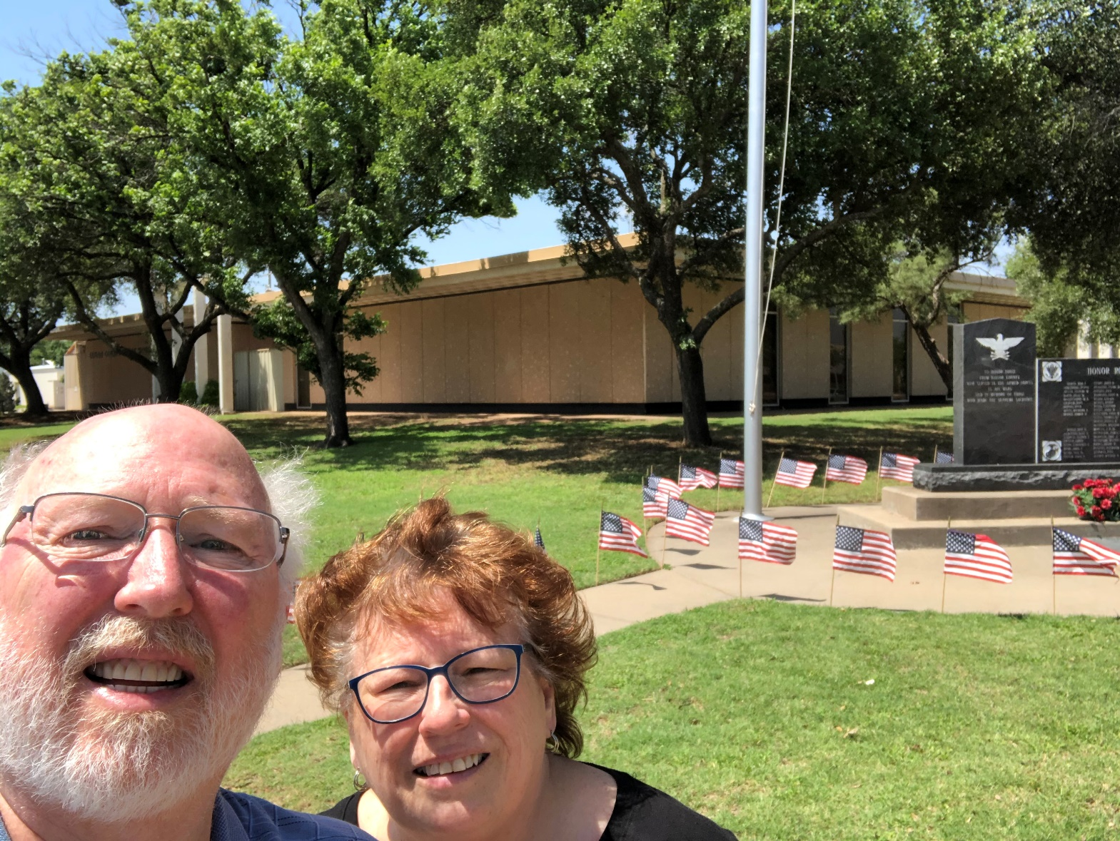
67 – Baylor County – Seymour, TX

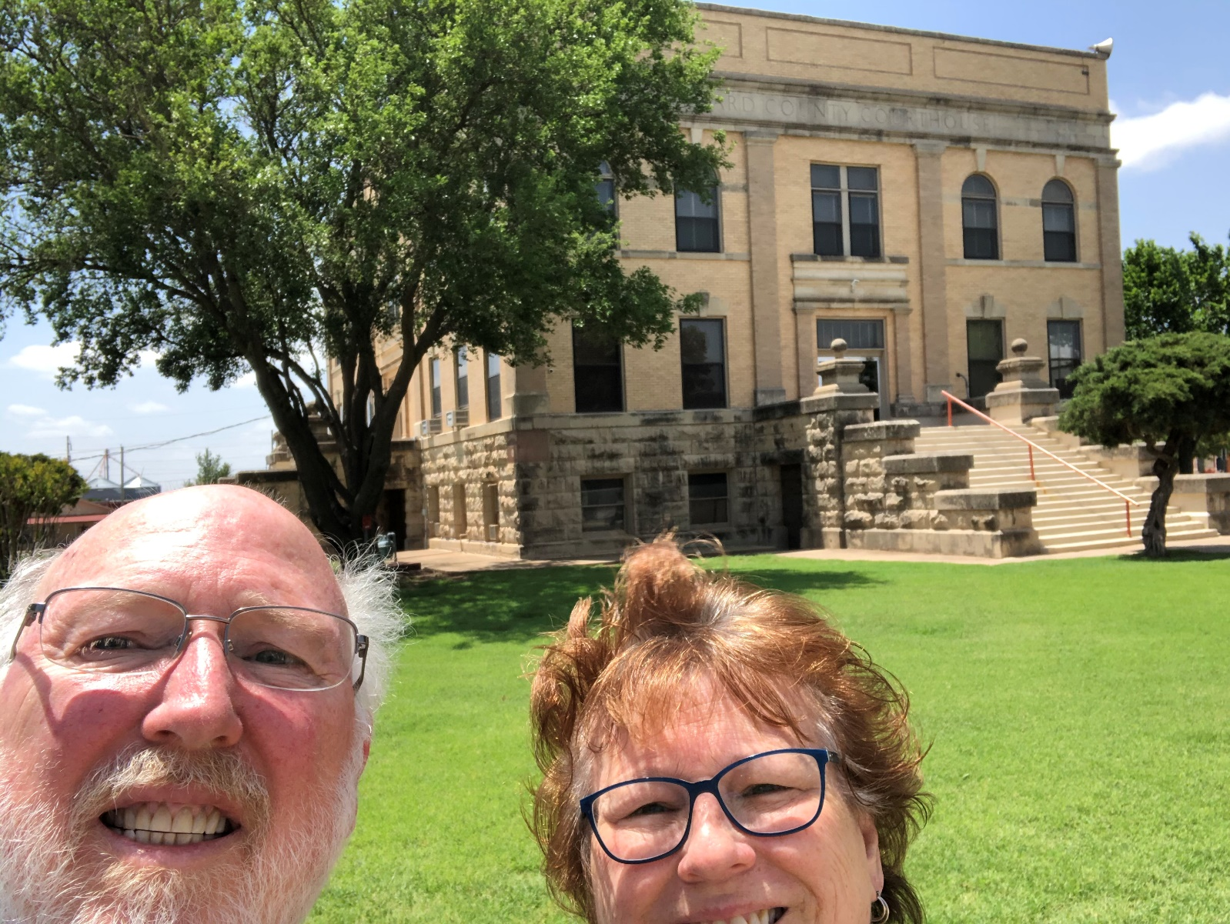
68 – Foard County – Crowell, TX
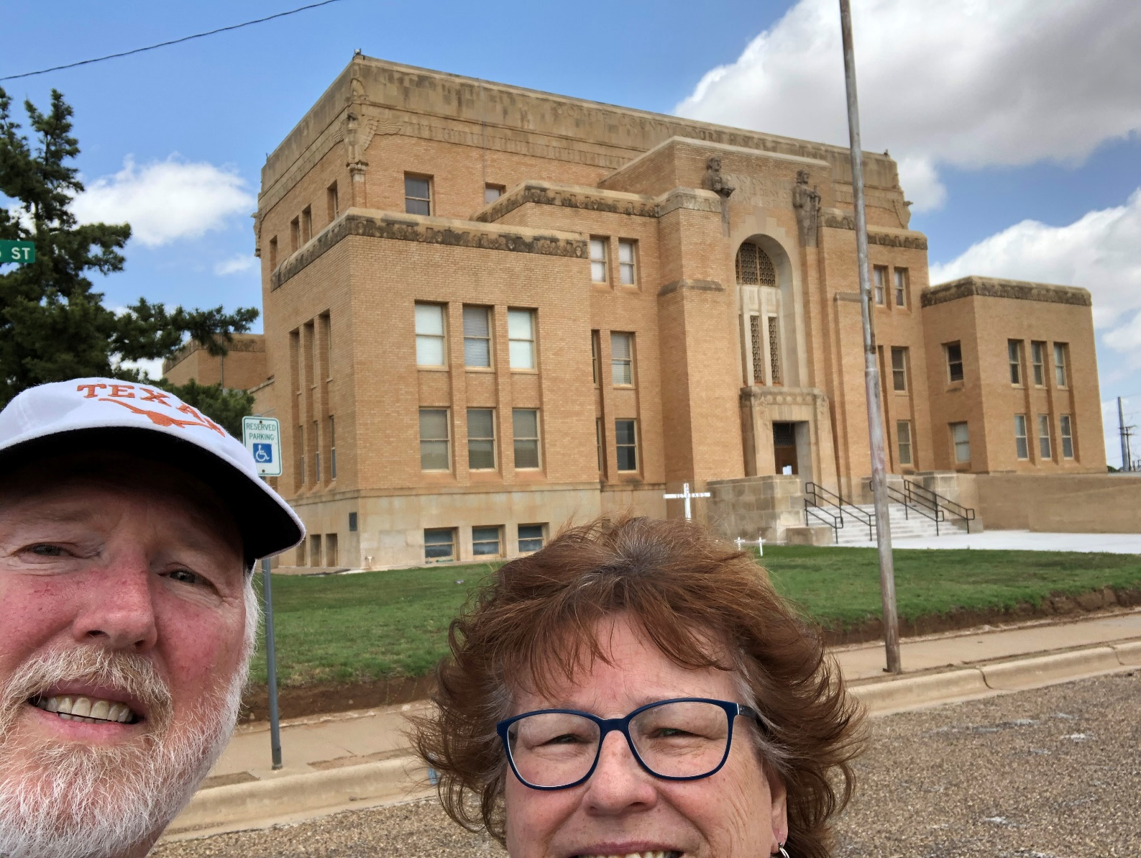
69 – Cottle County – Paducah, TX
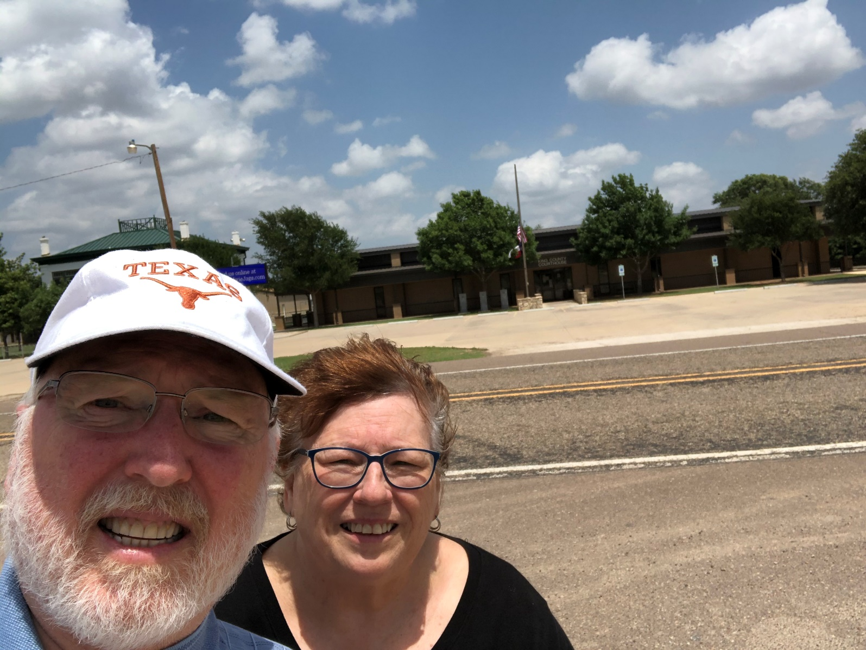
70 – King County – Guthrie, TX

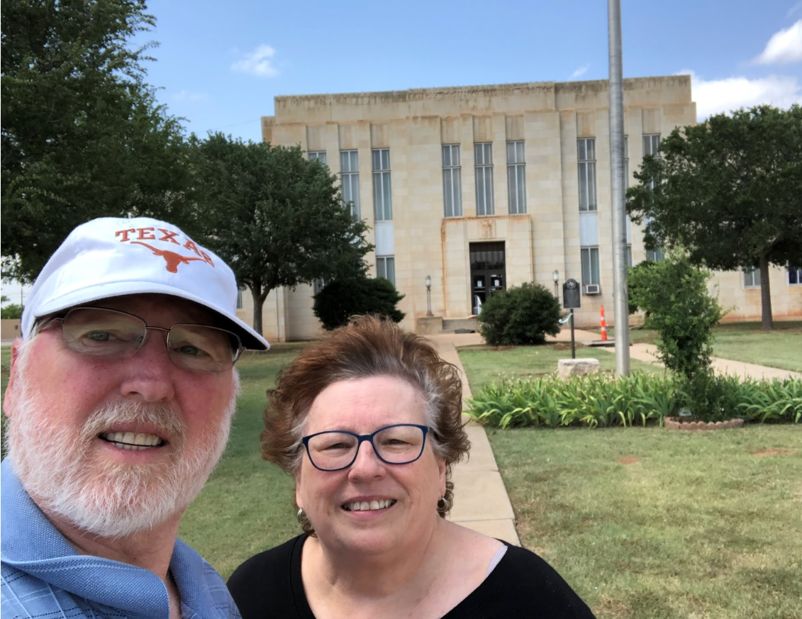
71 – Knox County – Benjamin, TX
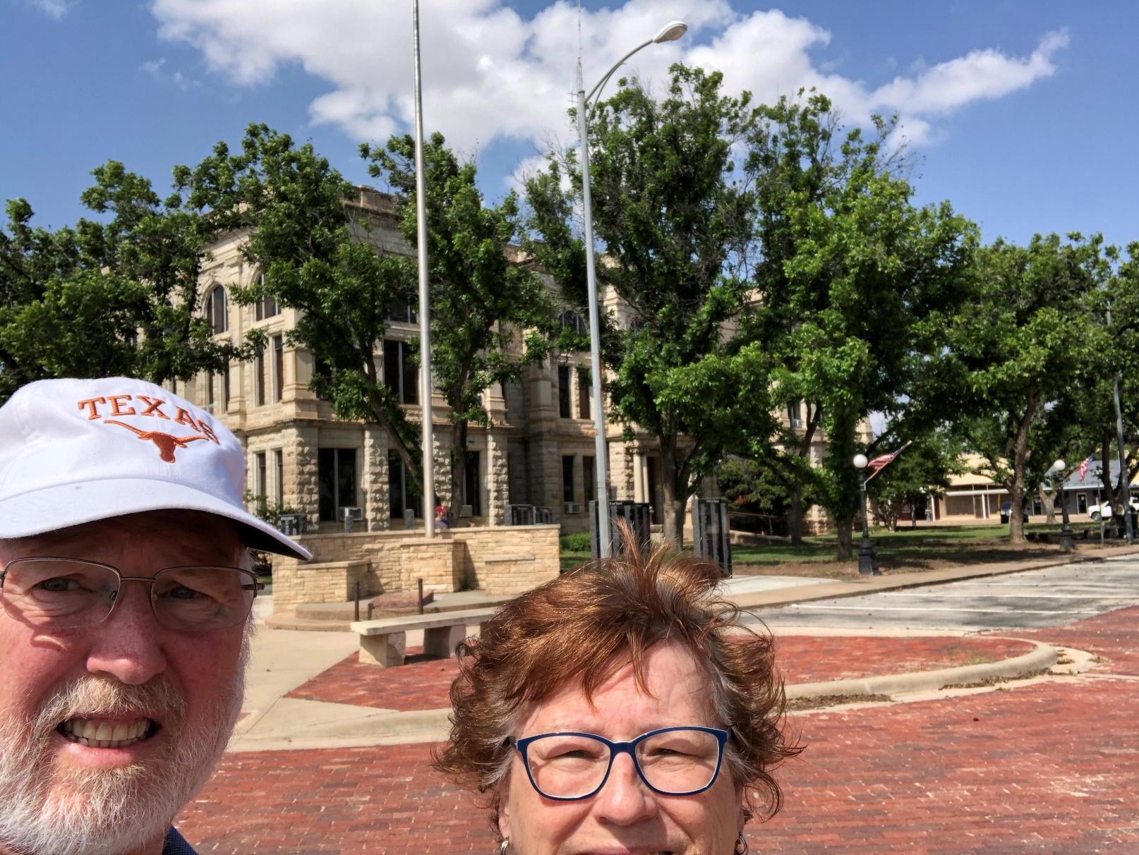
72 – Haskell County – Haskell, TX
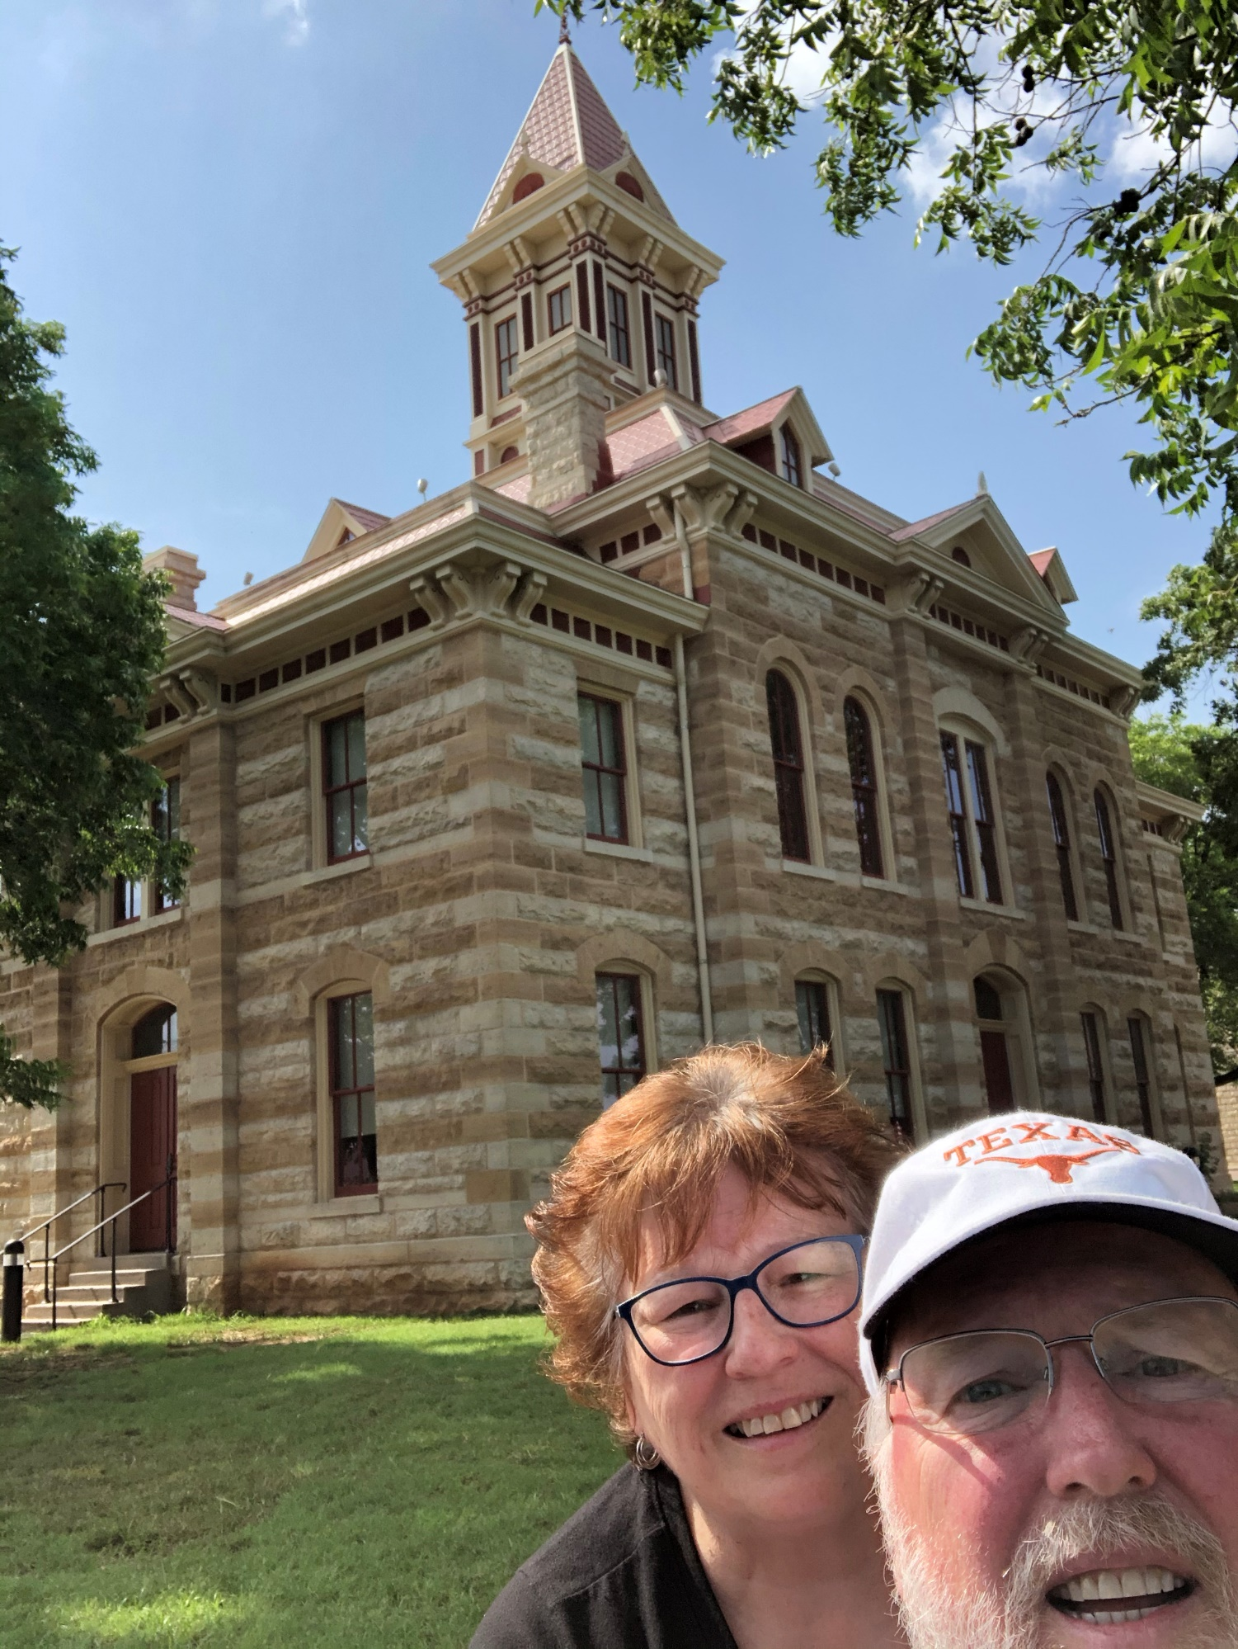
73 – Throckmorton – Throckmorton, TX
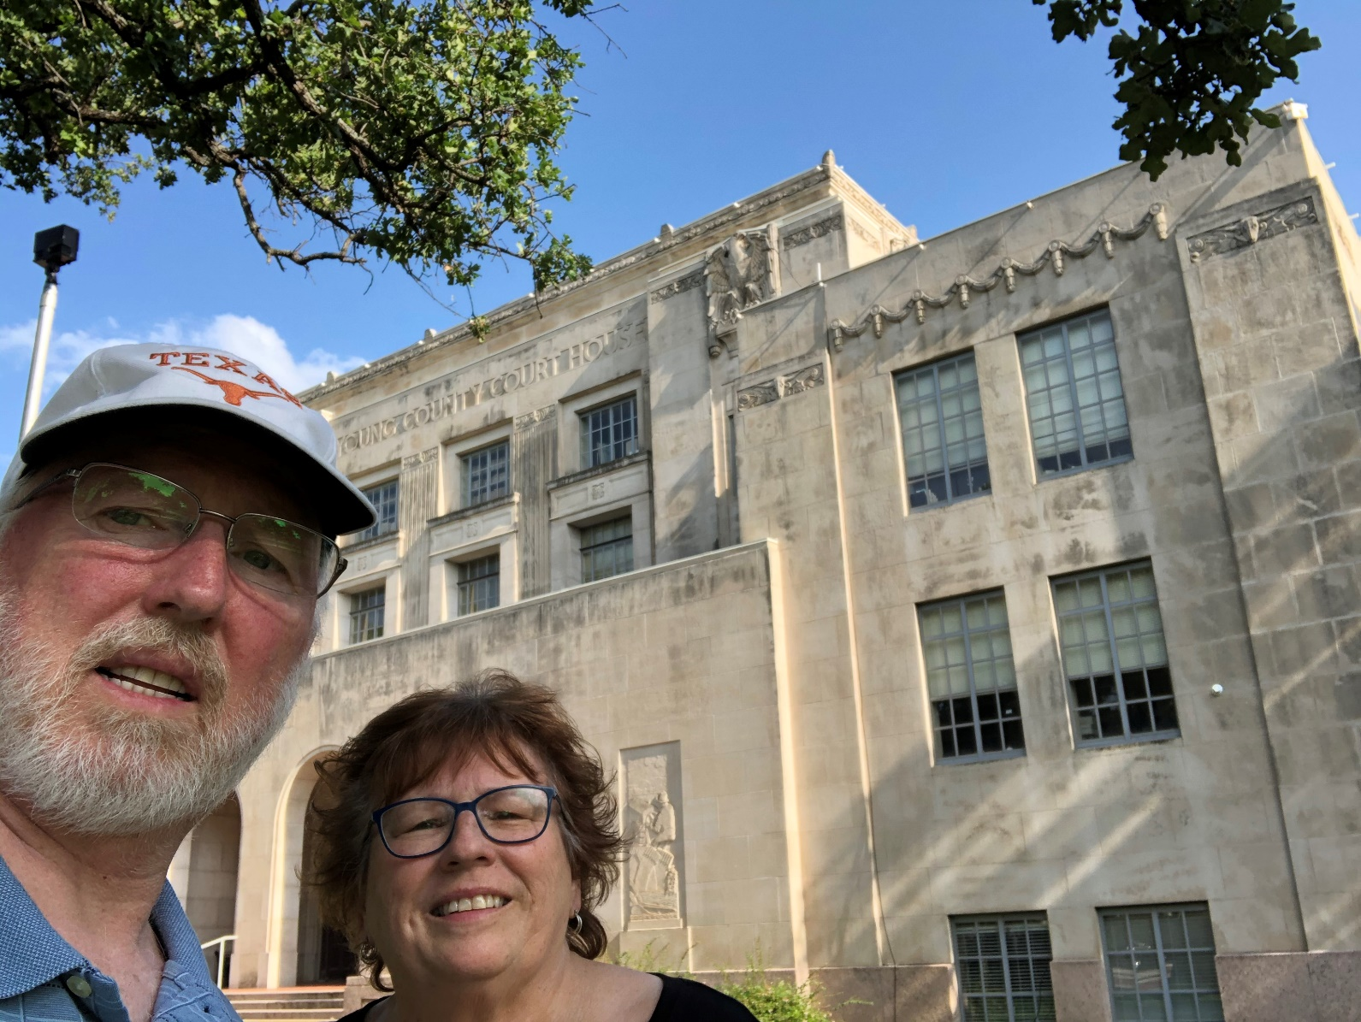
74 – Young County – Graham, TX
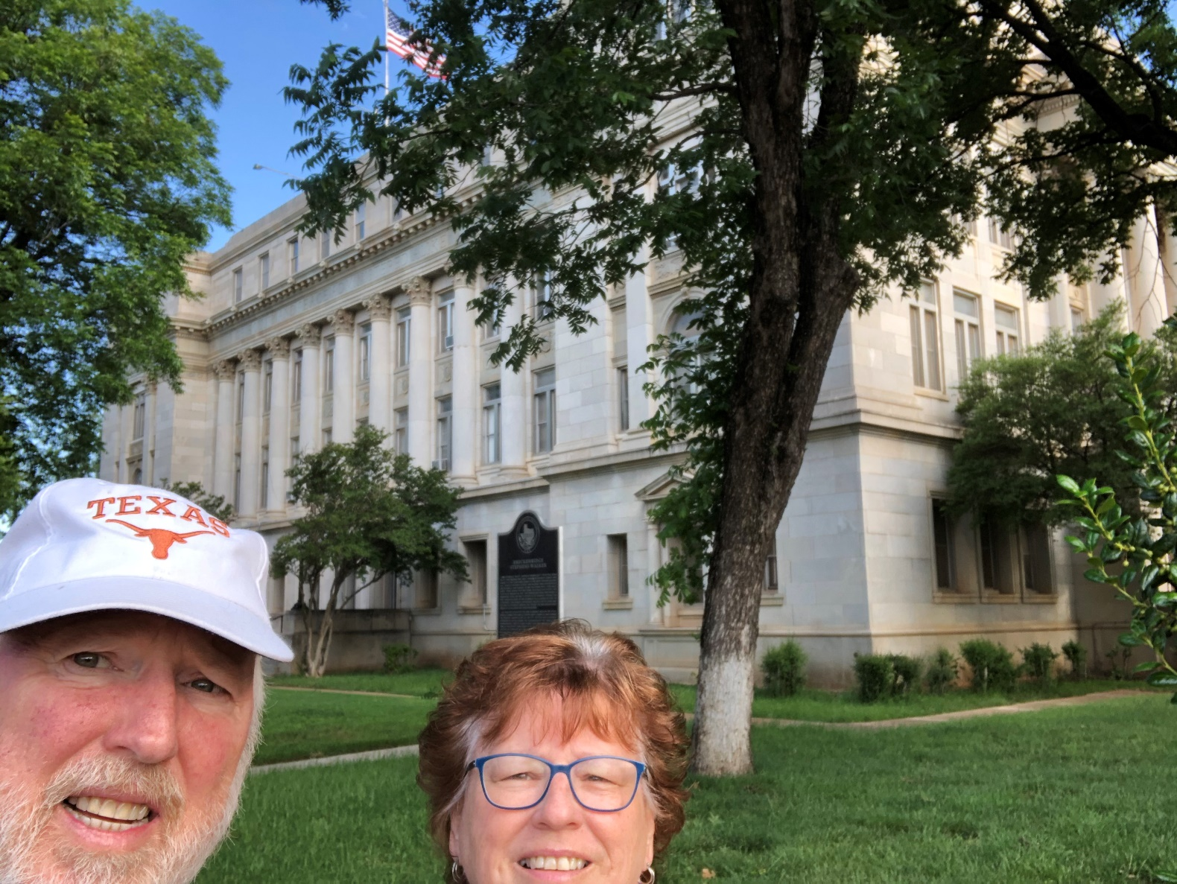
75 – Stephens County – Breckenridge, TX
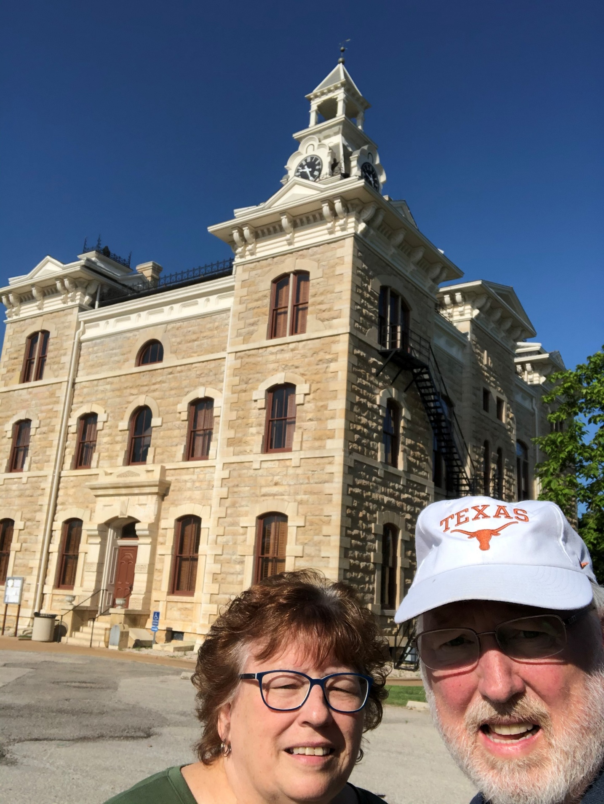
76 – Shackleford County – Albany, TX
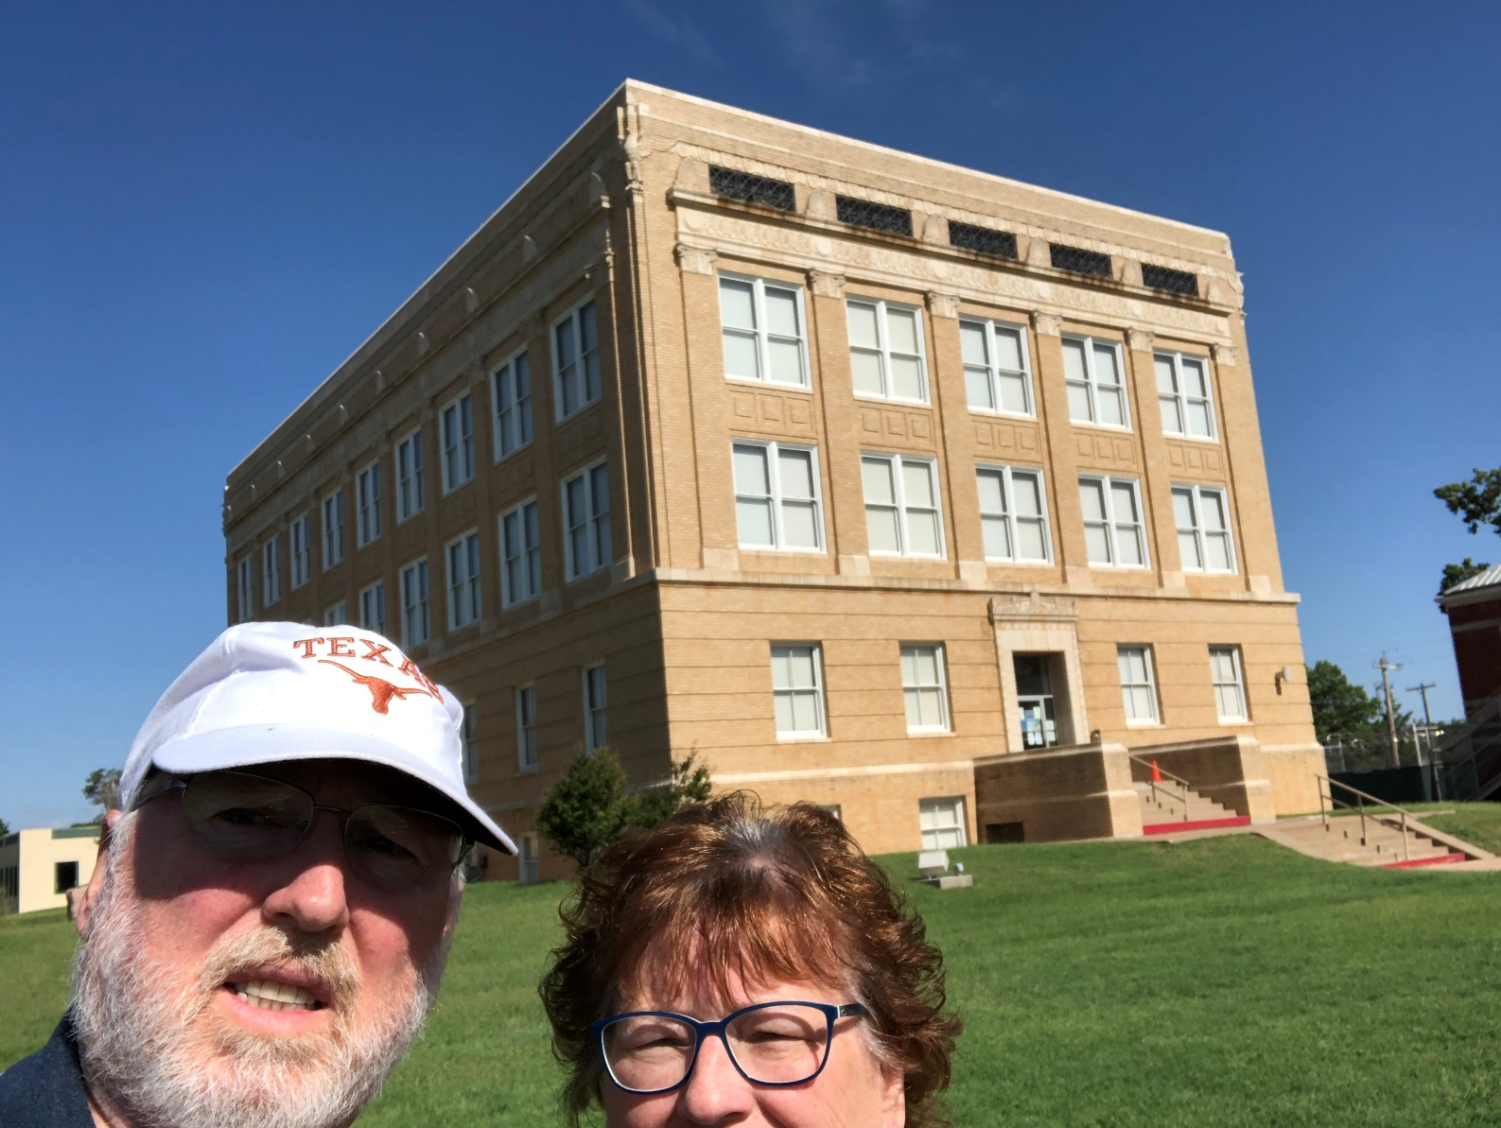
77 – Callahan County – Baird, TX
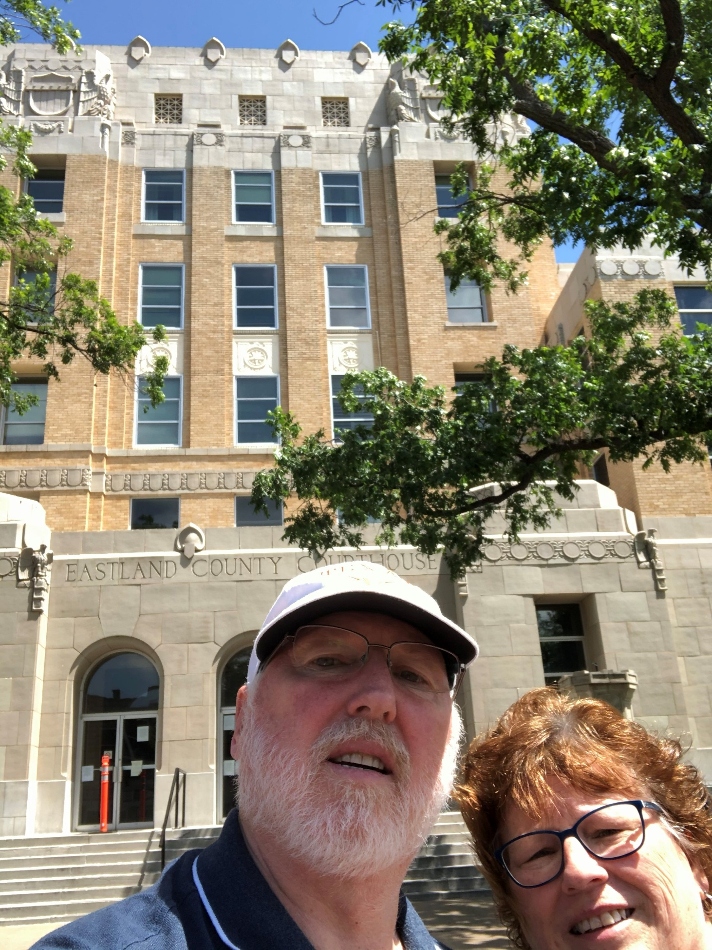
78 – Eastland County – Eastland, TX
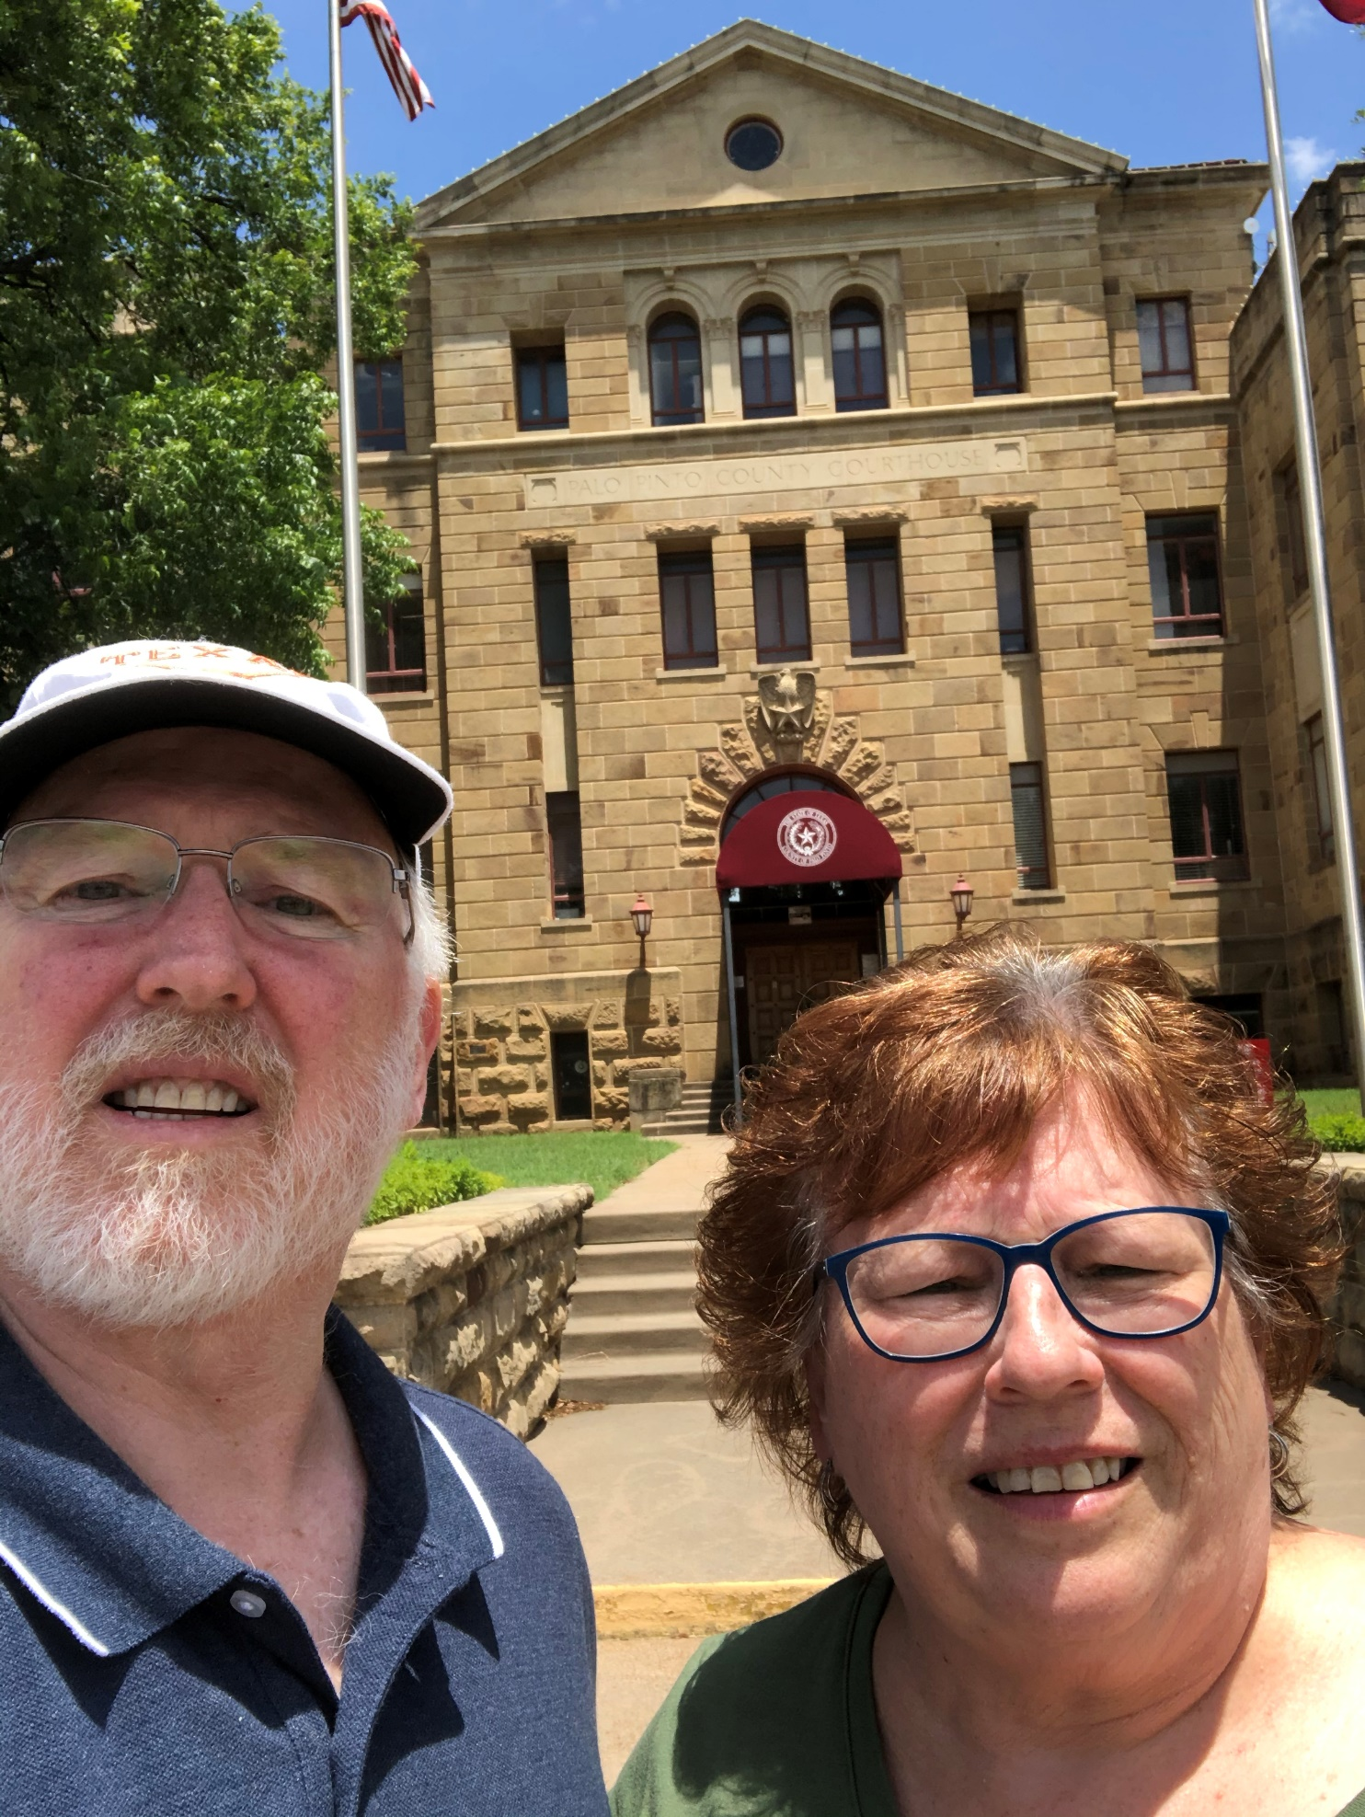
79 - Palo Pinto County – Palo Pinto, TX
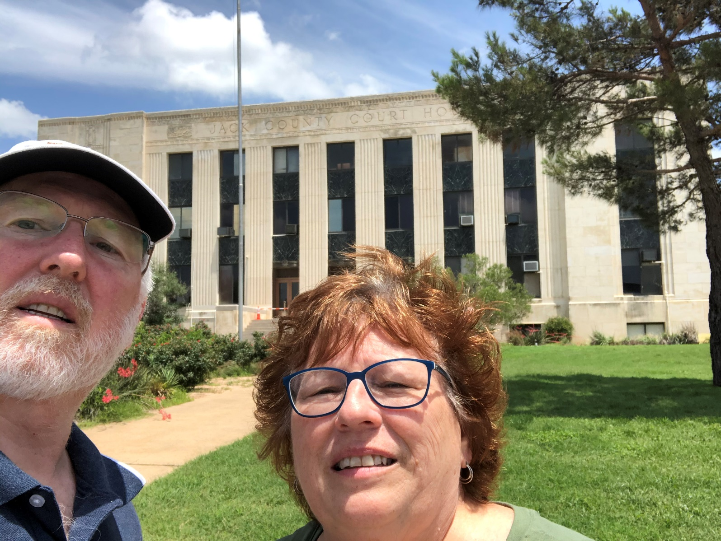
80 – Jack County – Jacksboro, TX

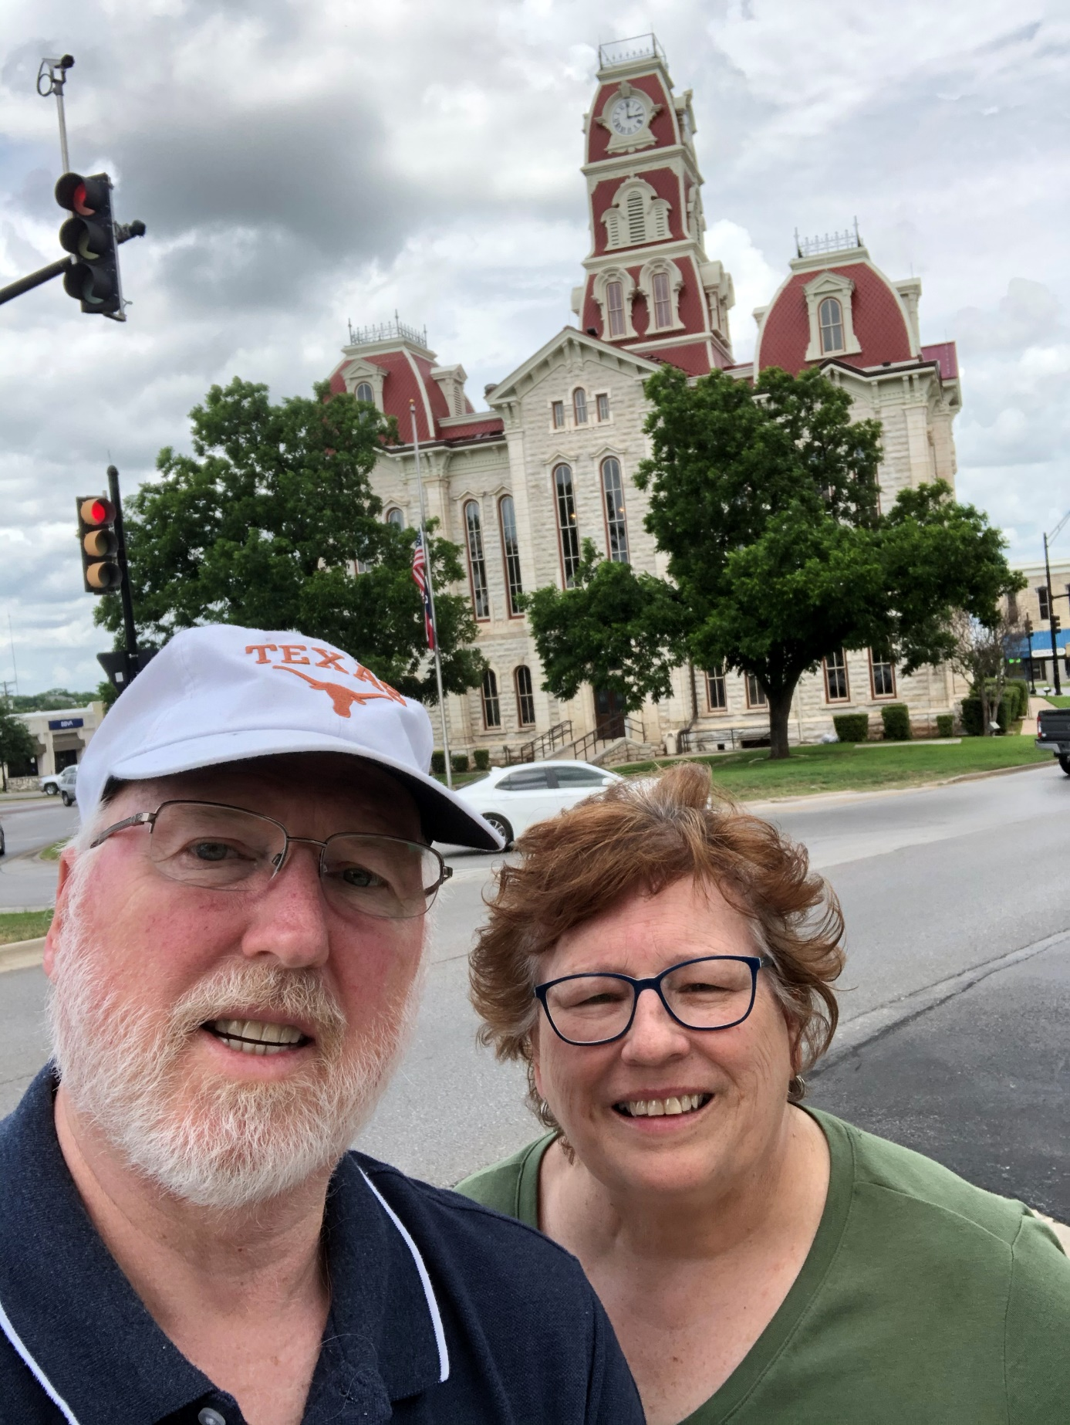
81 – Parker County – Weatherford, TX
End of Trip

