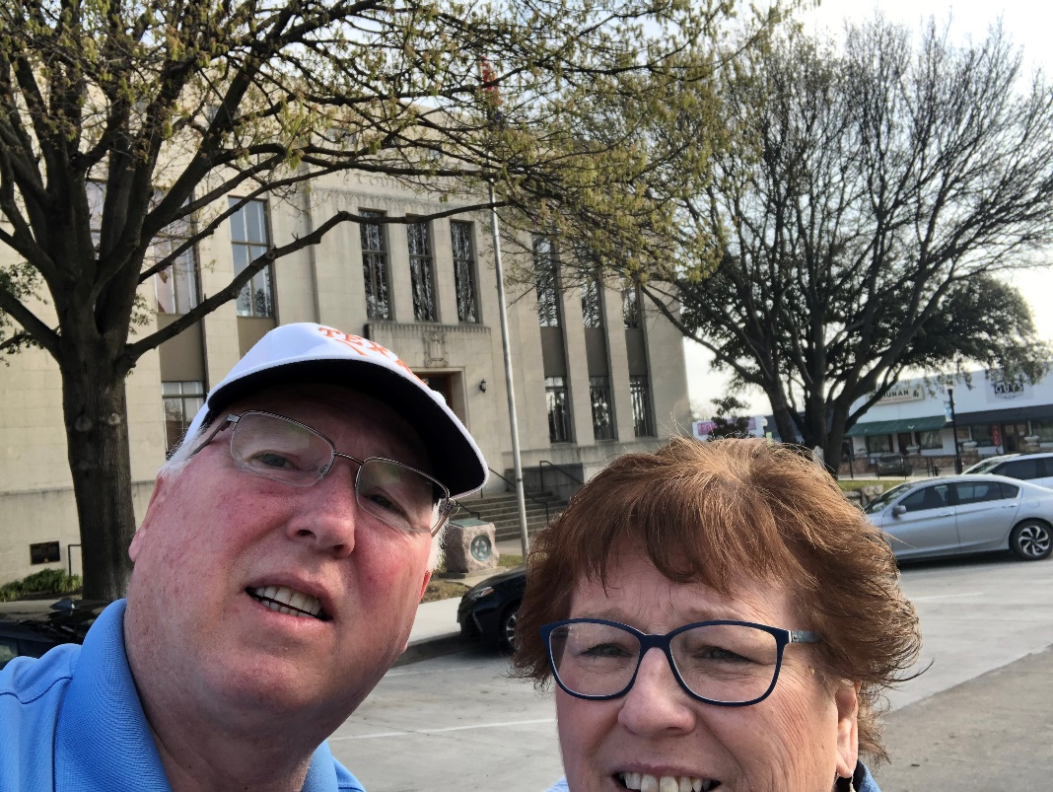
24a – Rockwall County – Rockwall, TX
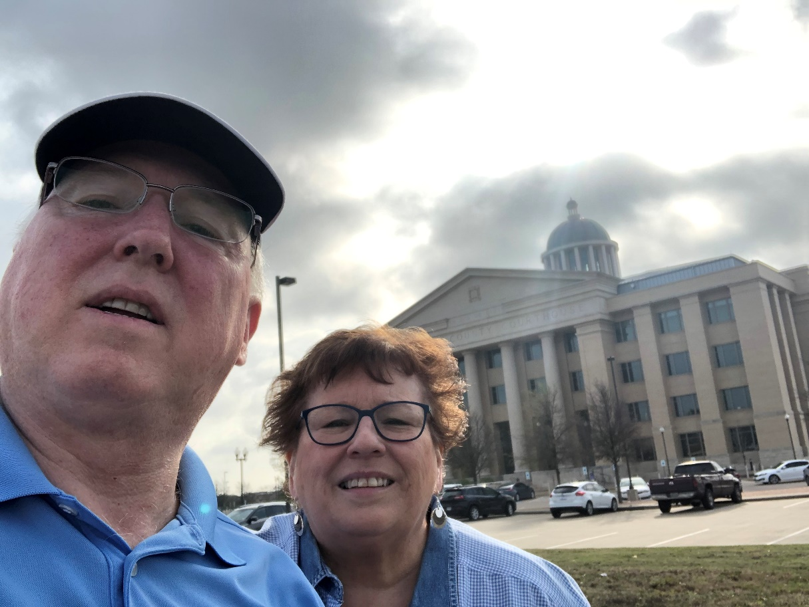
24b – Rockwall County – Rockwall, TX
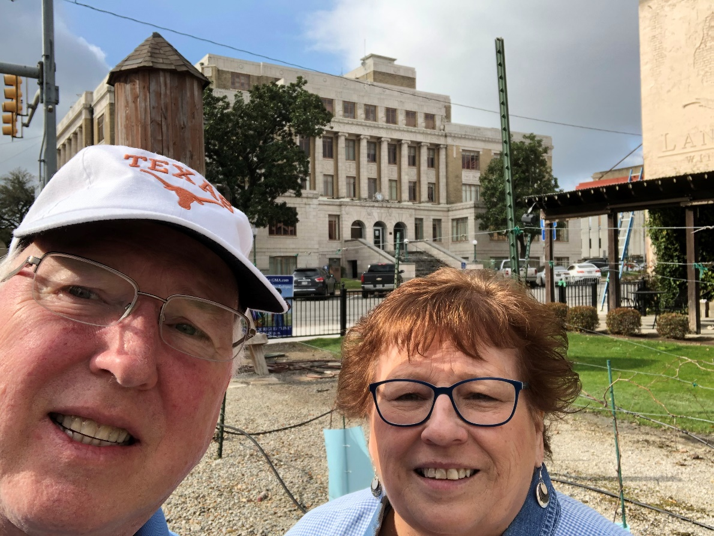
25 – Hunt County – Greenville, TX
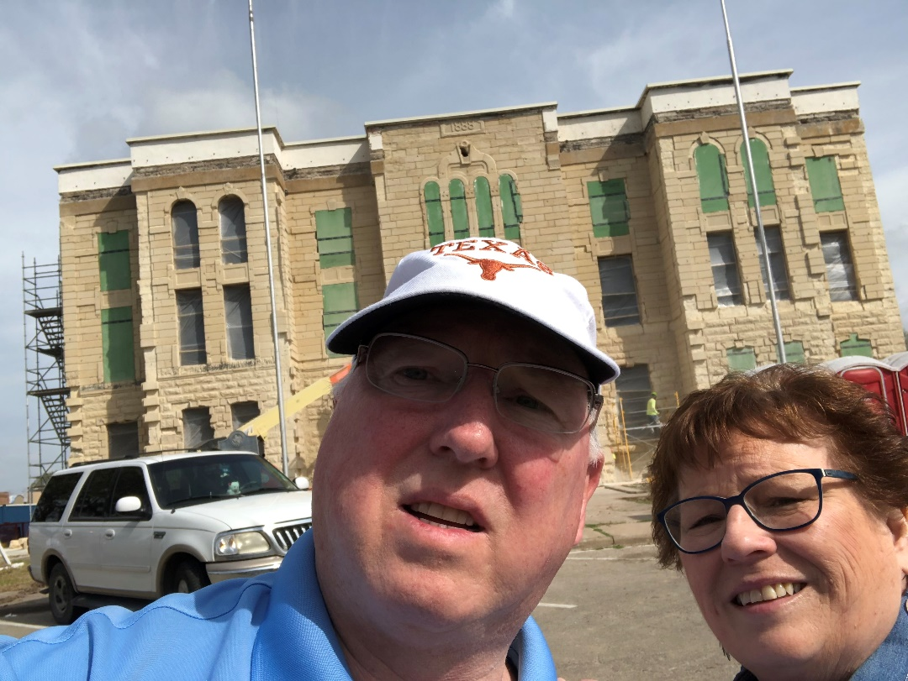
26 – Fannin County – Bonham, TX
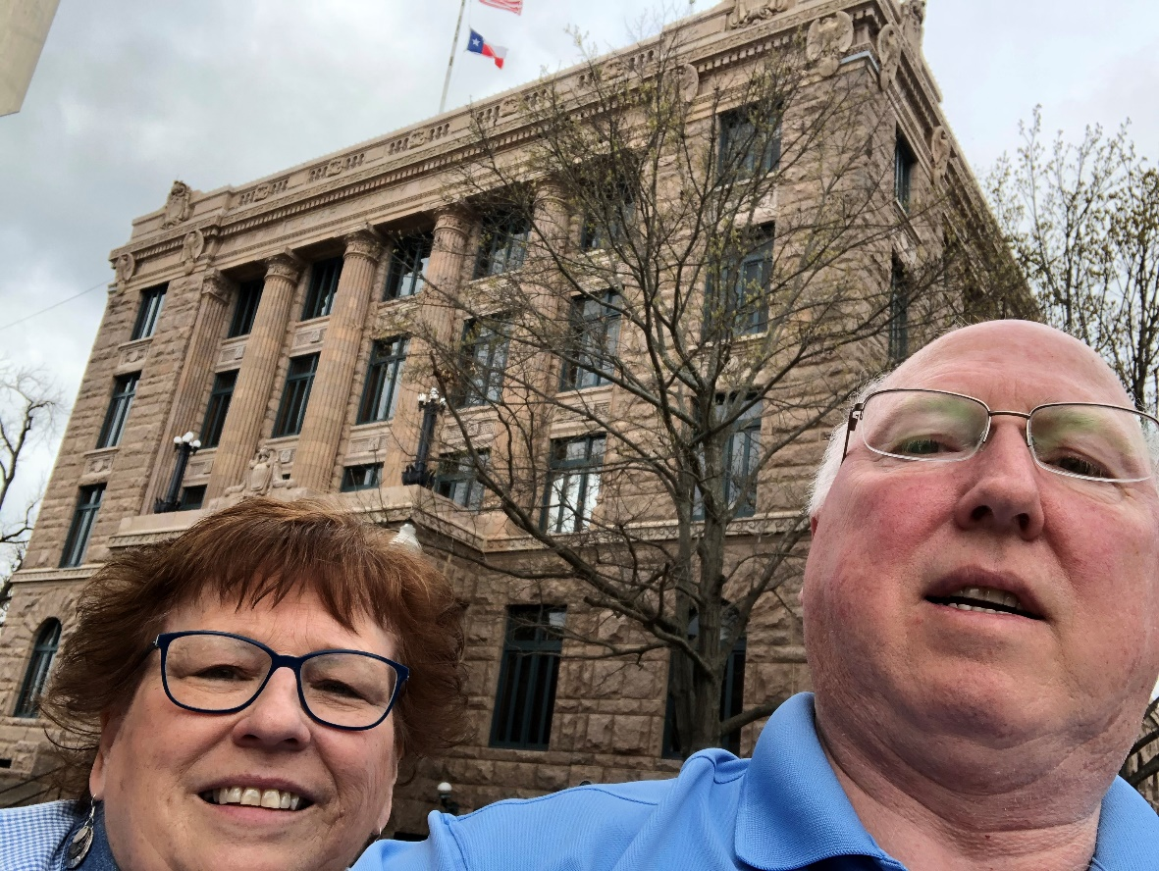
27 – Lamar County – Paris, TX
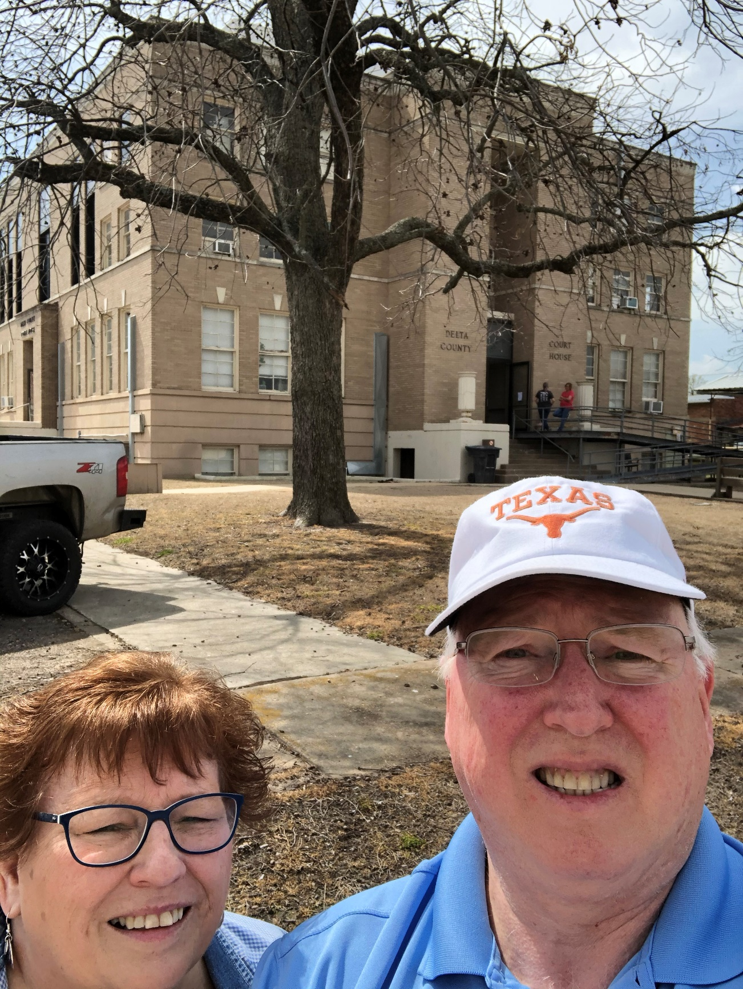
28 – Delta County – Cooper TX

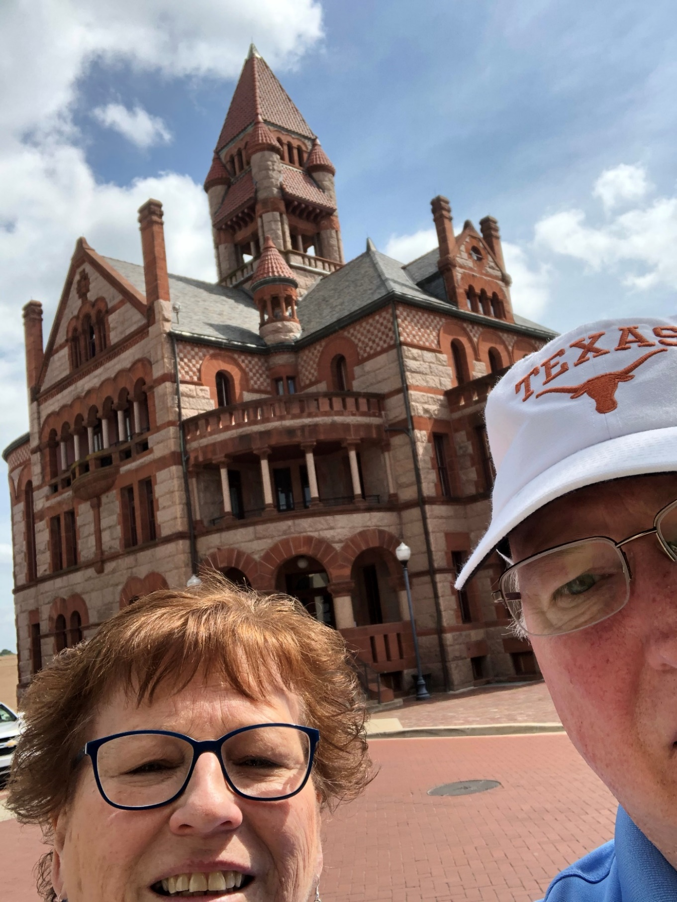
29–Hopkins County–Sulphur Springs,TX
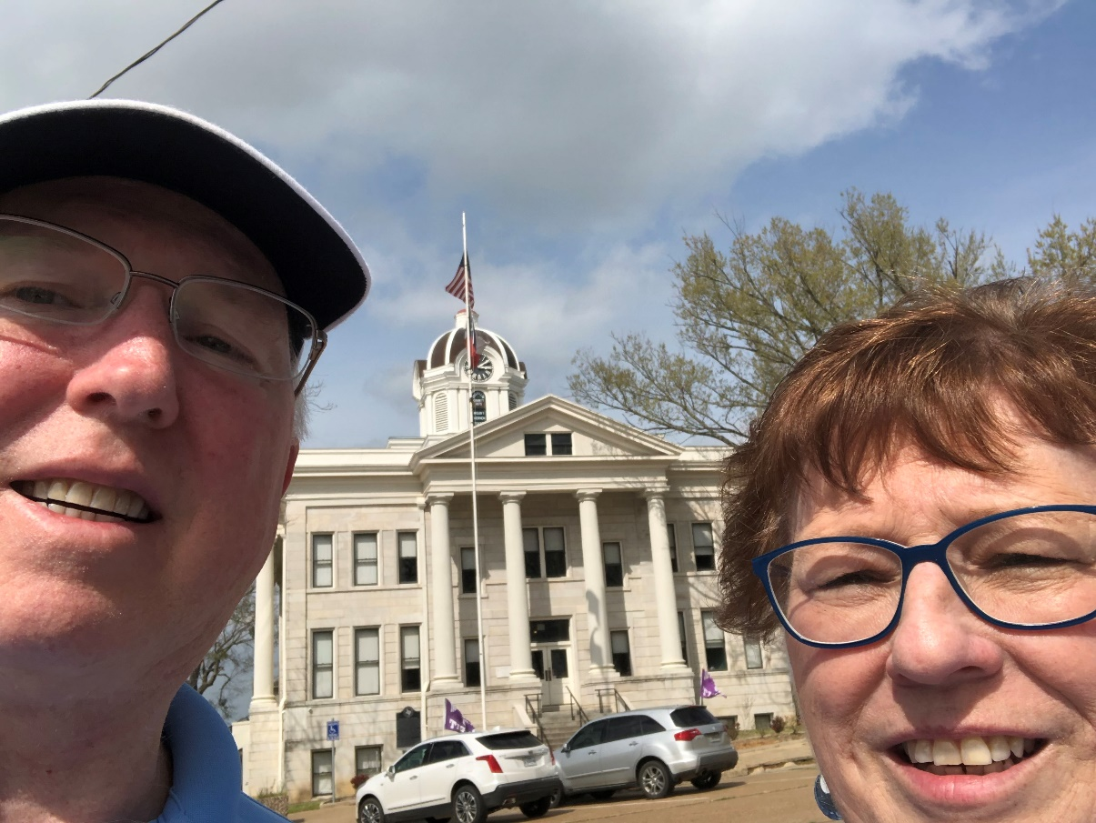
30– Franklin County – Mount Vernon, TX
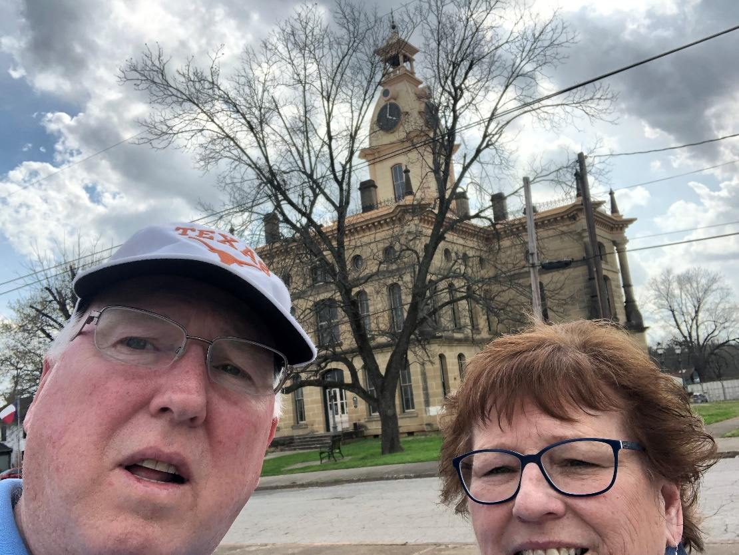
31 – Red River County – Clarksville, TX
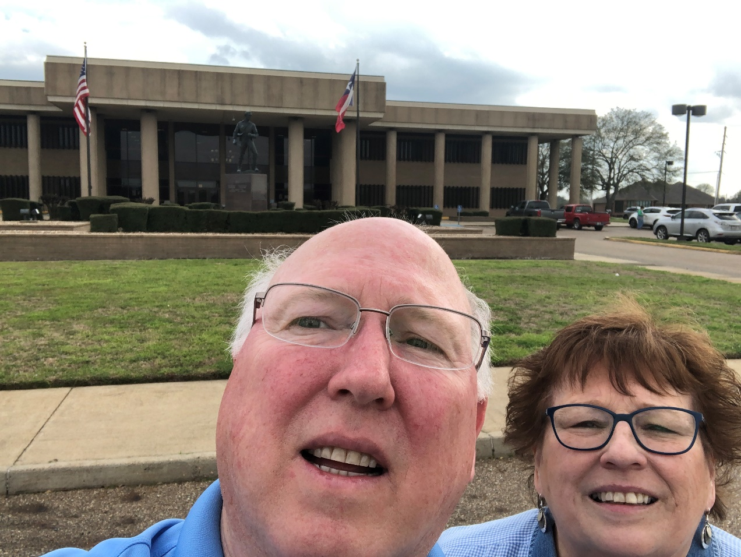
32 – Bowie County – New Boston, TX
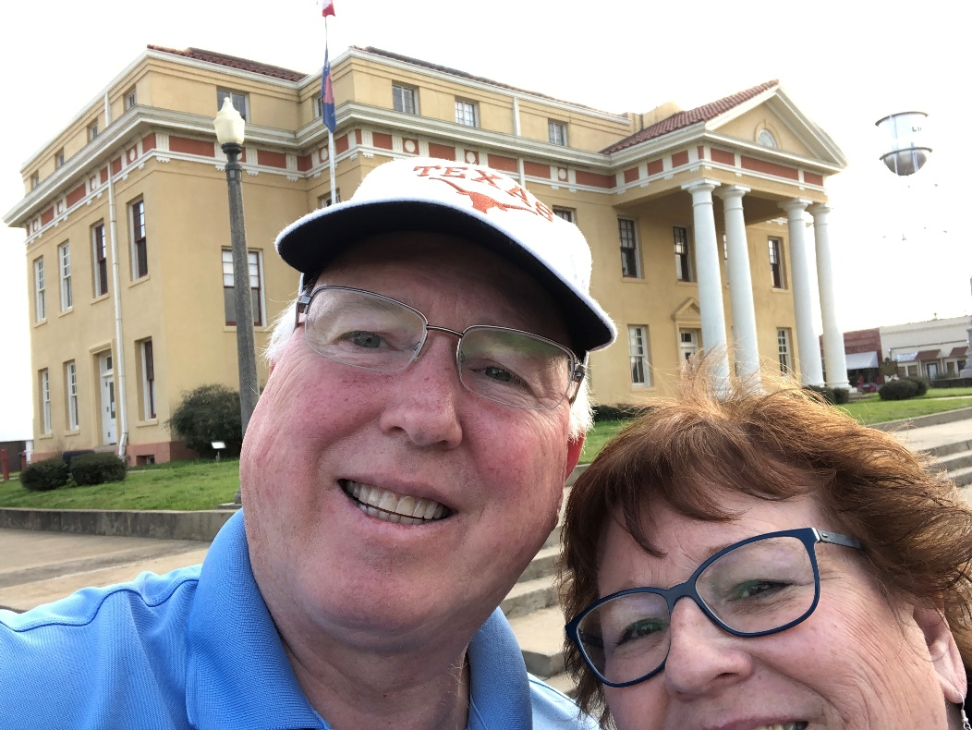
33 – Cass County – Linden, TX
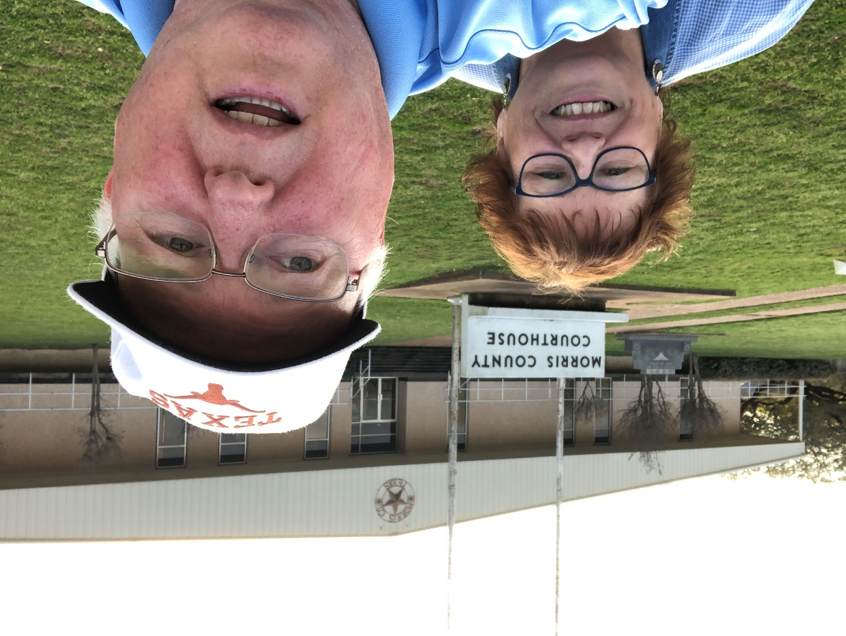
34 – Morris County – Daingerfield, TX
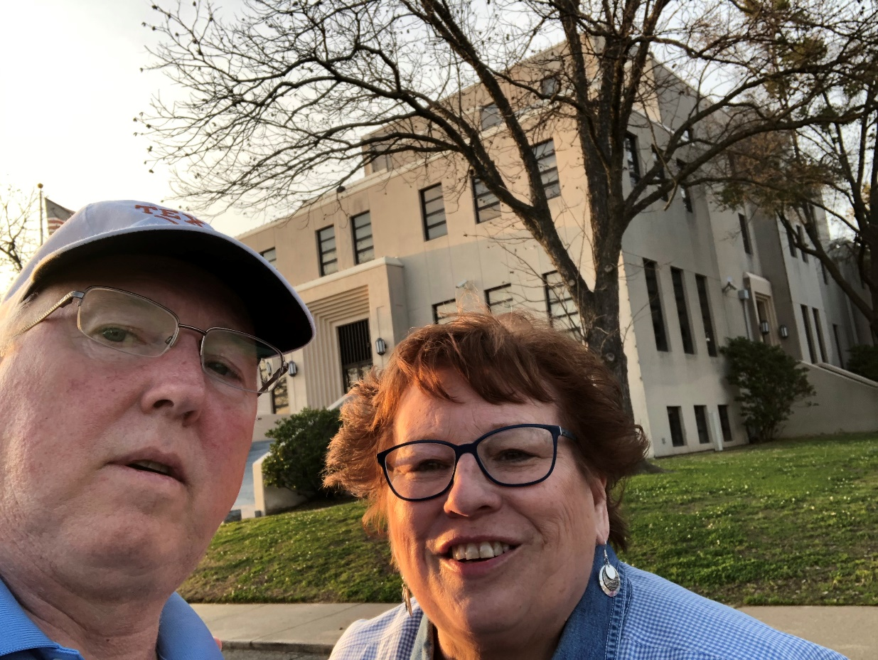
35 – Titus County – Mt. Pleasant, TX
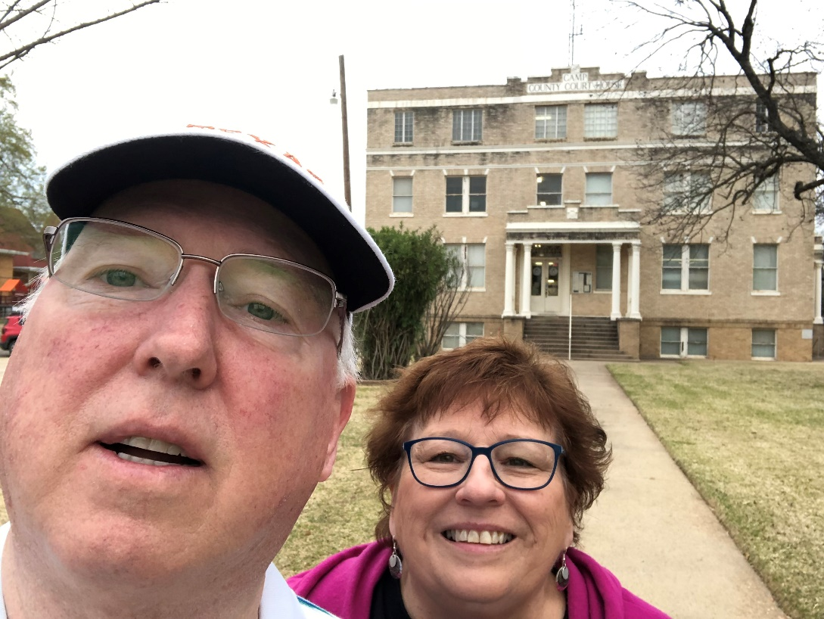
36 - Camp County – Pittsburg, TX
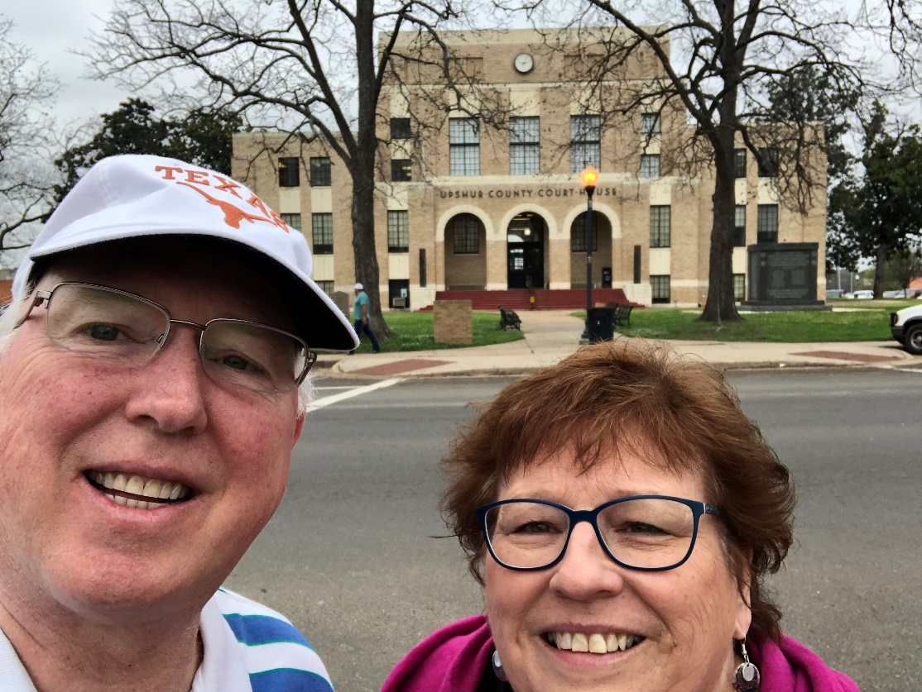
37 – Upshur County – Gilmer, TX
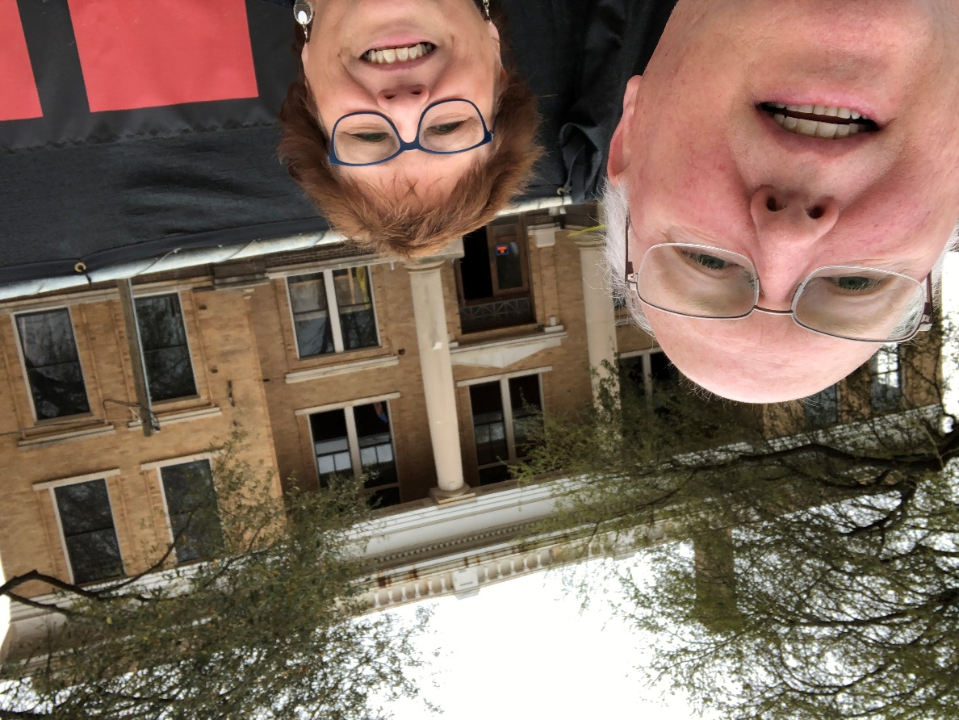
38 - Marion County – Jefferson, TX
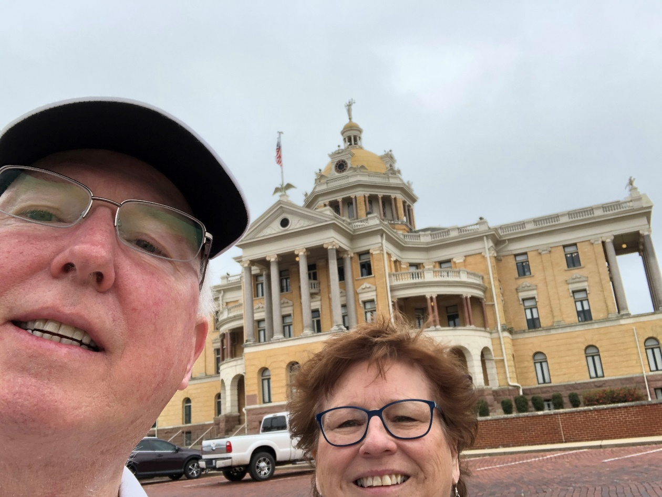
39a – Harrison County – Marshall, TX
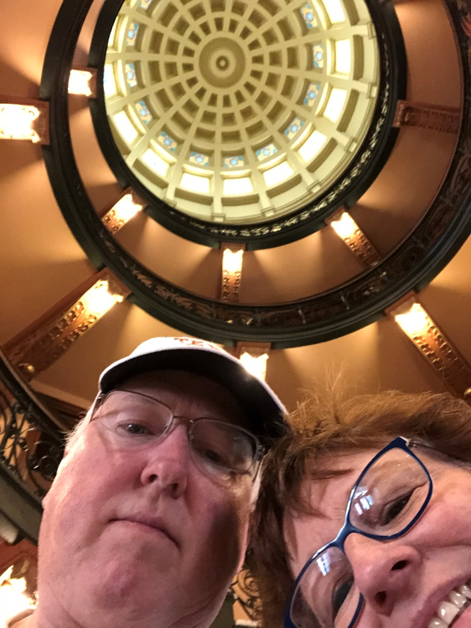
39b – Harrison County – Marshall, TX
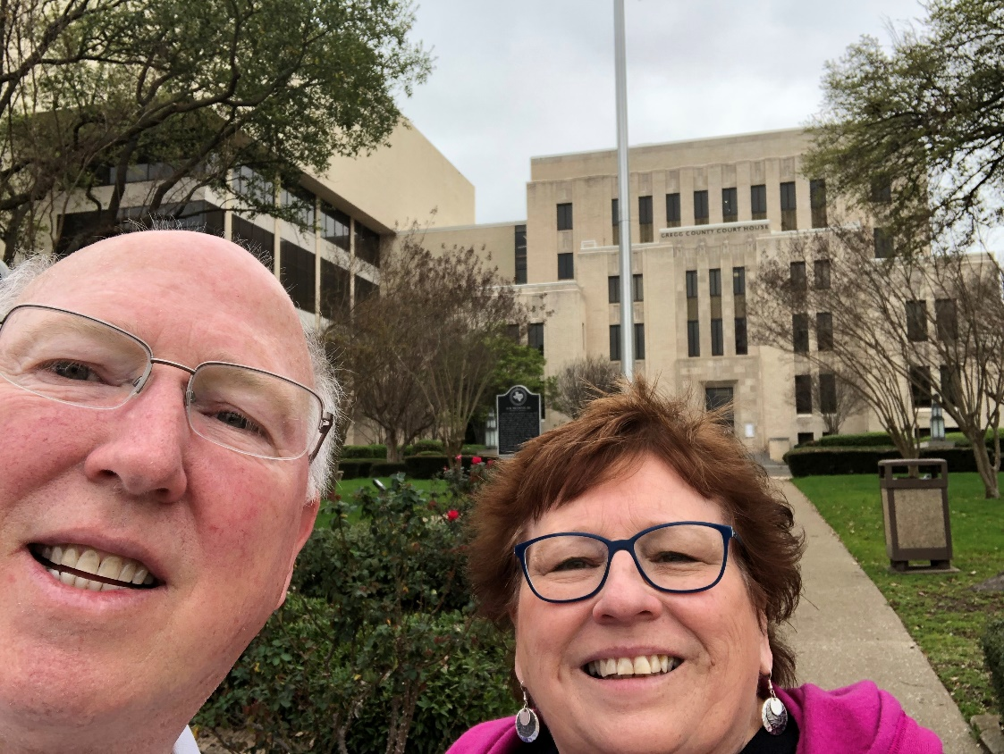
40 – Gregg County – Longview, TX
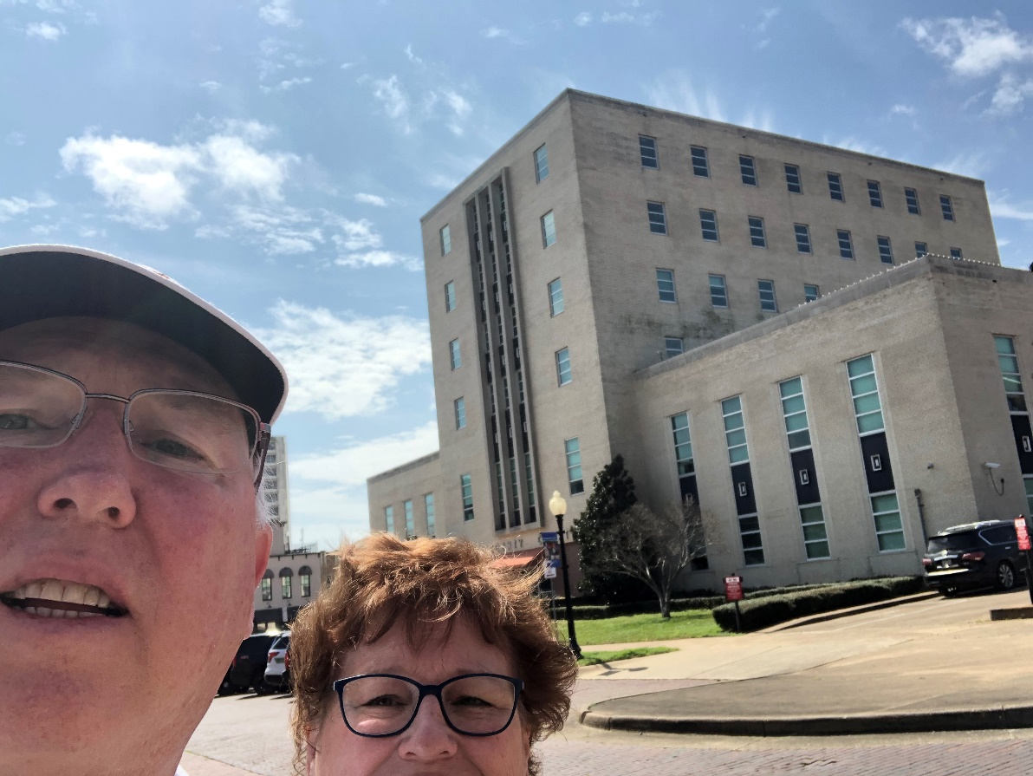
41 – Smith County – Tyler, TX
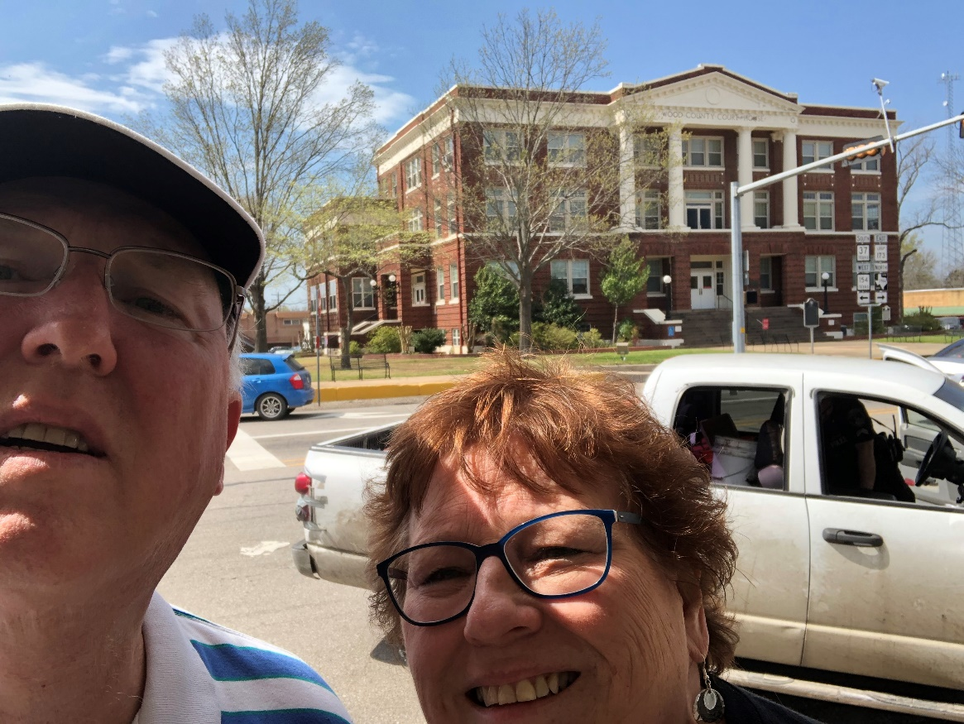
42 – Wood County – Quitman, TX

43 – Rains County – Emory, TX
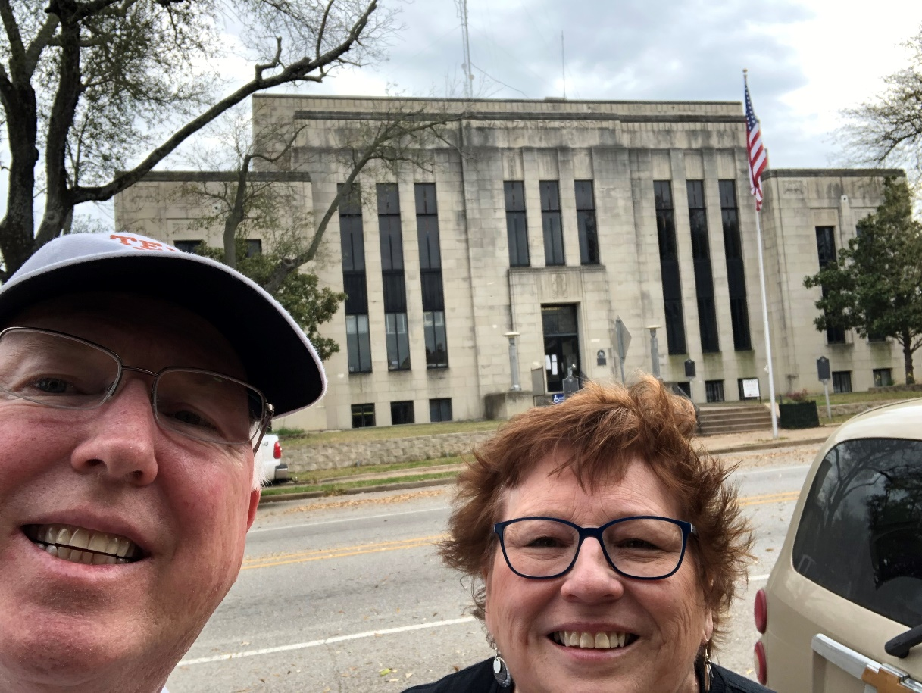
44 – Van Zandt County – Canton, TX
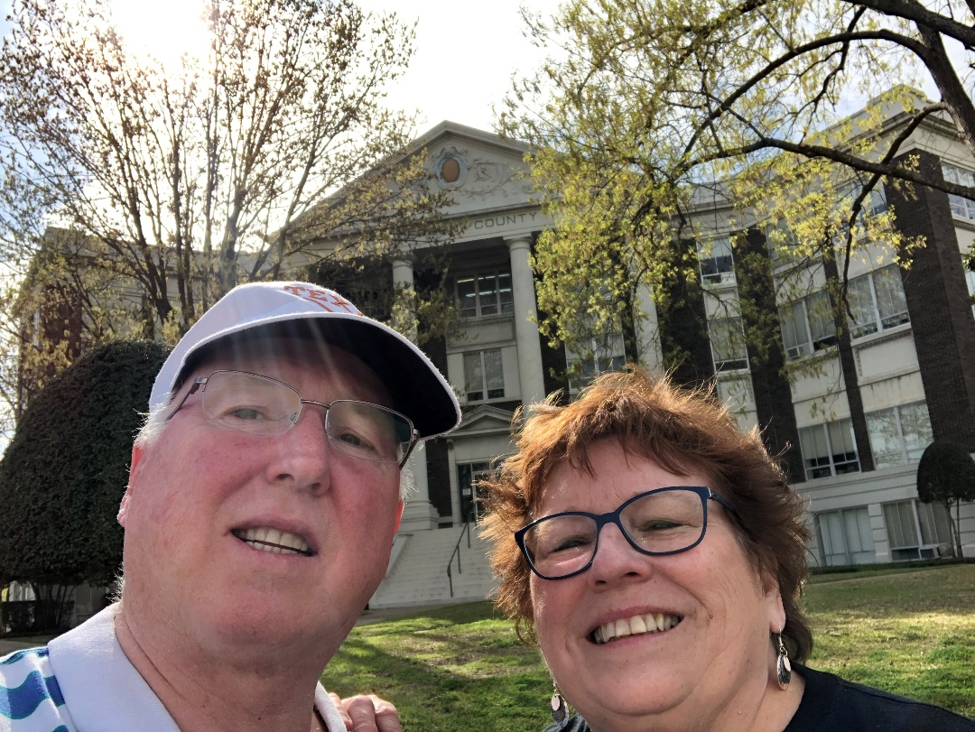
45 – Henderson County – Athens, TX
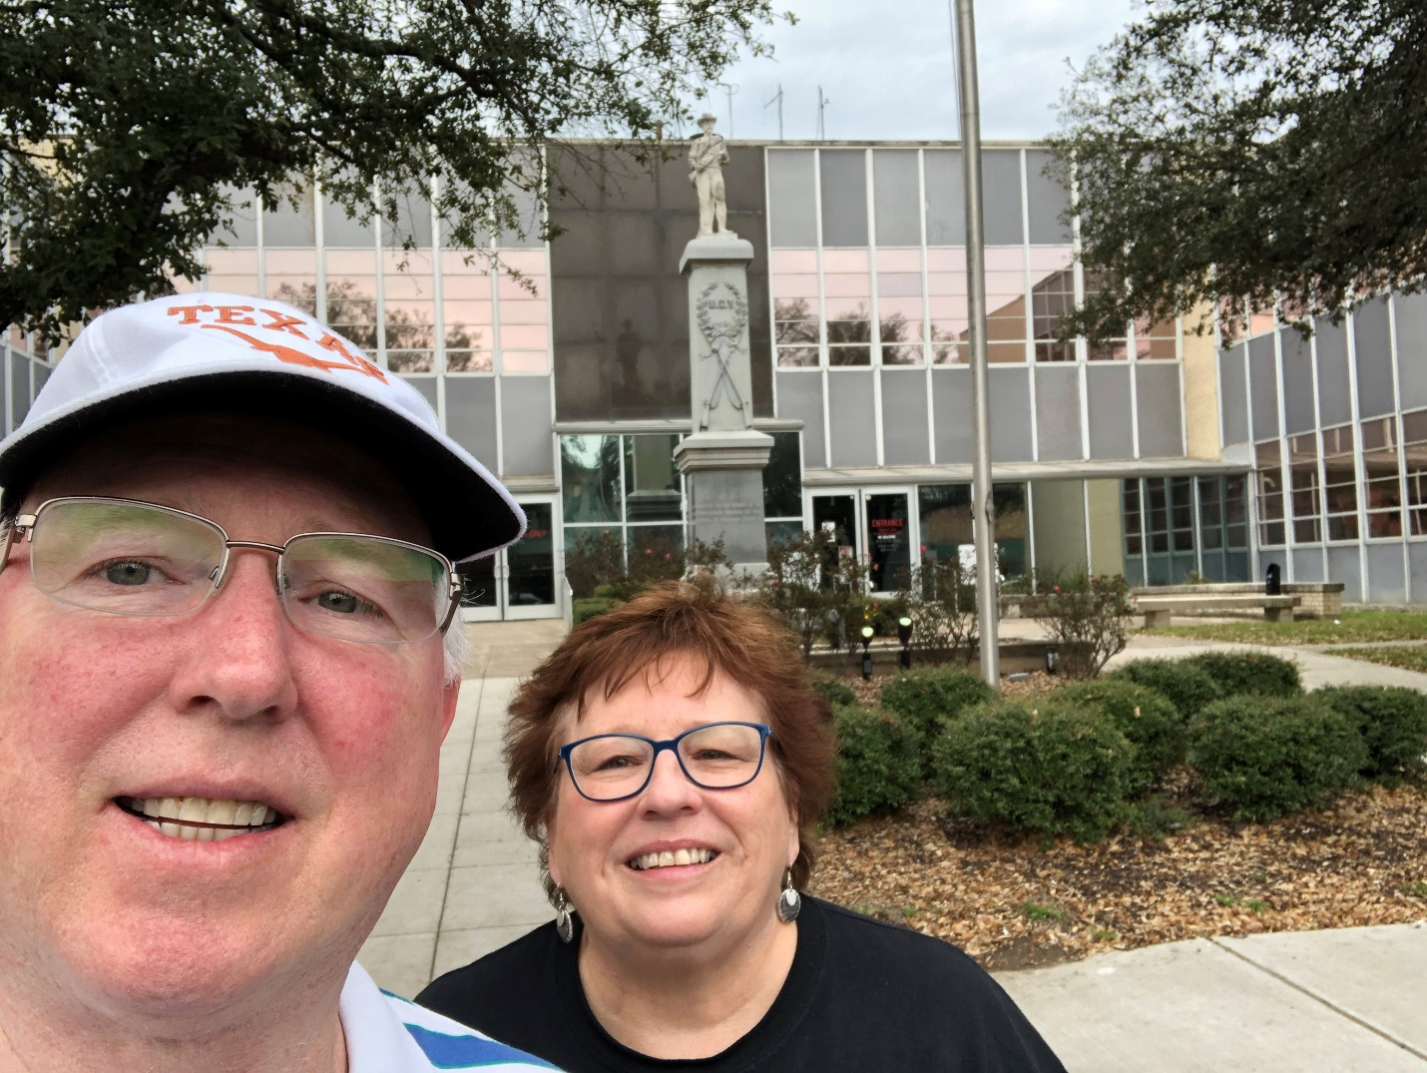
46 – Kaufman County – Kaufman, TX

End of Trip

