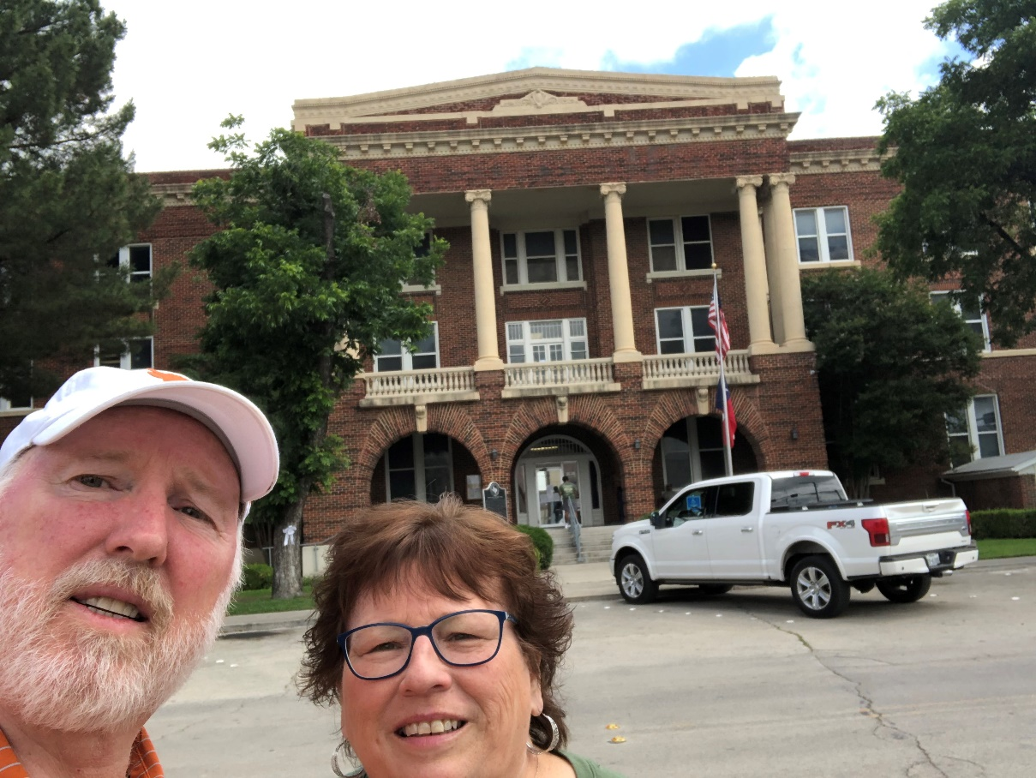
82 – Brown County – Brownwood, TX
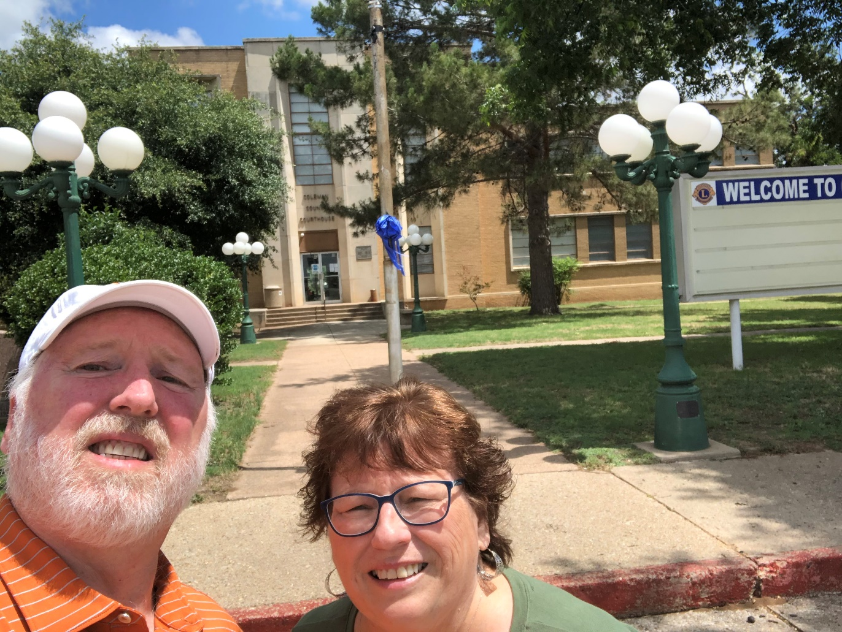
83 – Coleman County, Coleman, TX
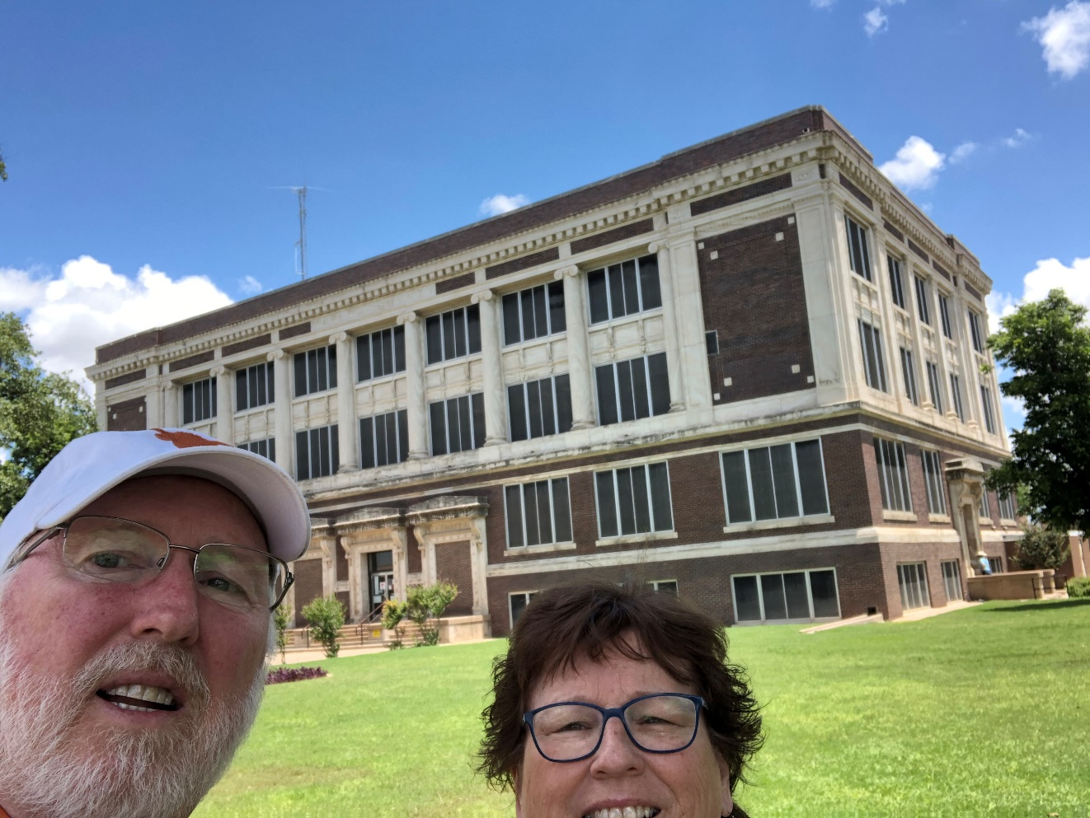
84 – Taylor County – Abilene, TX
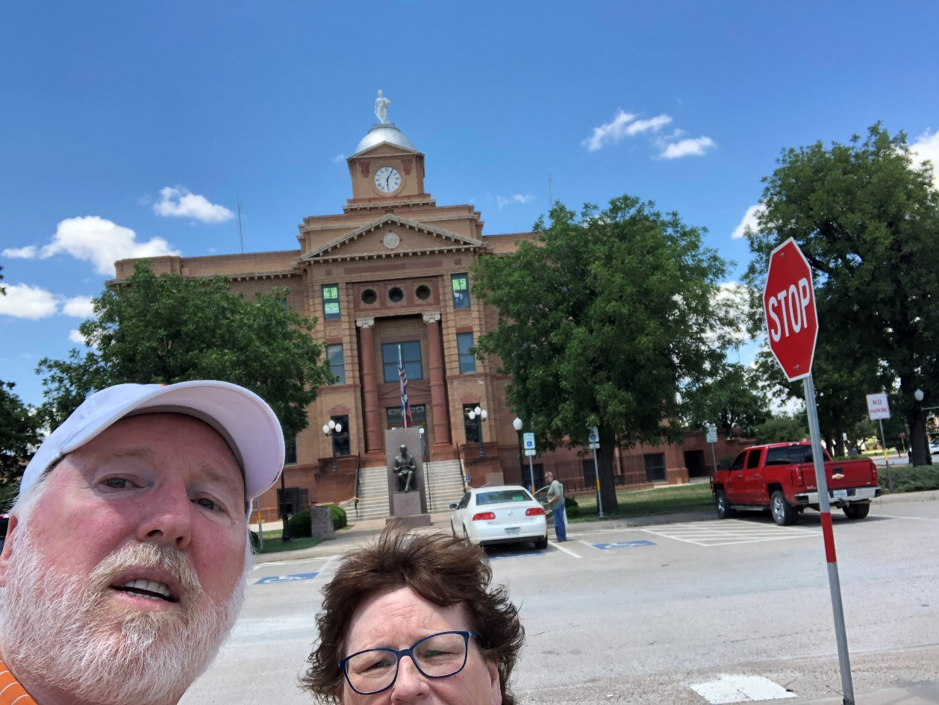
85 – Jones County – Anson, TX
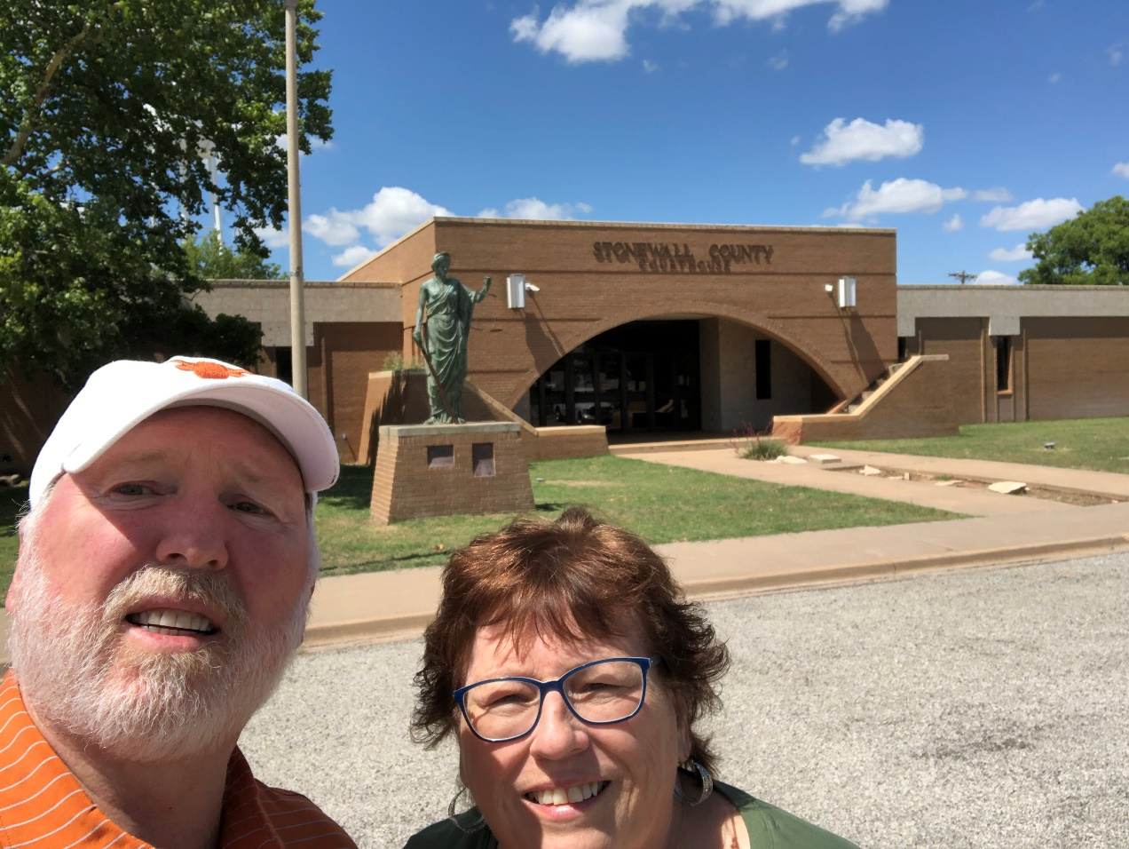
86 – Stonewall County – Aspermont, TX
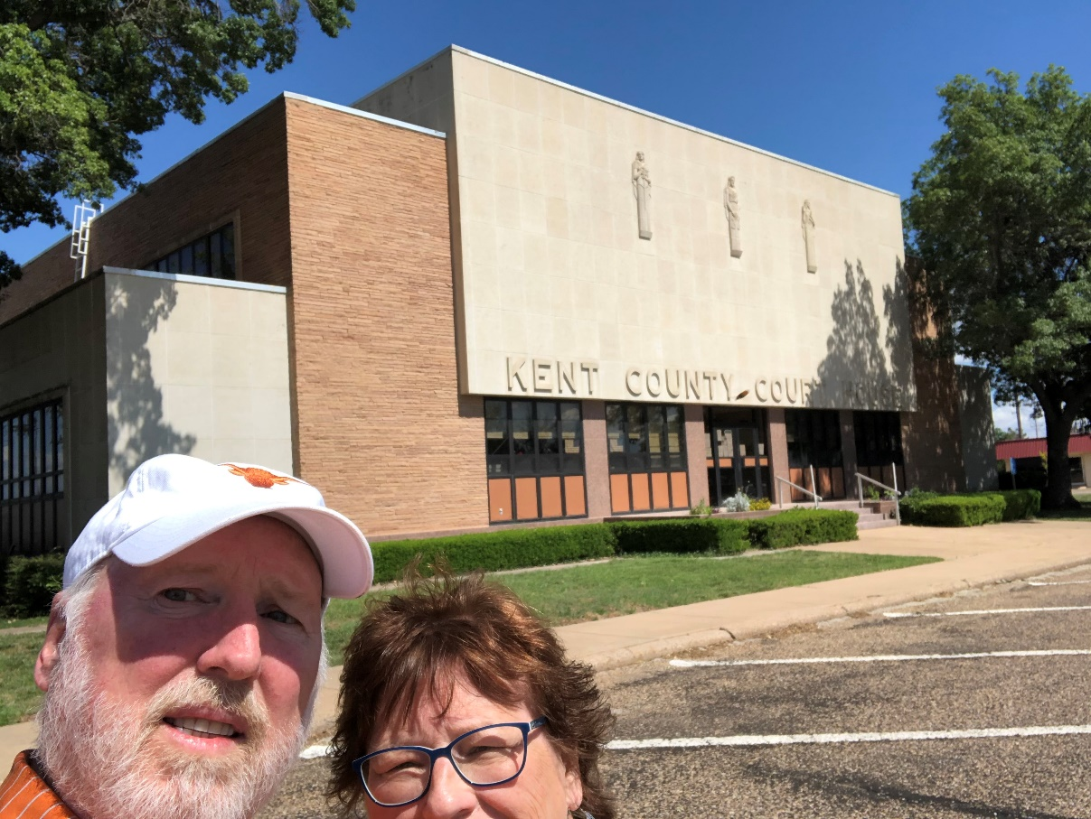
87 – Kent County – Jayton, TX
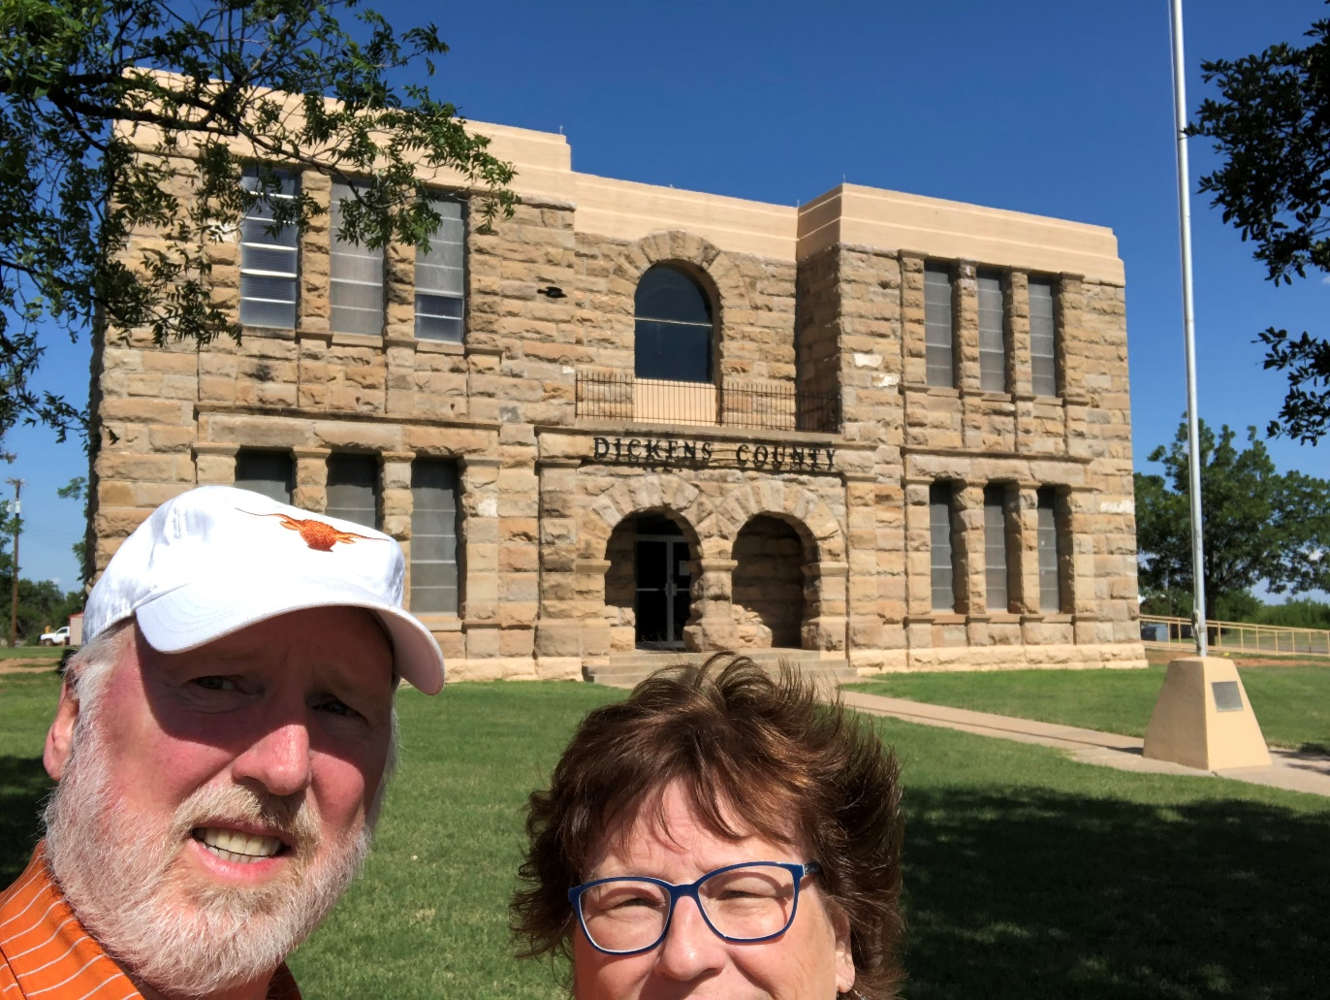
88 – Dickens County – Dickens, TX
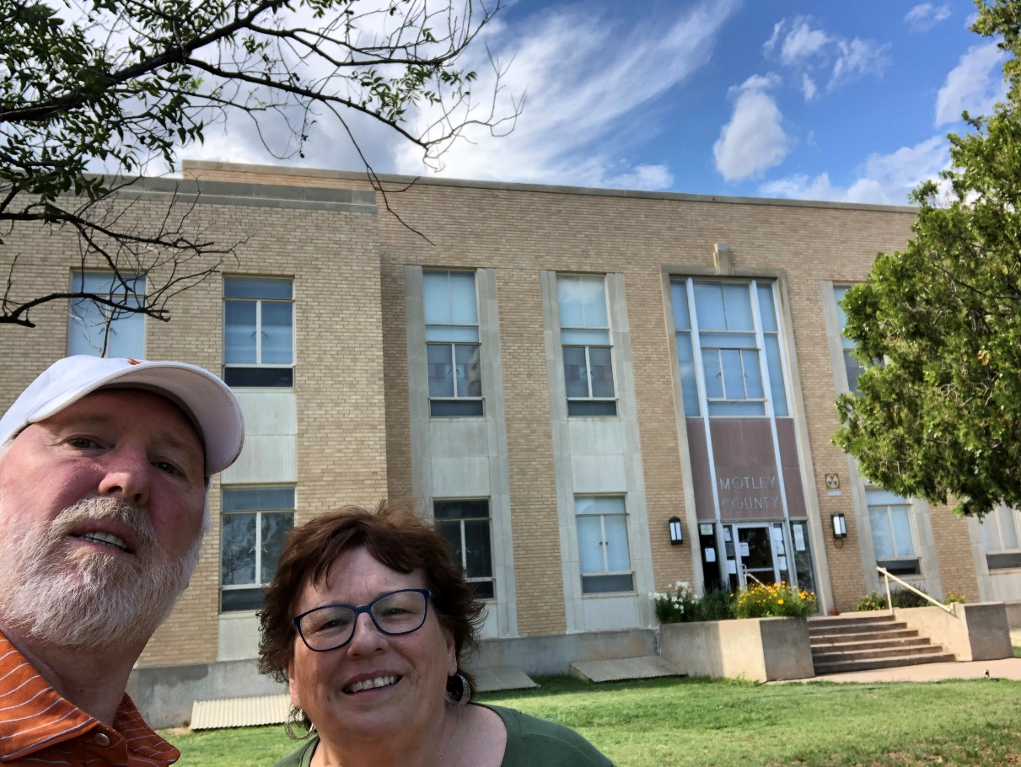
89 – Motley County – Matador, TX
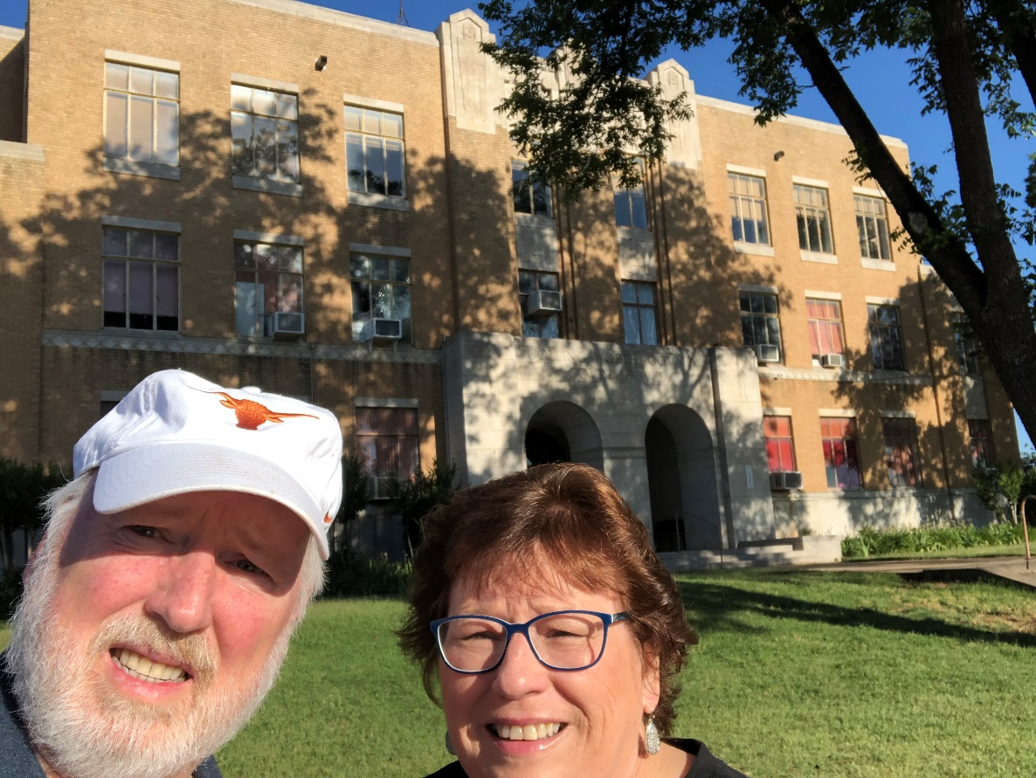
90 – Collingsworth – Wellington, TX
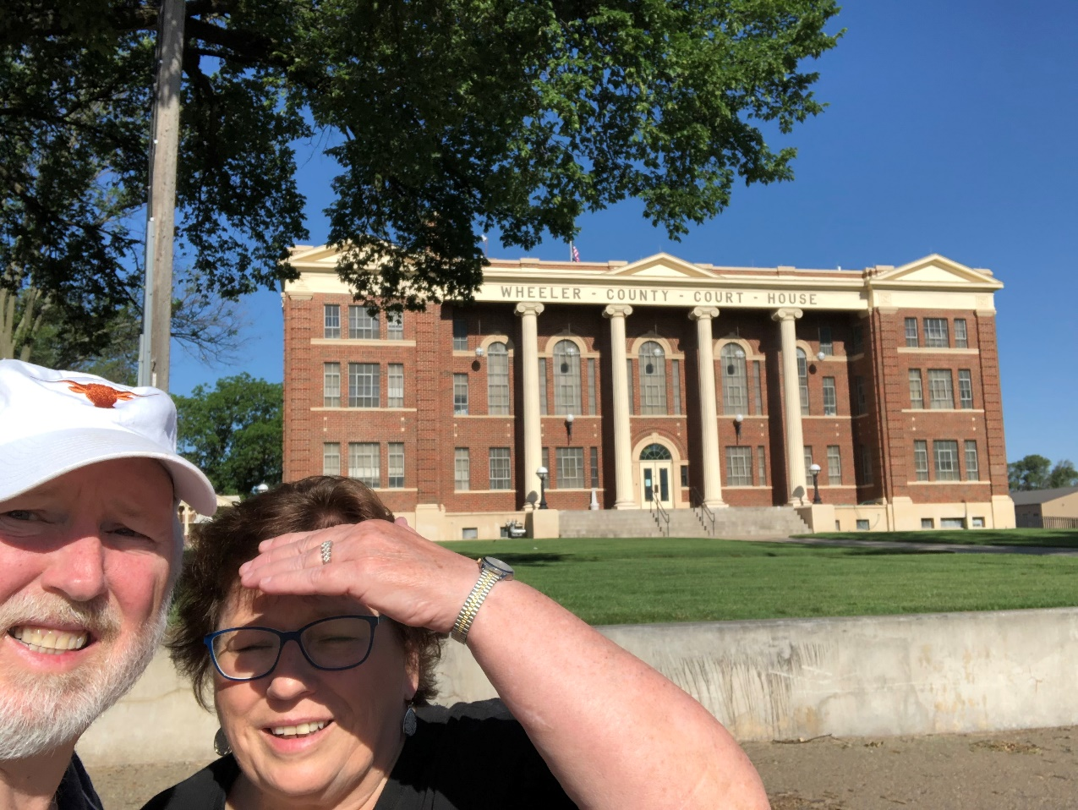
91 – Wheeler County – Wheeler, TX
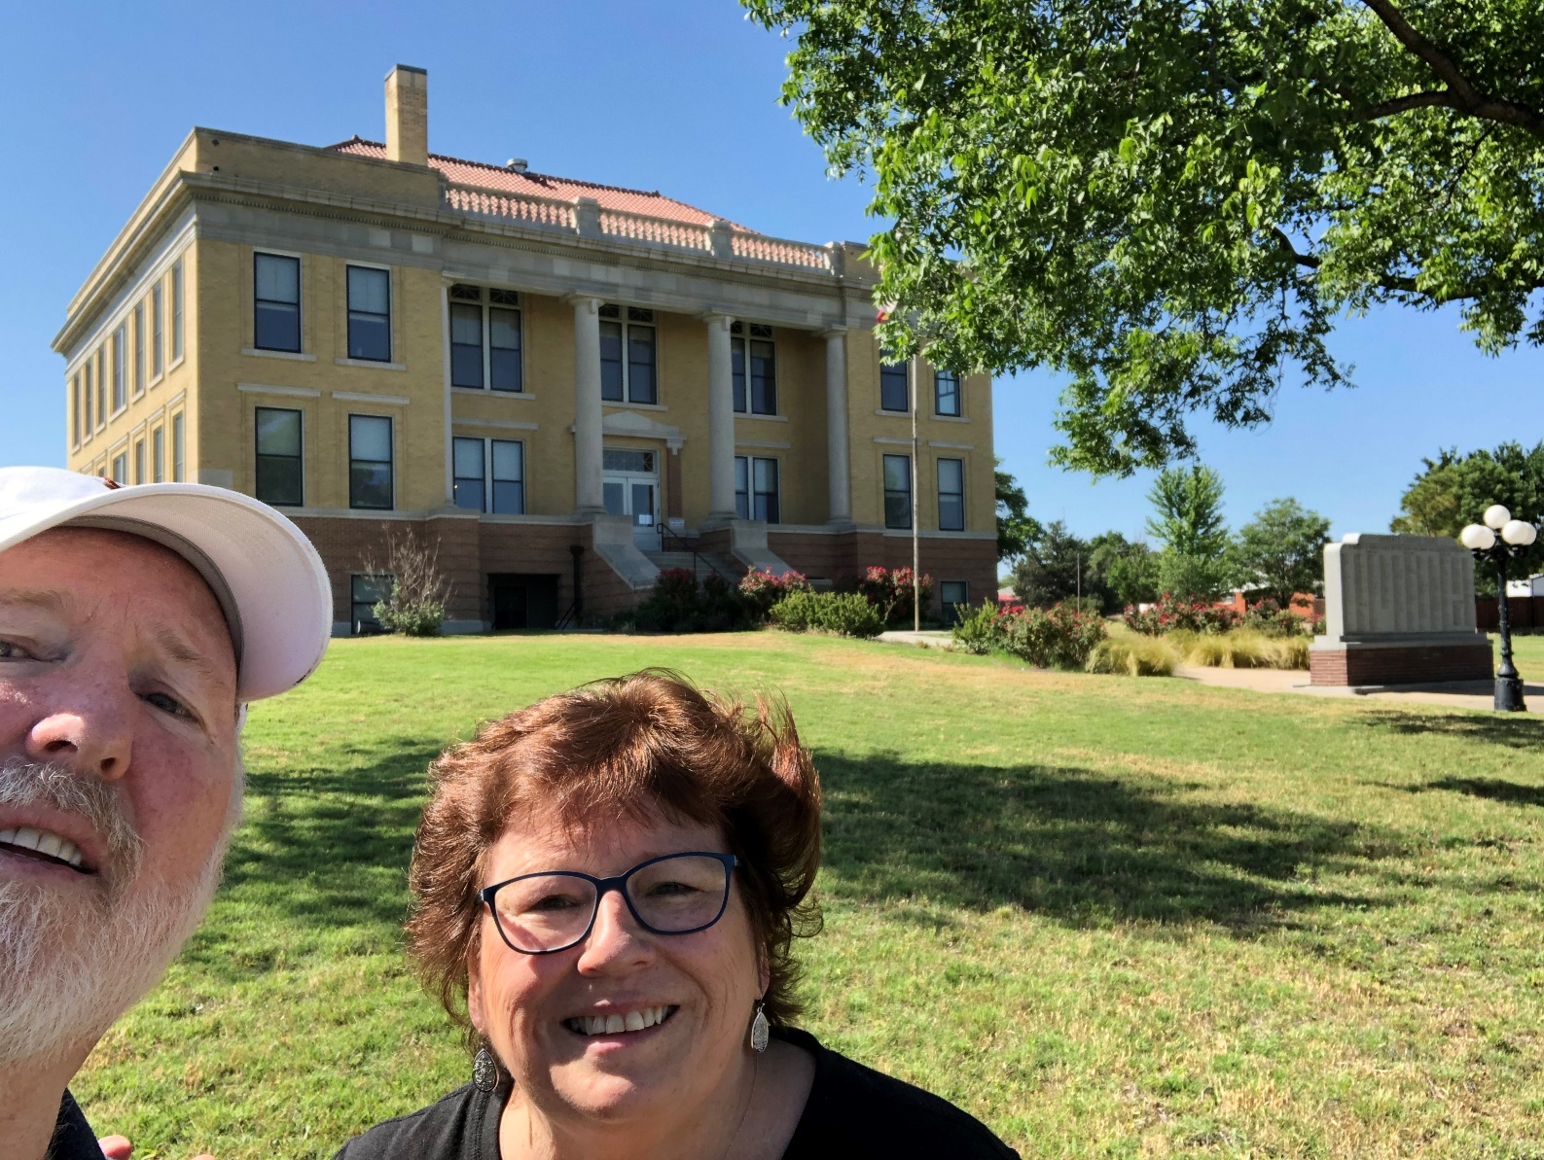
92 – Roberts County – Miami, TX

93 – Hemphill County – Canadian, TX
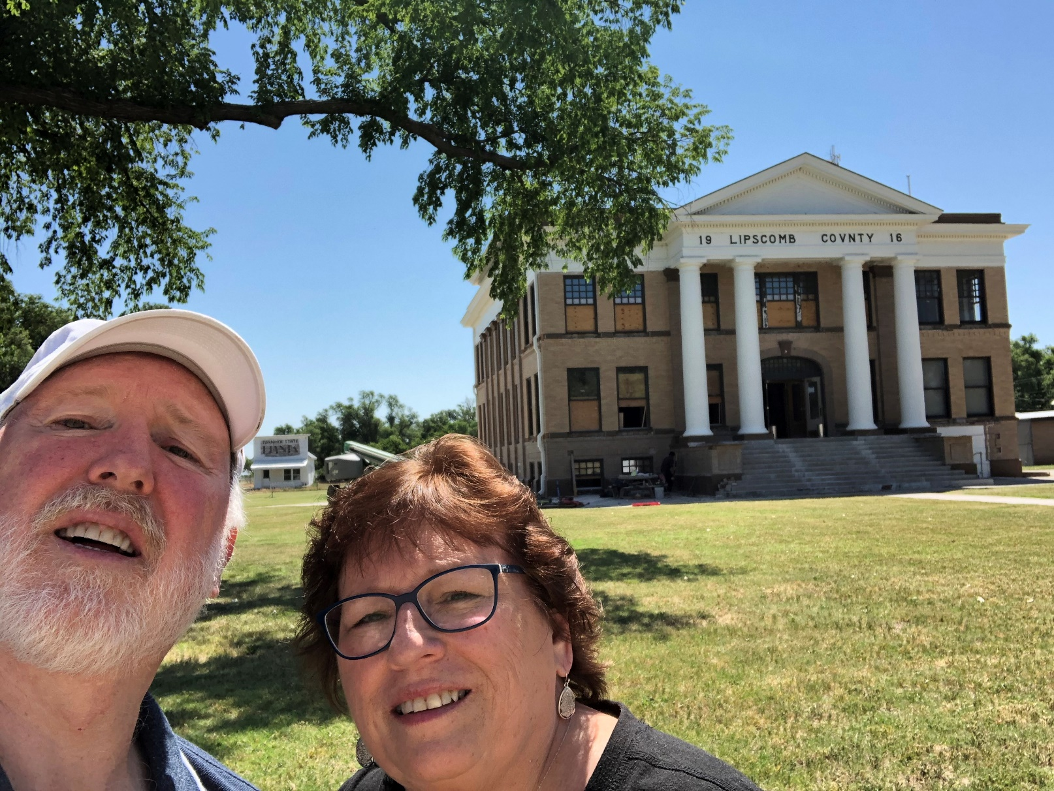
94 – Lipscomb County – Lipscomb, TX
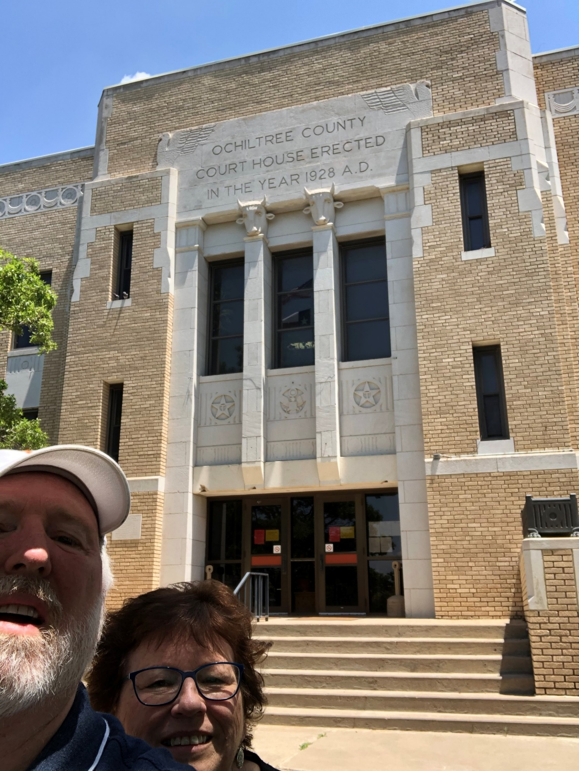
95 – Ochiltree County – Perryton, TX
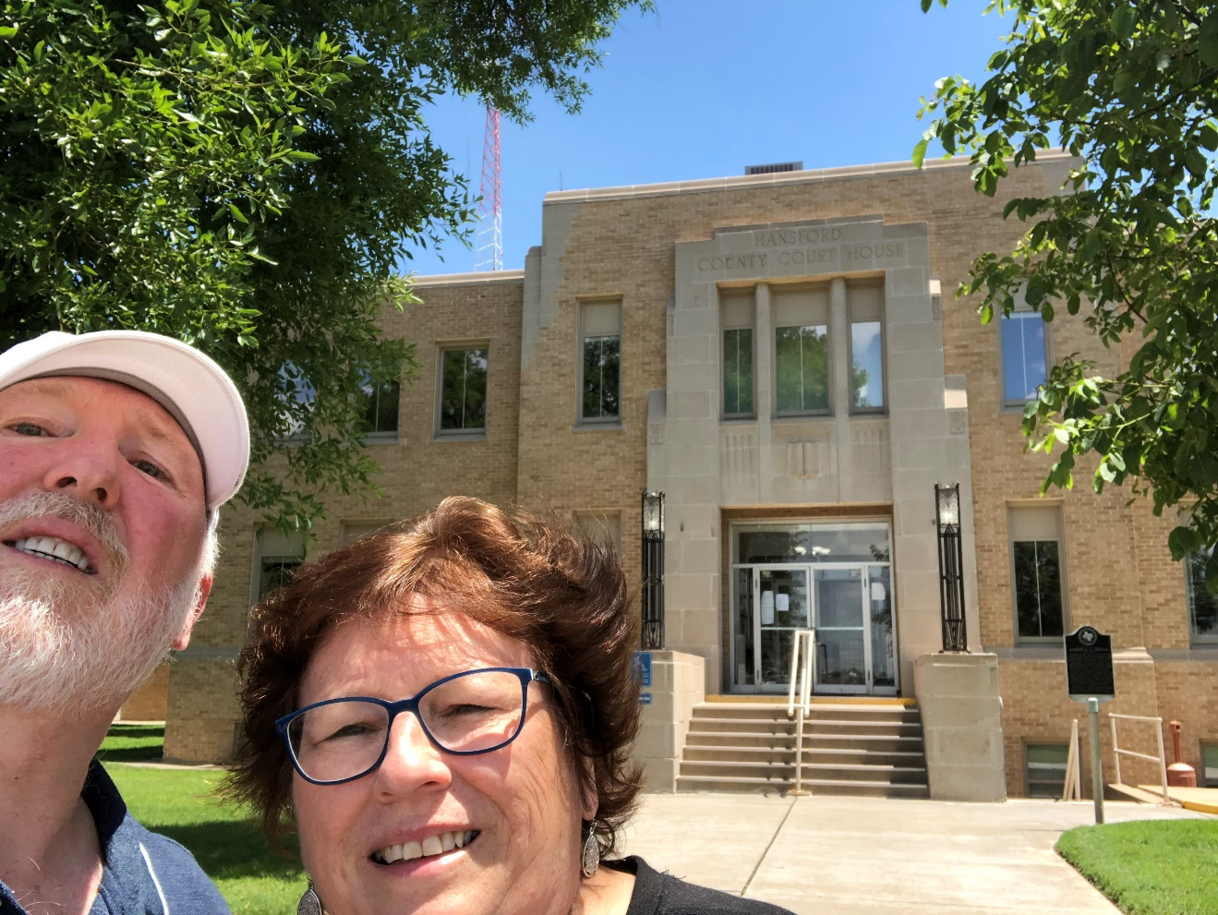
96 – Hansford County – Spearman, TX
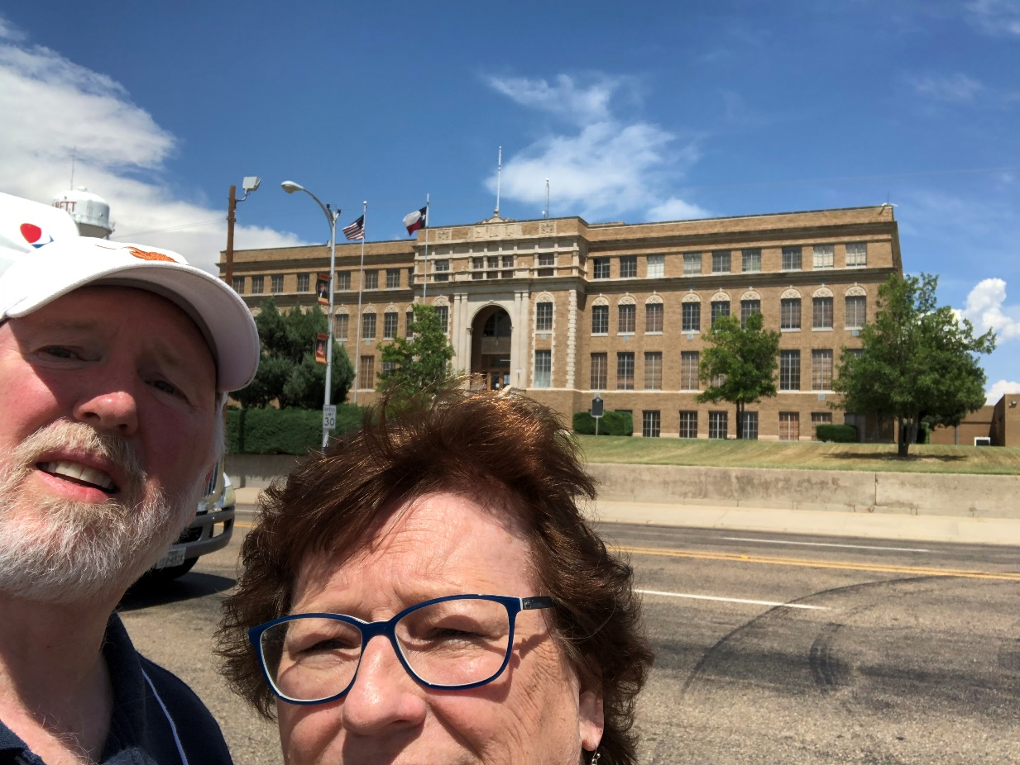
97 – Hutchinson County – Stinnett, TX
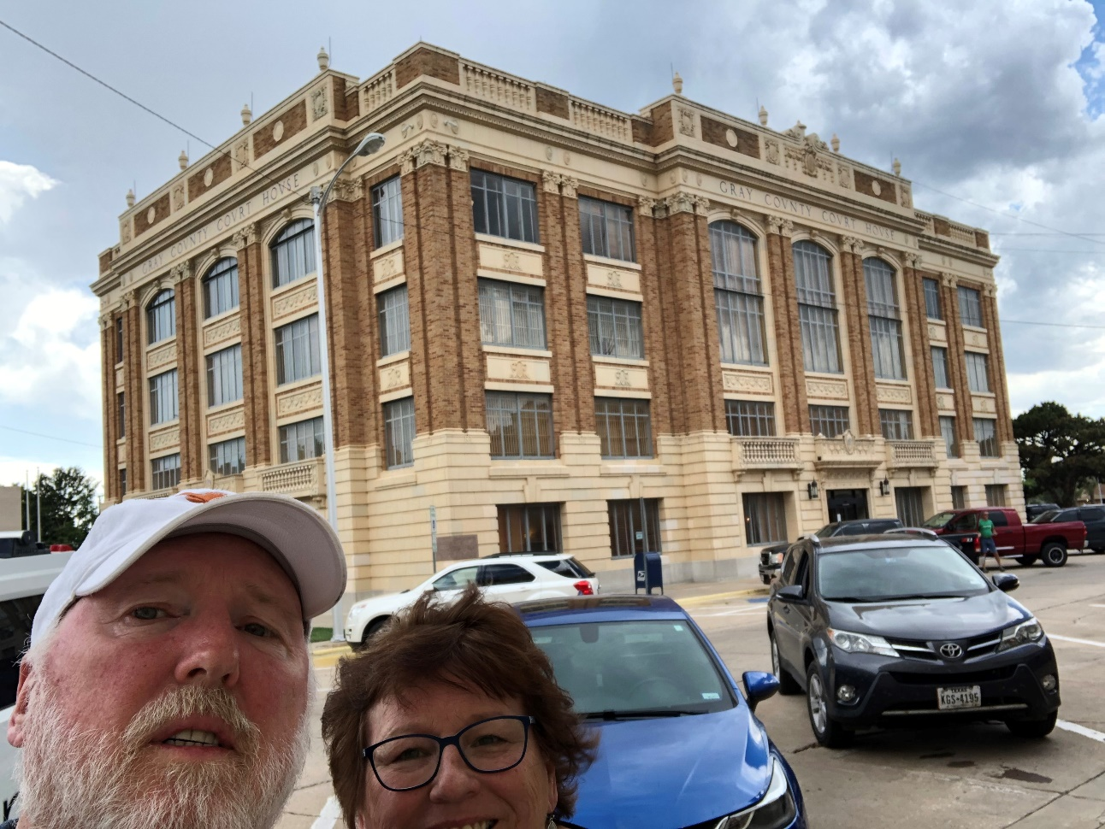
98 – Gray County – Pampa, TX
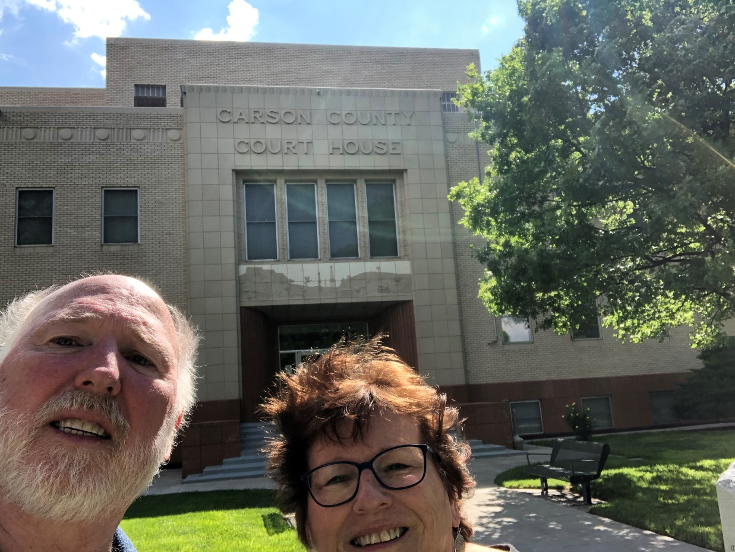
99 – Carson County – Panhandle, TX
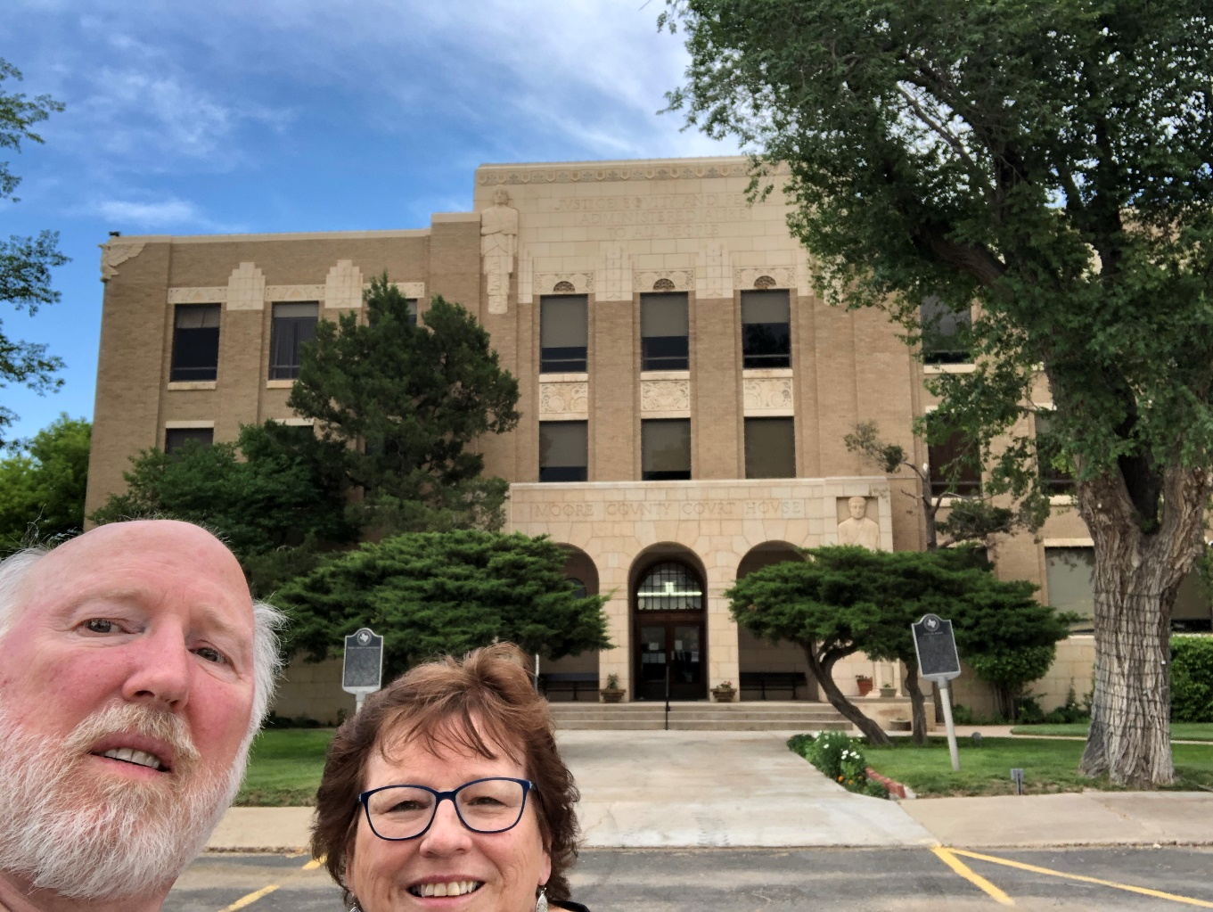
100 – Moore County – Dumas, TX
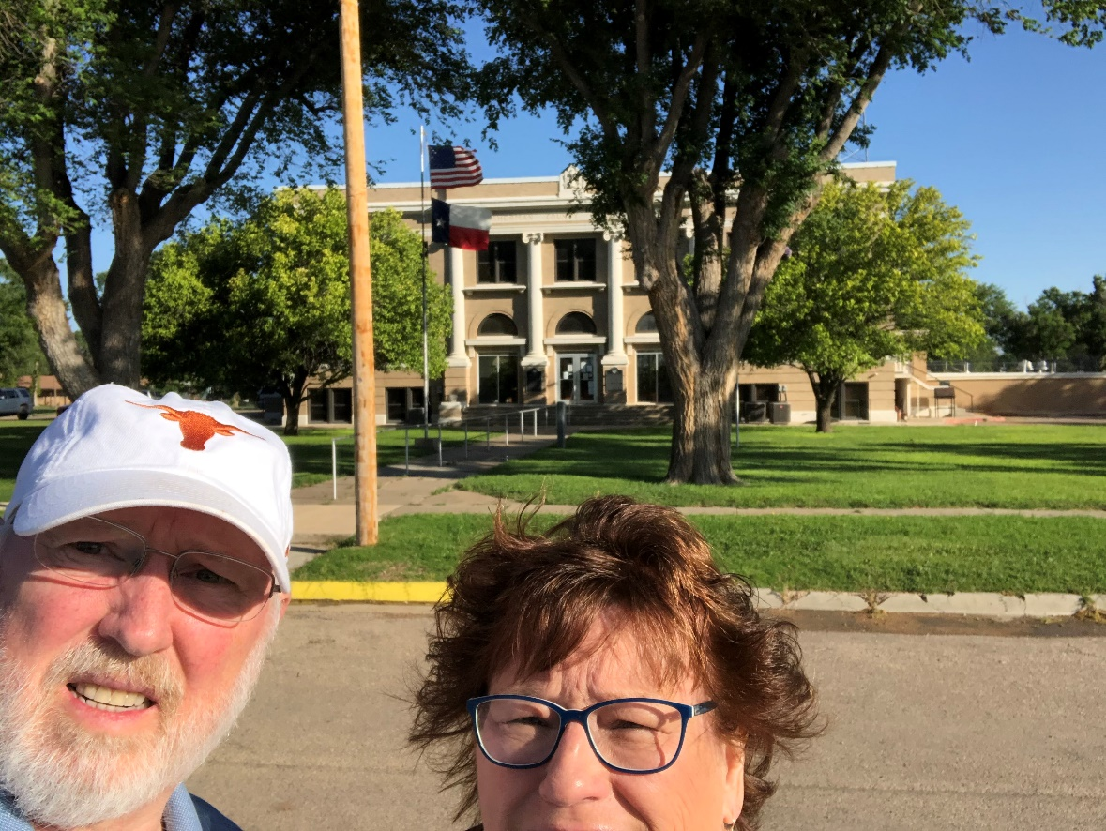
101 – Sherman County – Stratford, TX
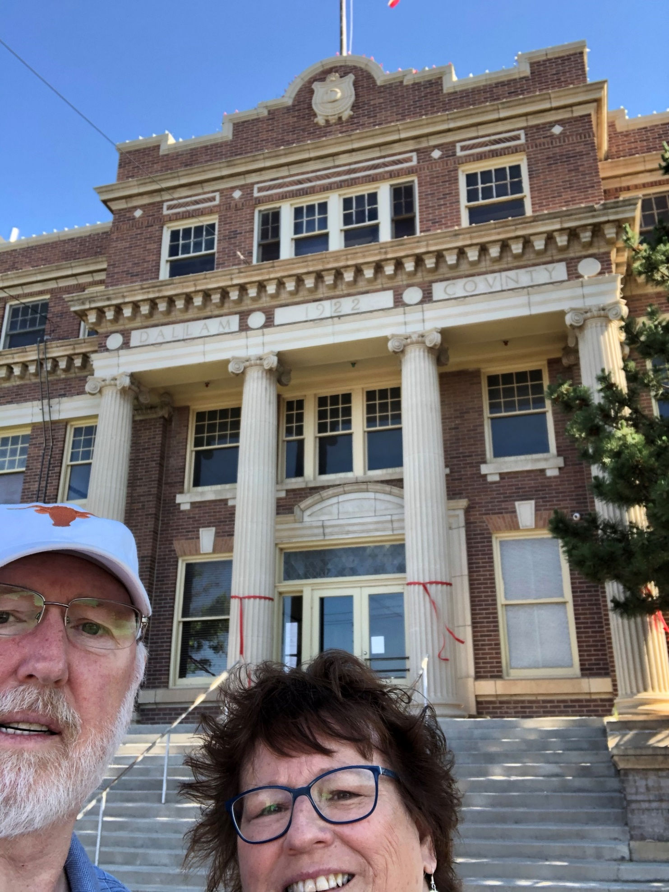
102 – Dallam County – Dalhart, TX
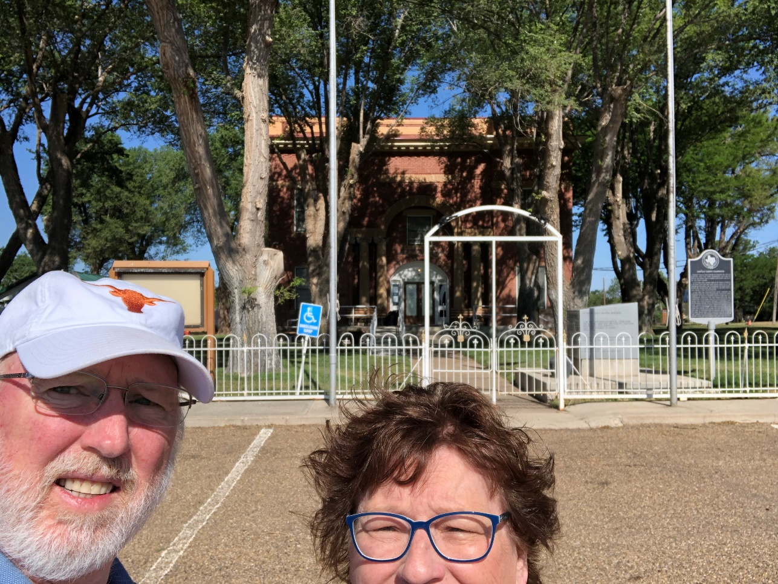
103 – Hartley County – Channing, TX
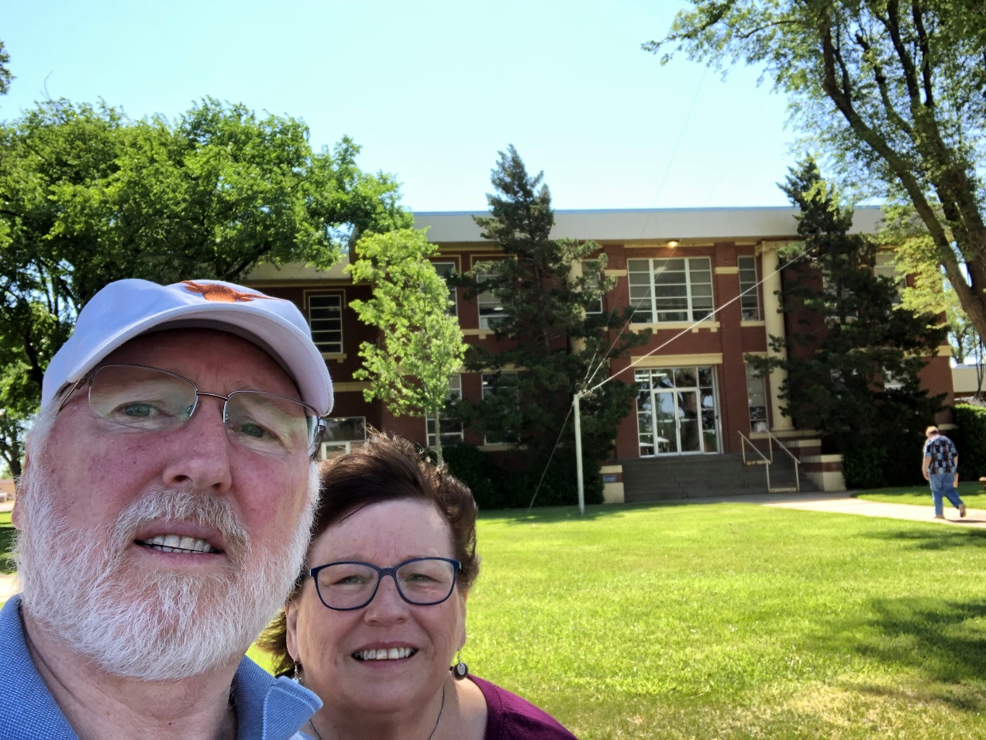
104 – Oldham County – Vega, TX
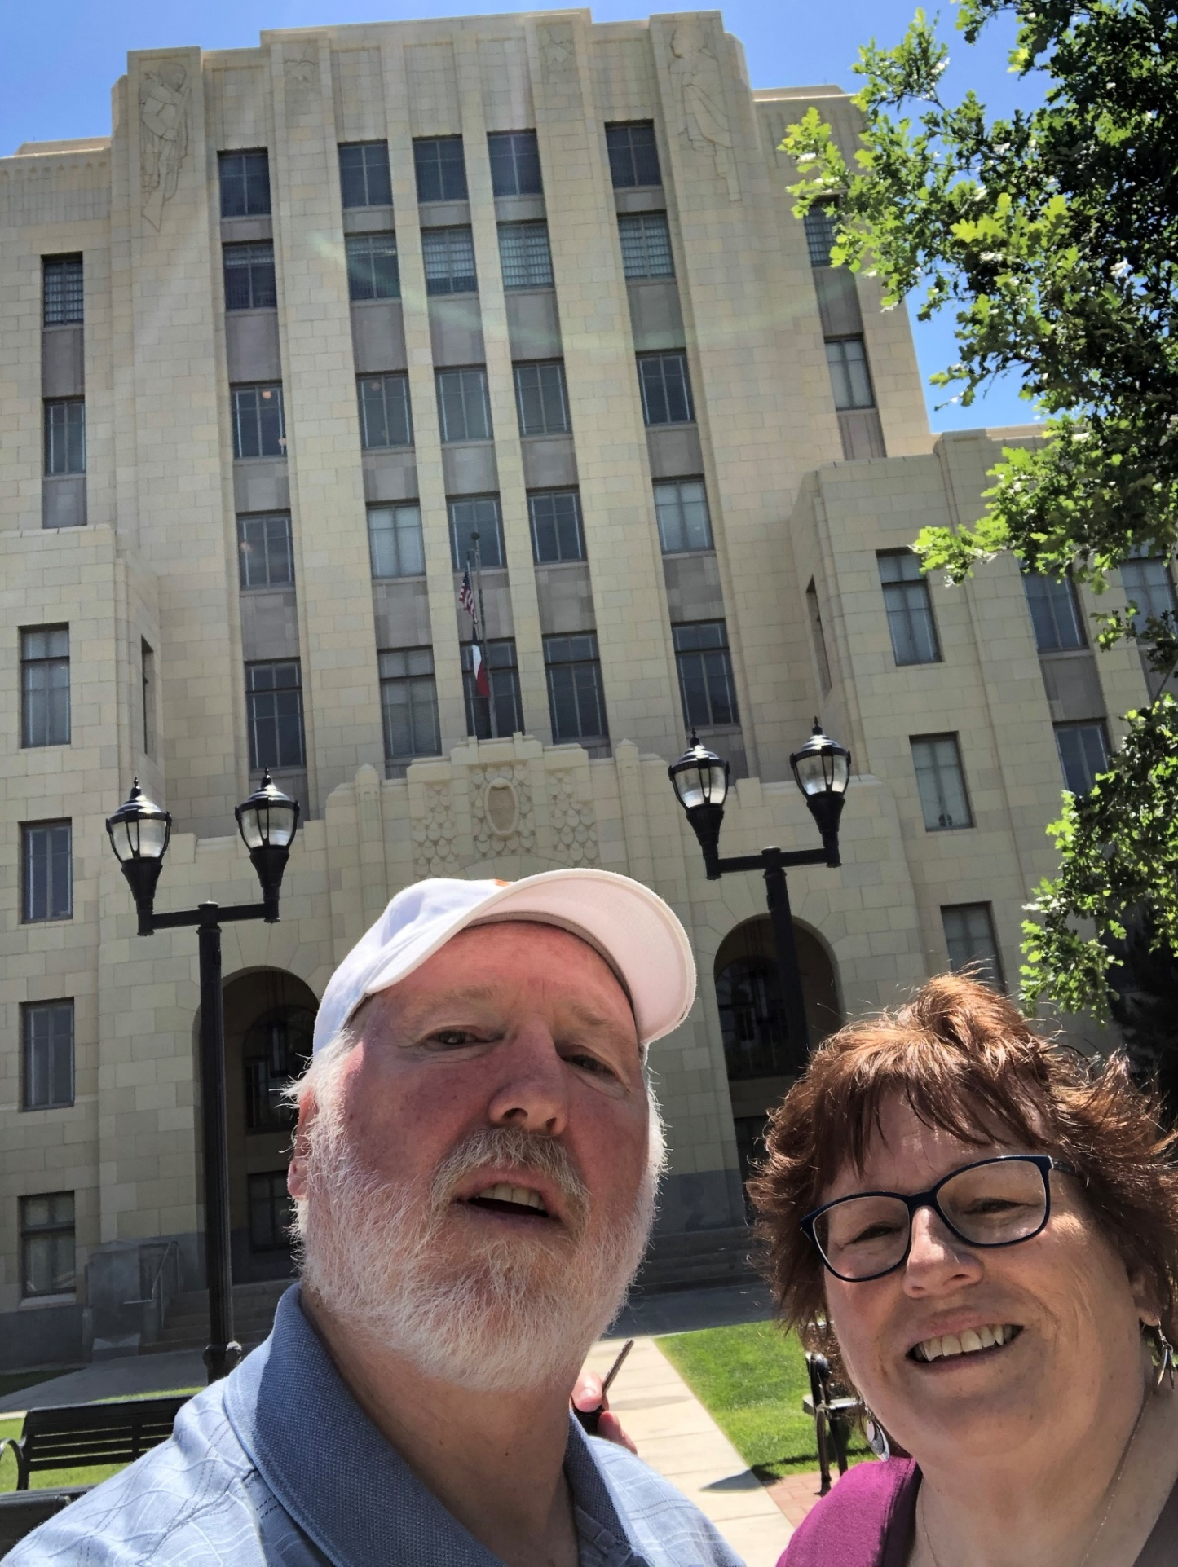
105 – Potter County – Amarillo, TX
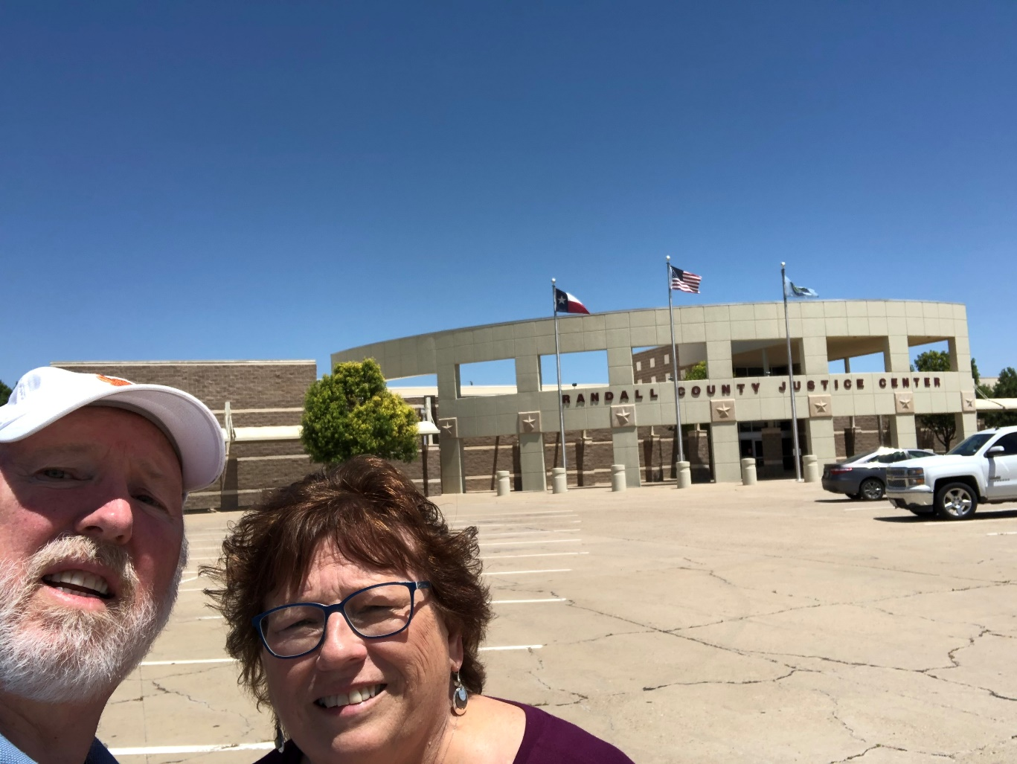
106 – Randall County new – Canyon, TX
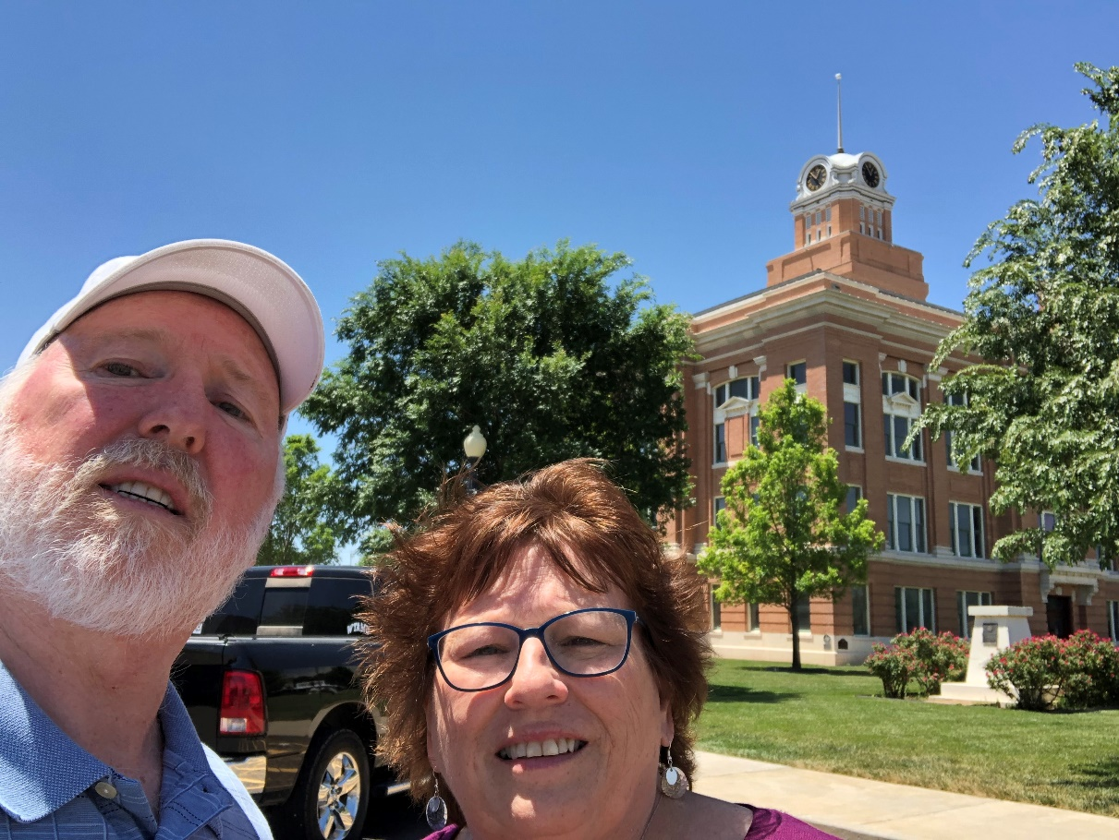
106 – Randall County old – Canyon, TX
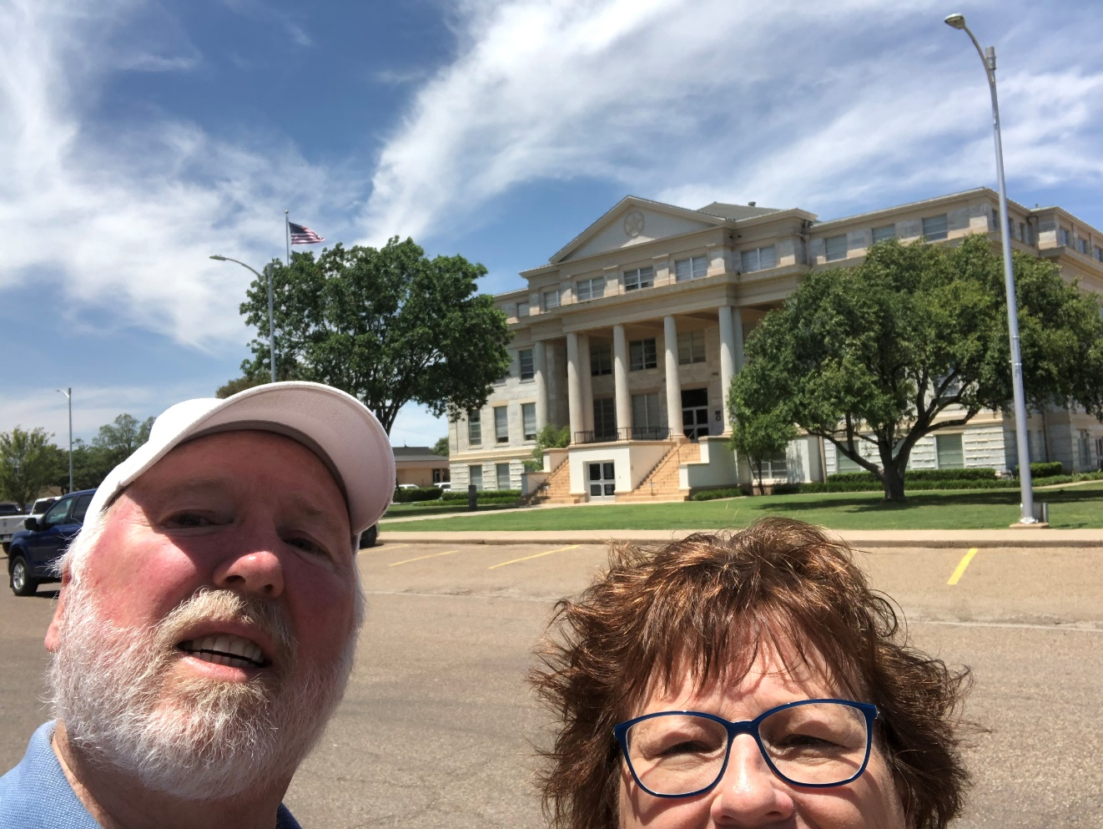
107 – Deaf Smith County – Herford, TX
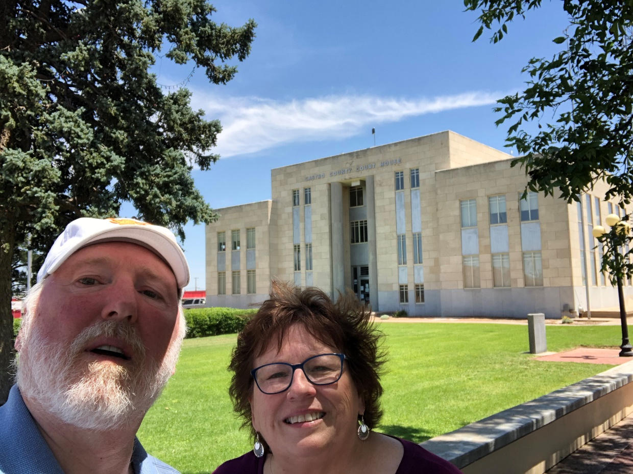
108 – Castro County – Dimmitt, TX
End of Trip

