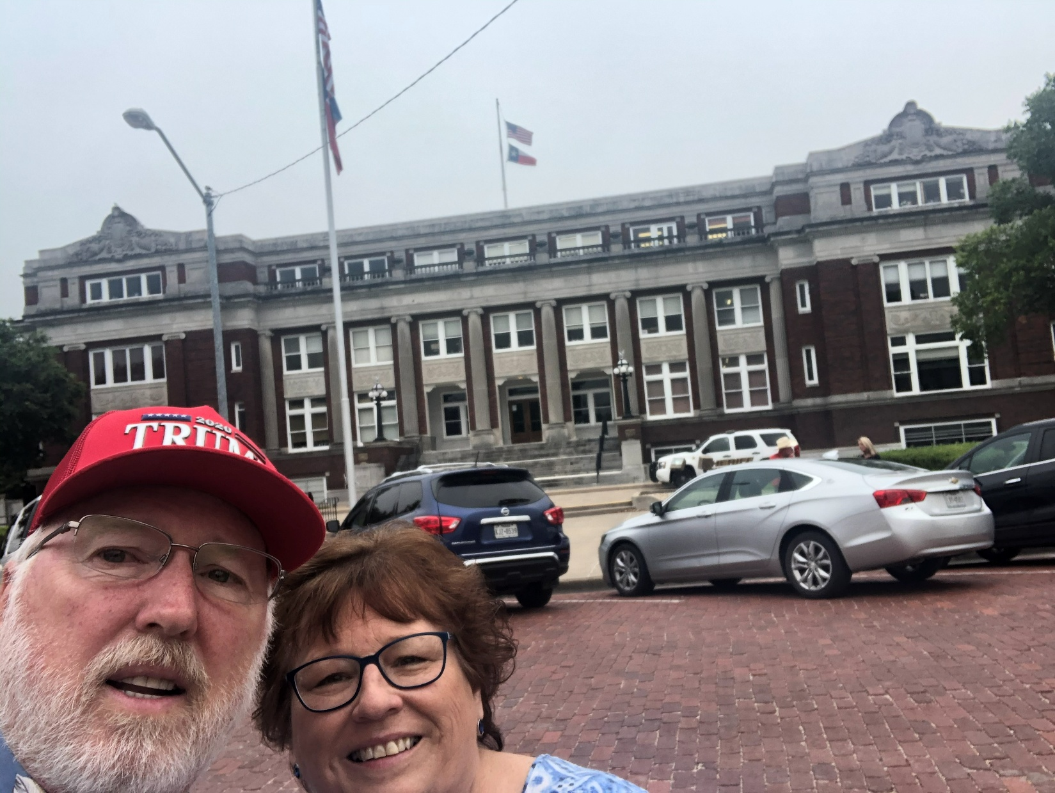
136 – Limestone County - Groesbeck, TX
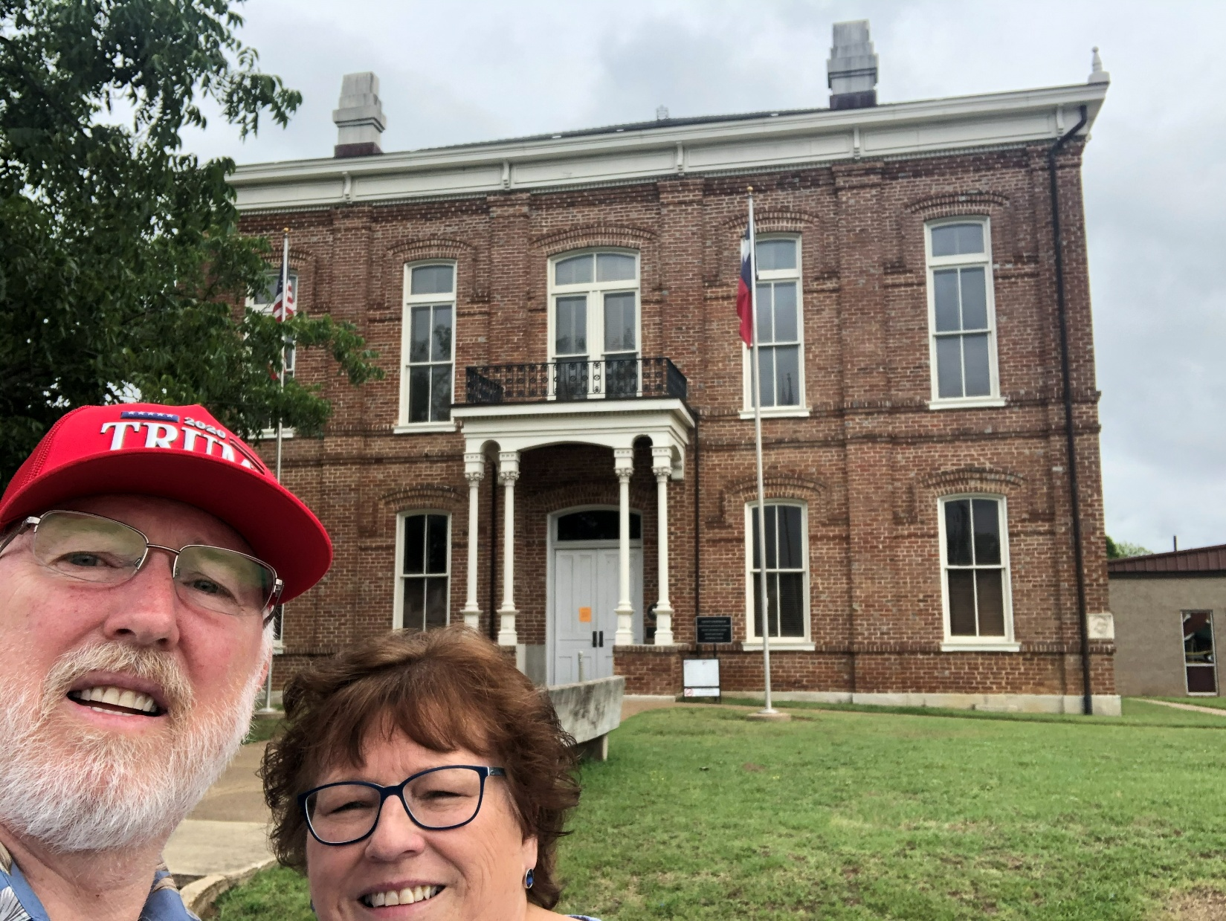
137 – Leon County - Centerville, TX
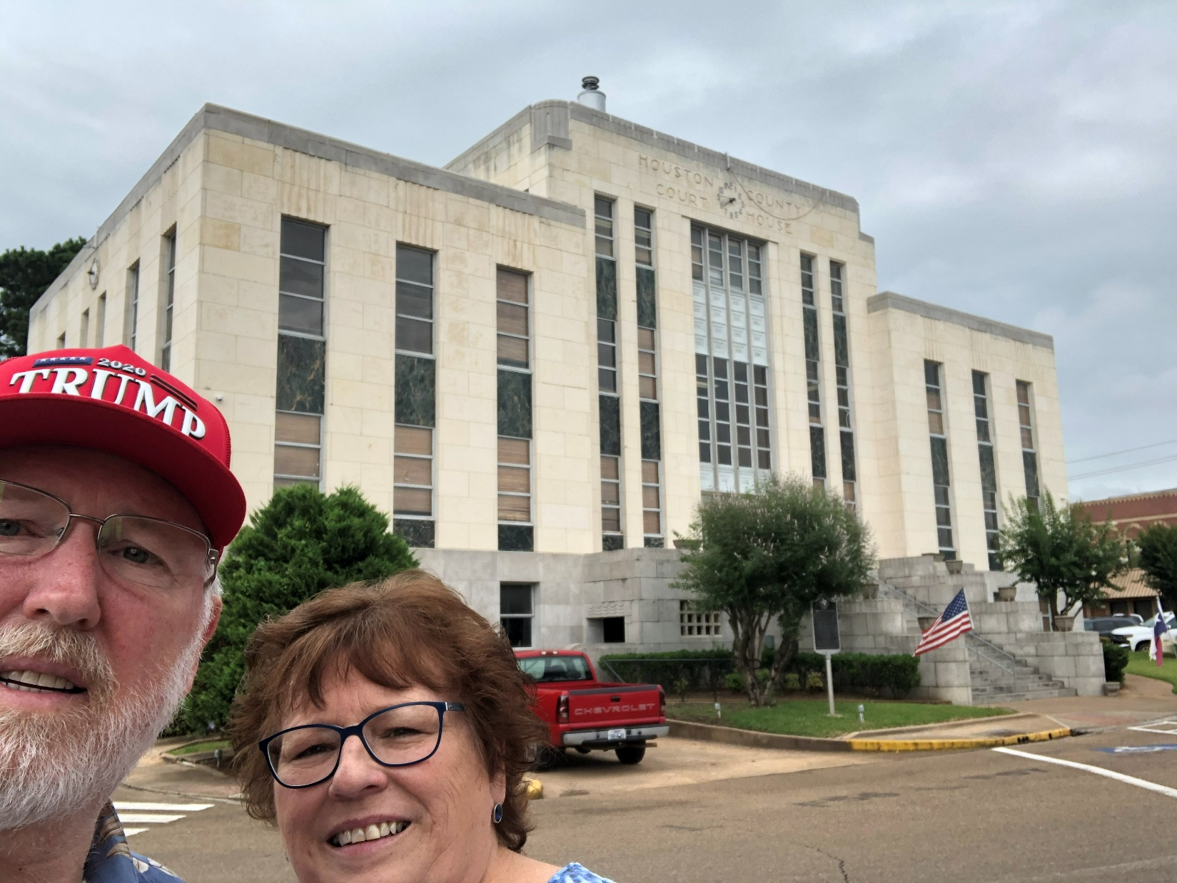
138 – Houston County - Crockett, TX
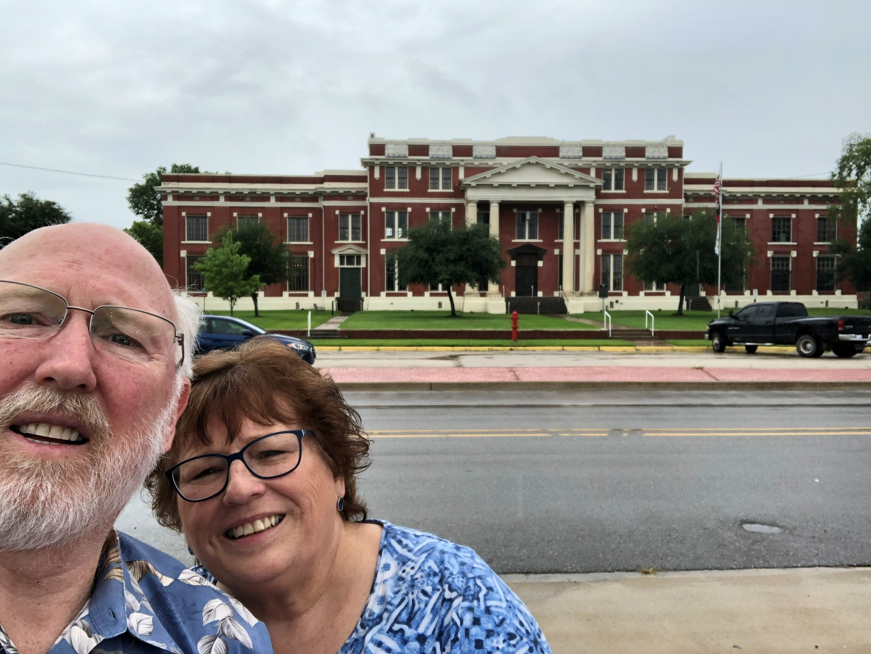
139 – Trinity County - Groveton, TX
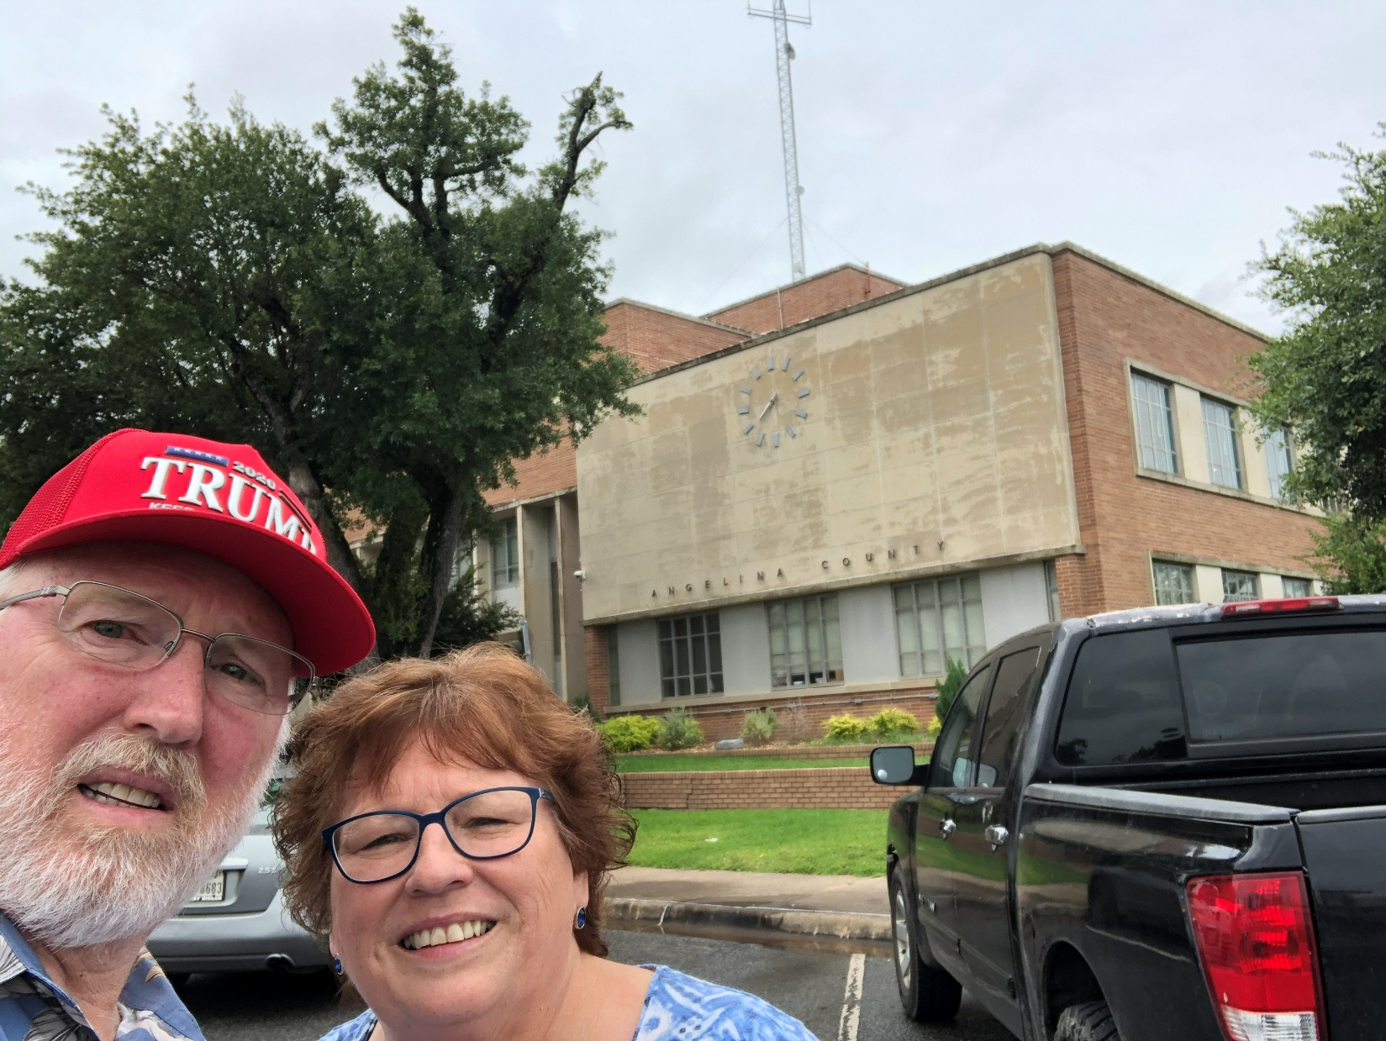
140 – Angelina County - Lufkin, TX
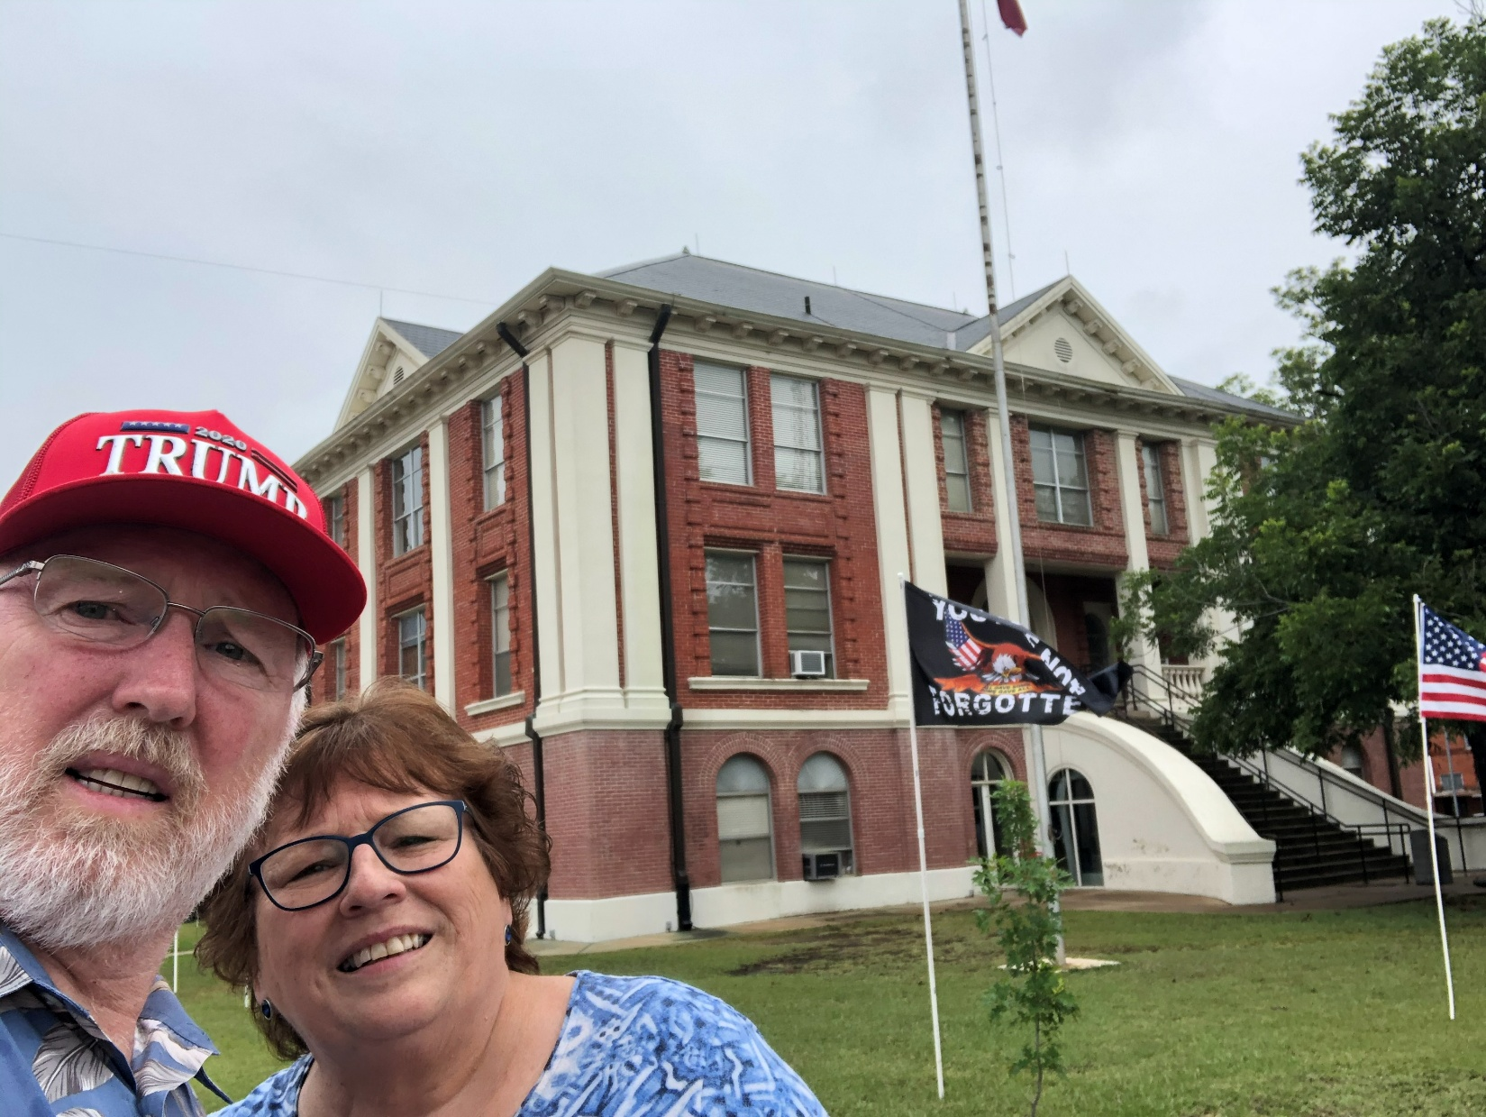
141 – Sabine County - Hemphill, TX
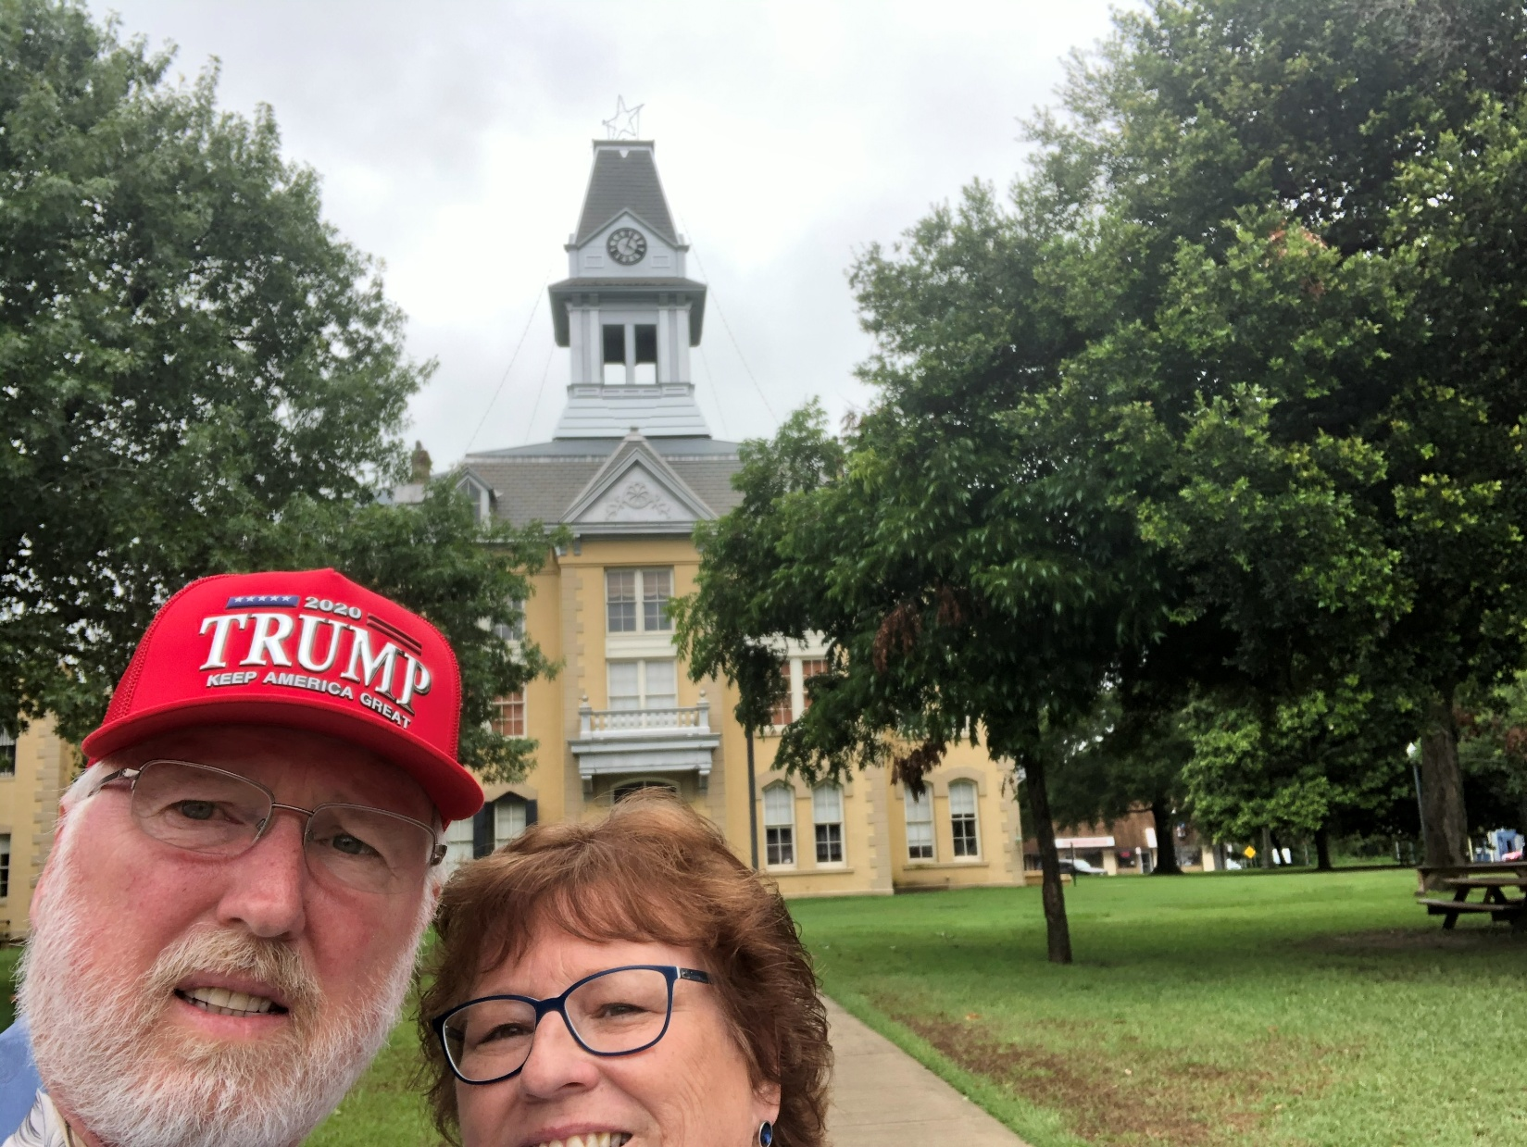
142 – Newton County – Newton, TX
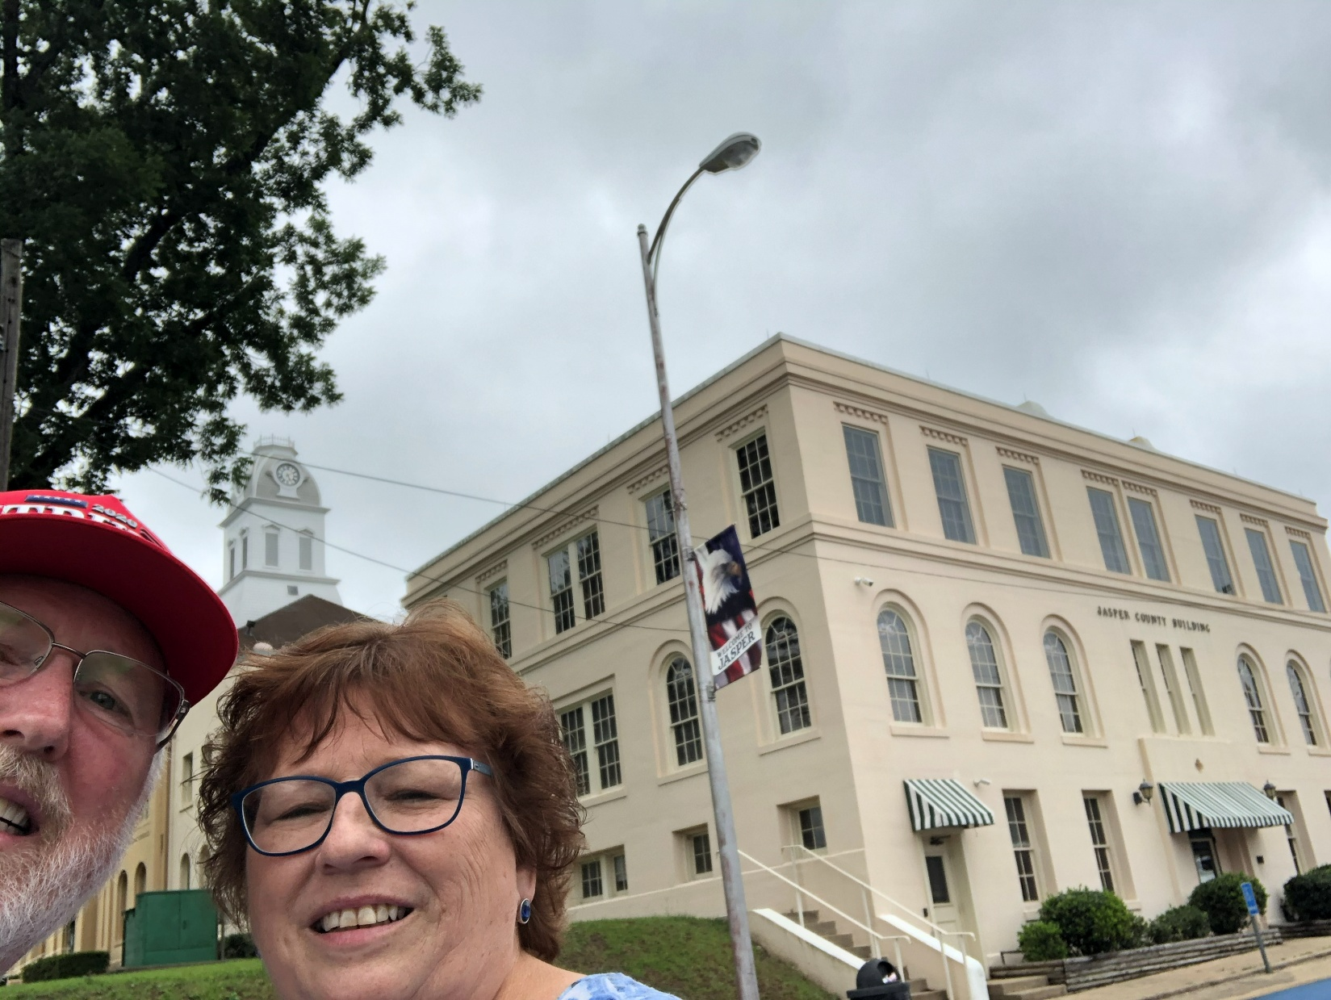
143 – Jasper County – Jasper, TX
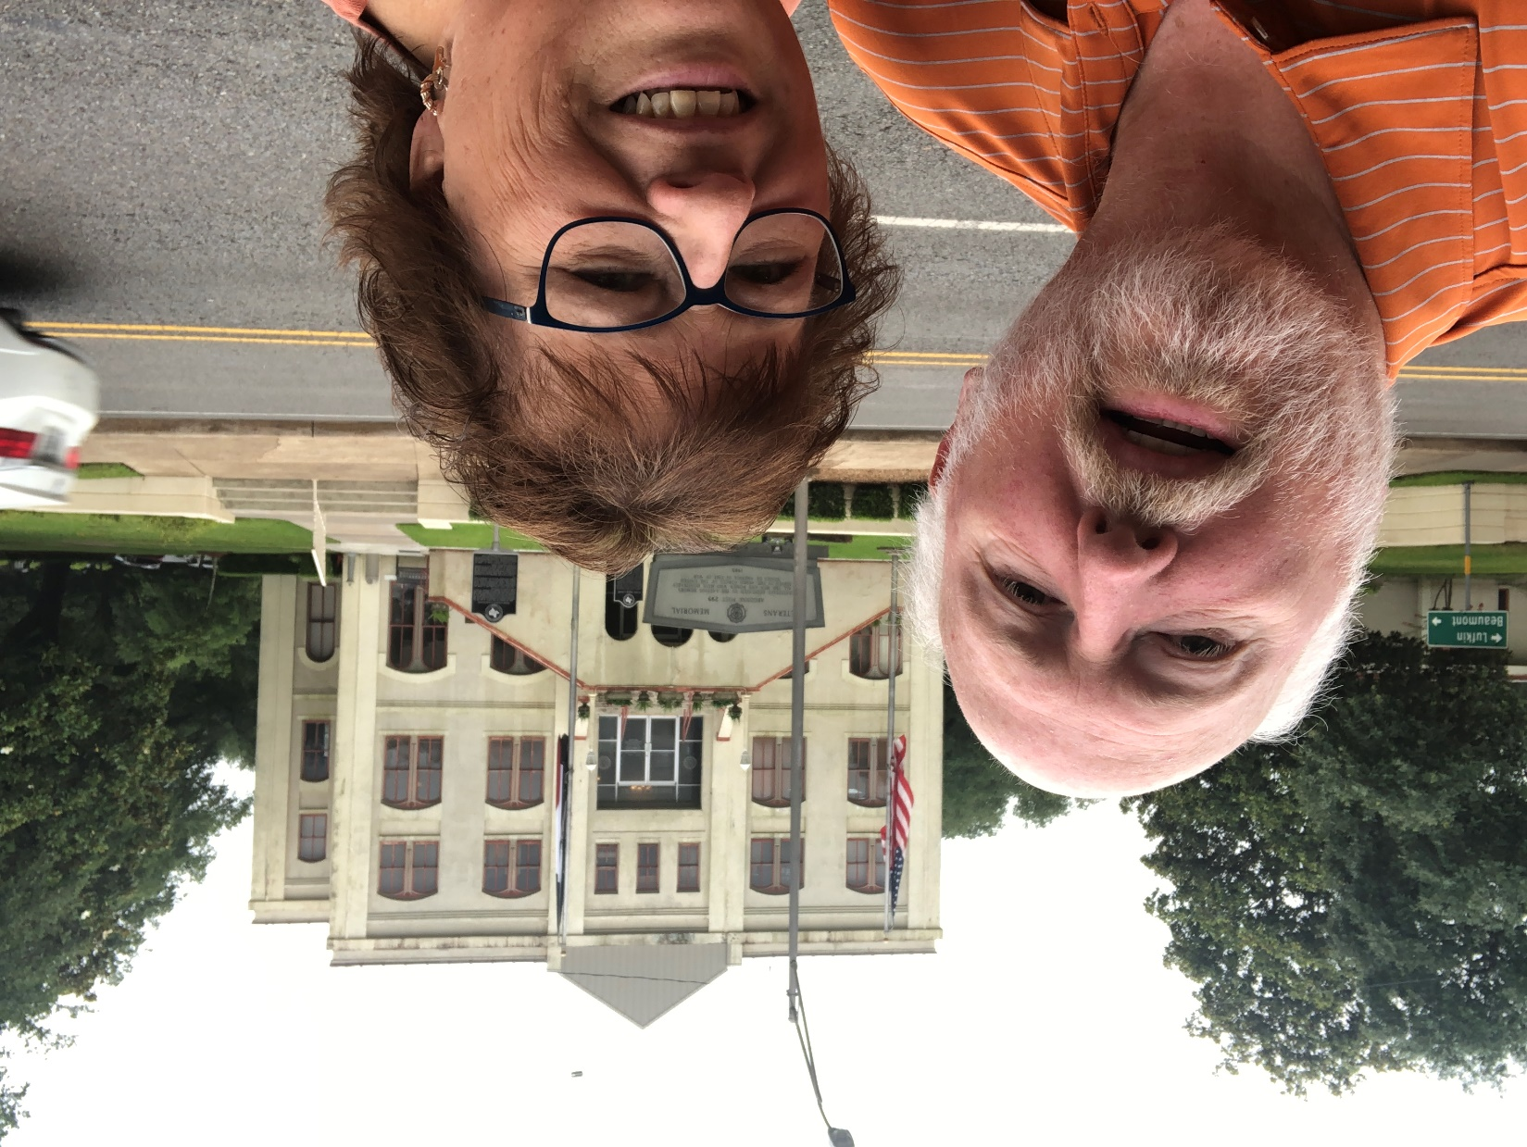
144 – Tyler County – Woodville, TX
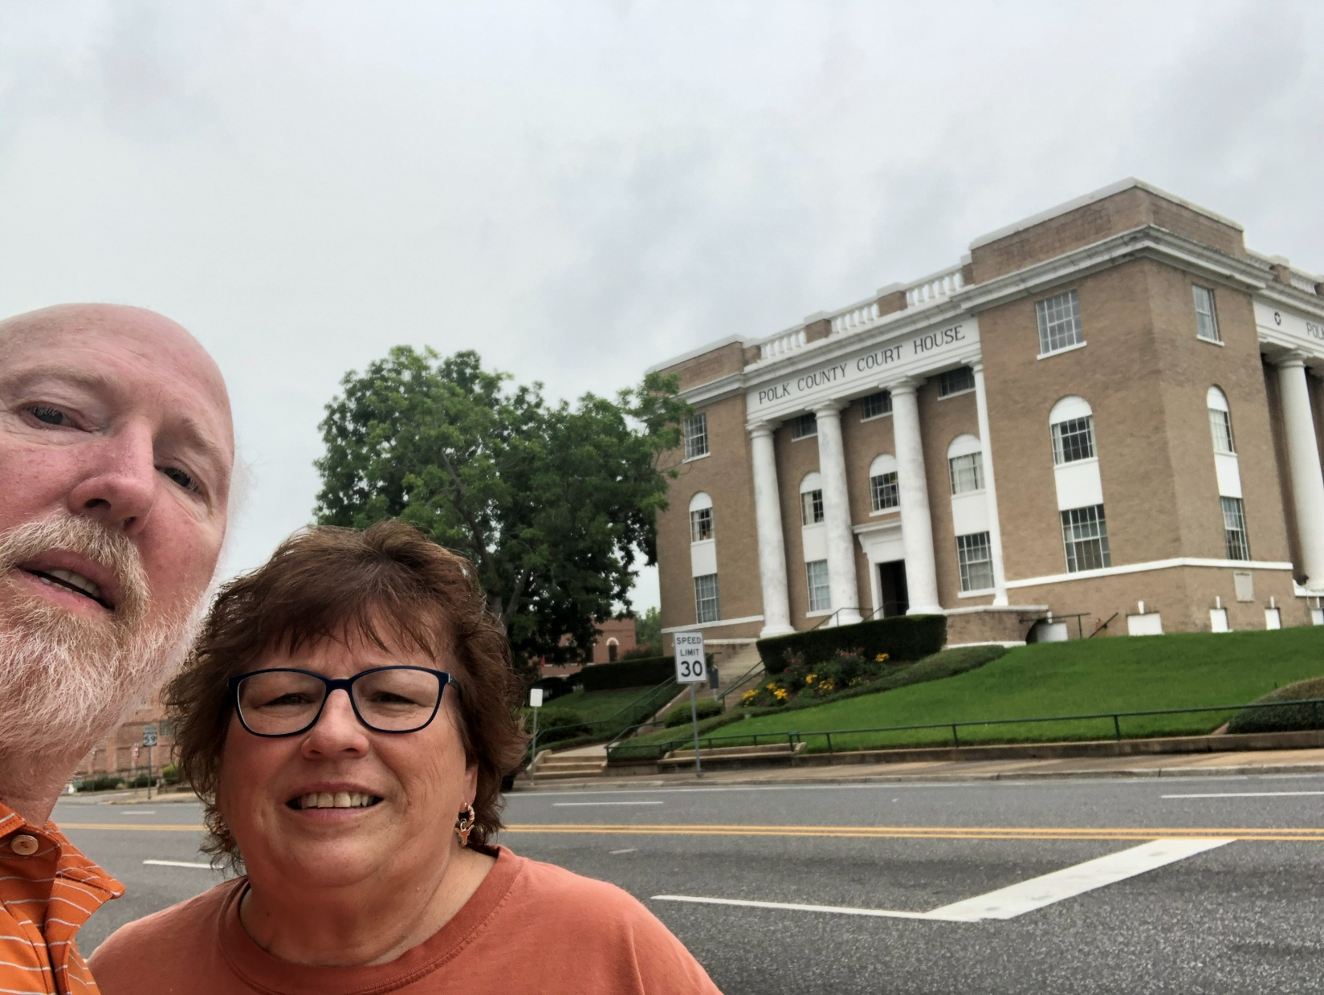
145 – Polk County – Livingston, TX
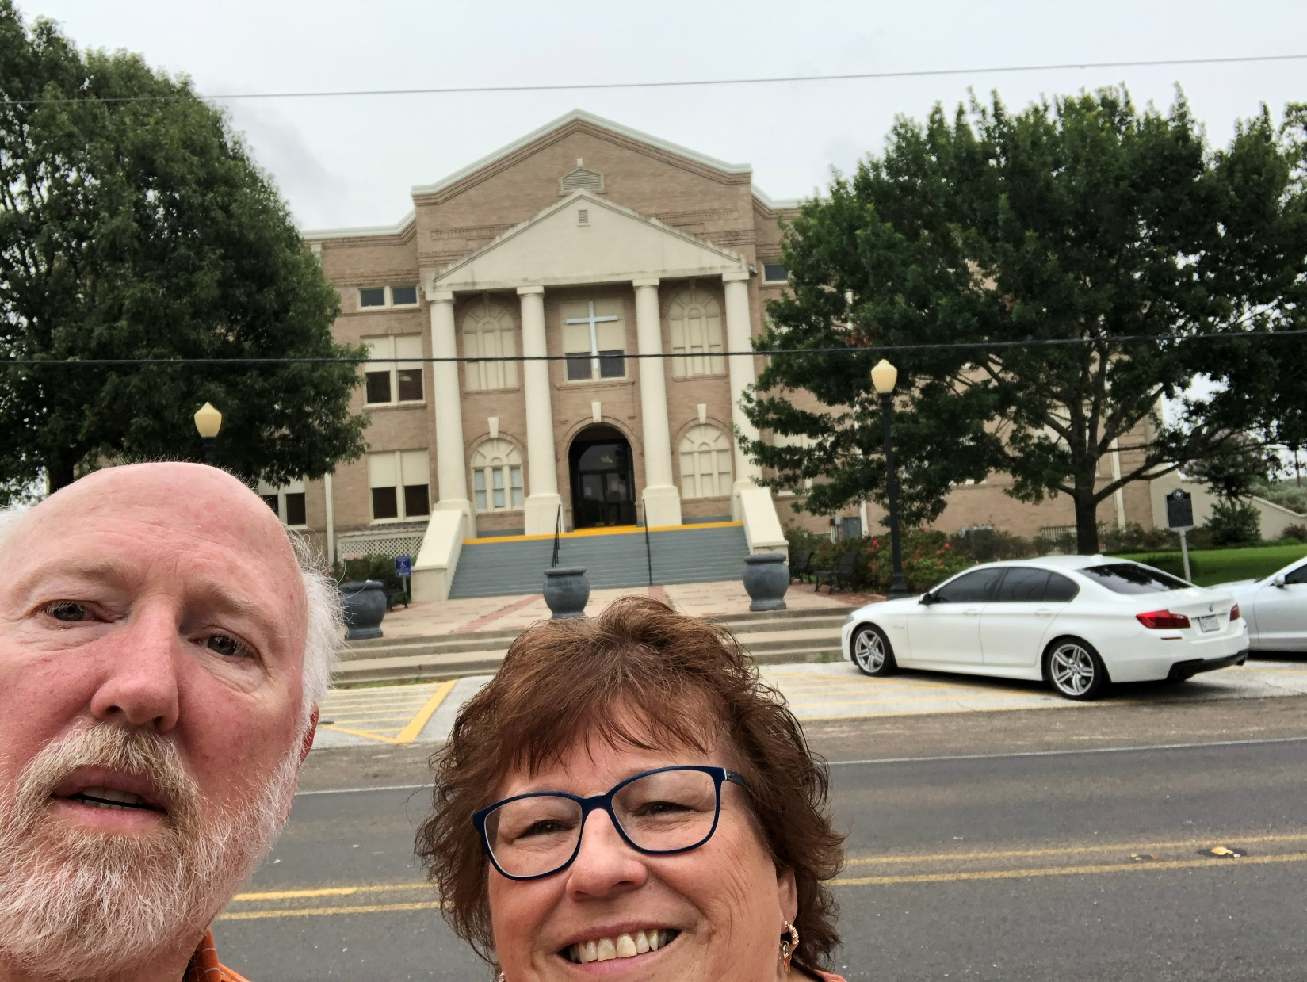
146 – San Jacinto County – Coldspring, TX
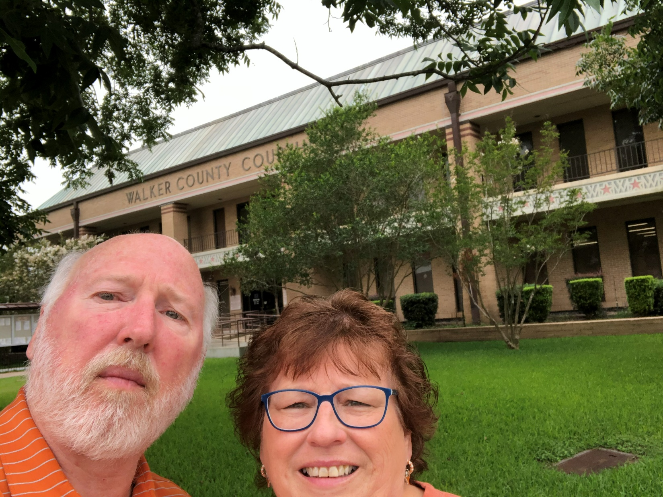
147 – Walker County – Huntsville, TX
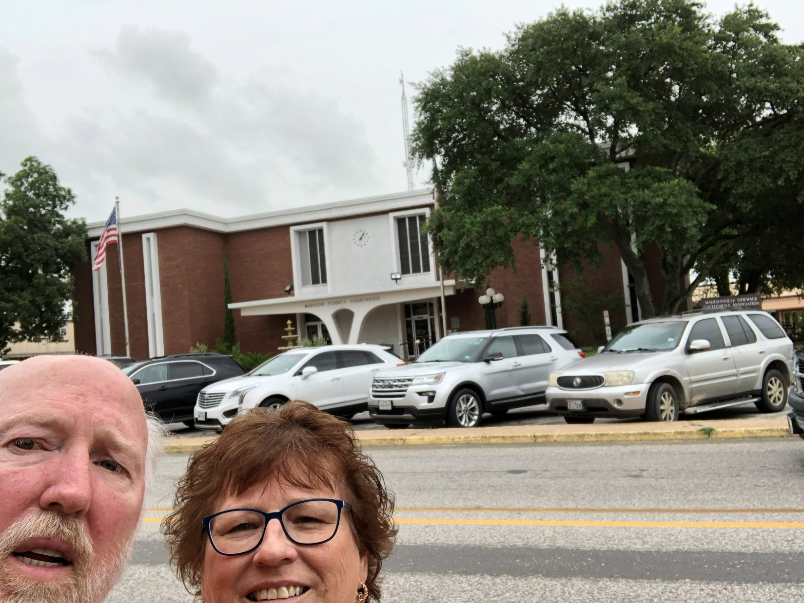
148 – Madison County – Madisonville, TX
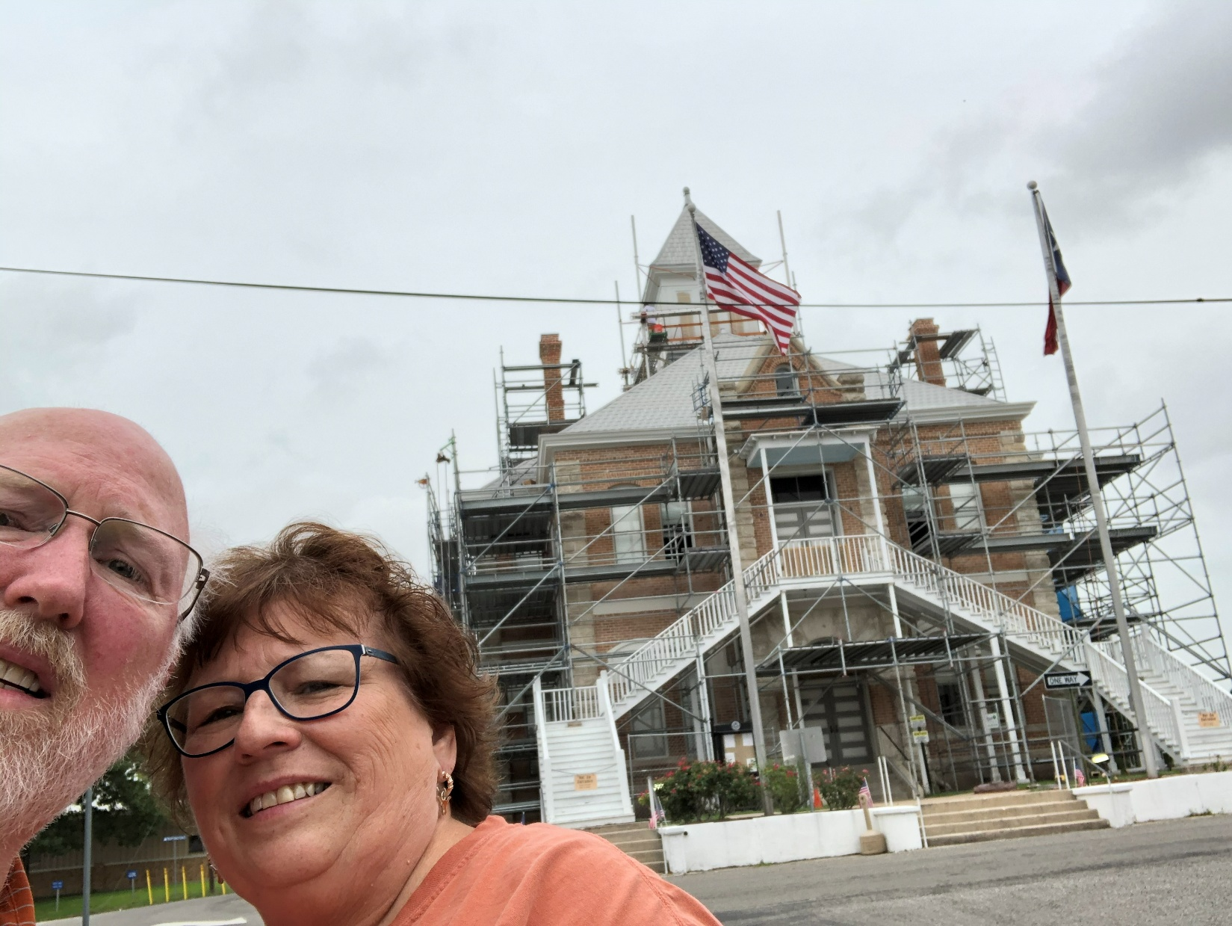
149 – Grimes County – Anderson, TX
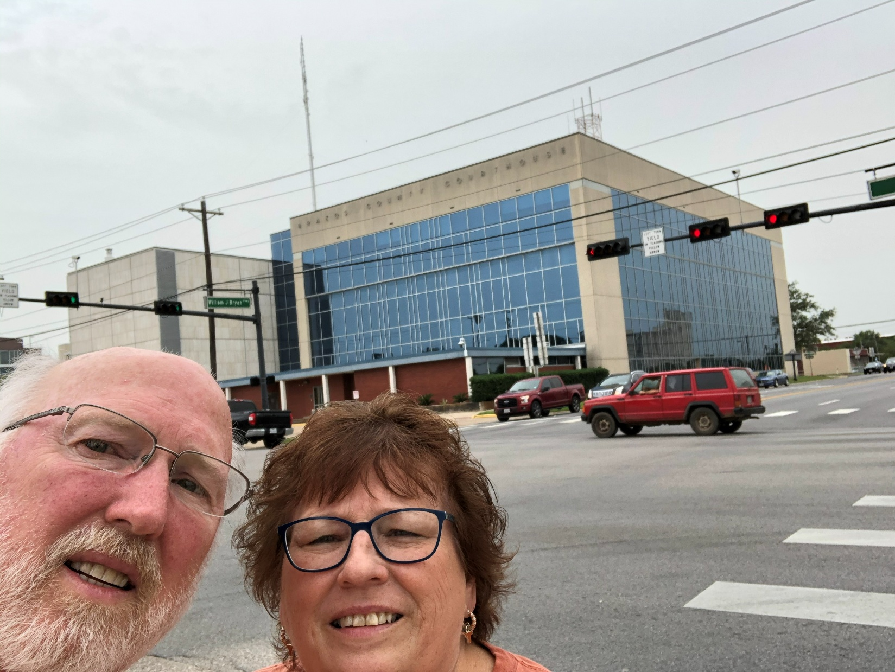
150 – Brazos County – Bryan, TX
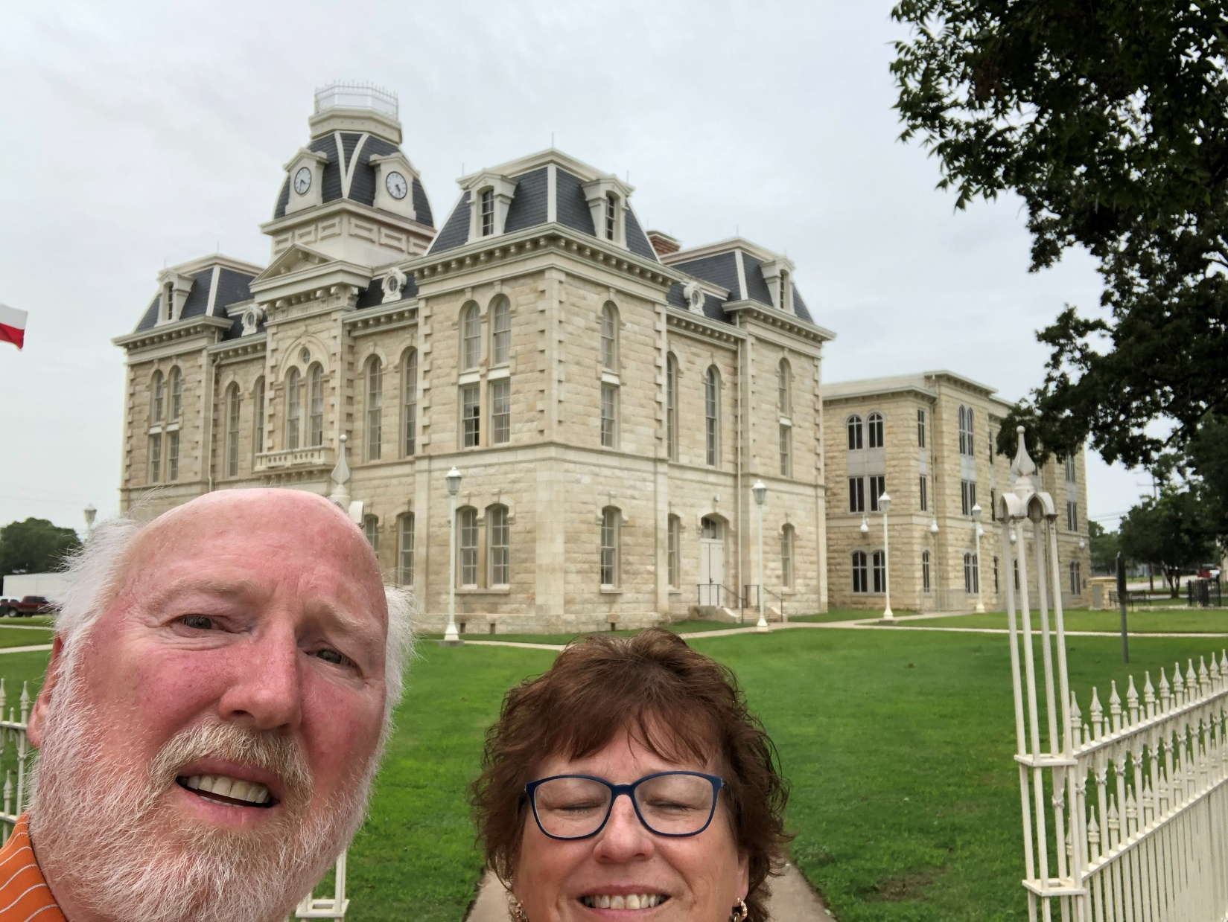
151 – Robertson County – Franklin, TX
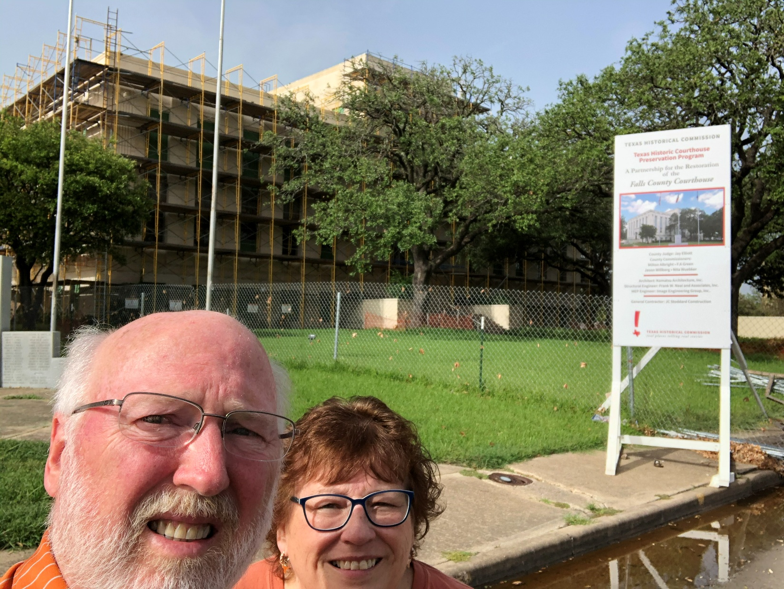
152 – Falls County – Marlin, TX
End of Trip

