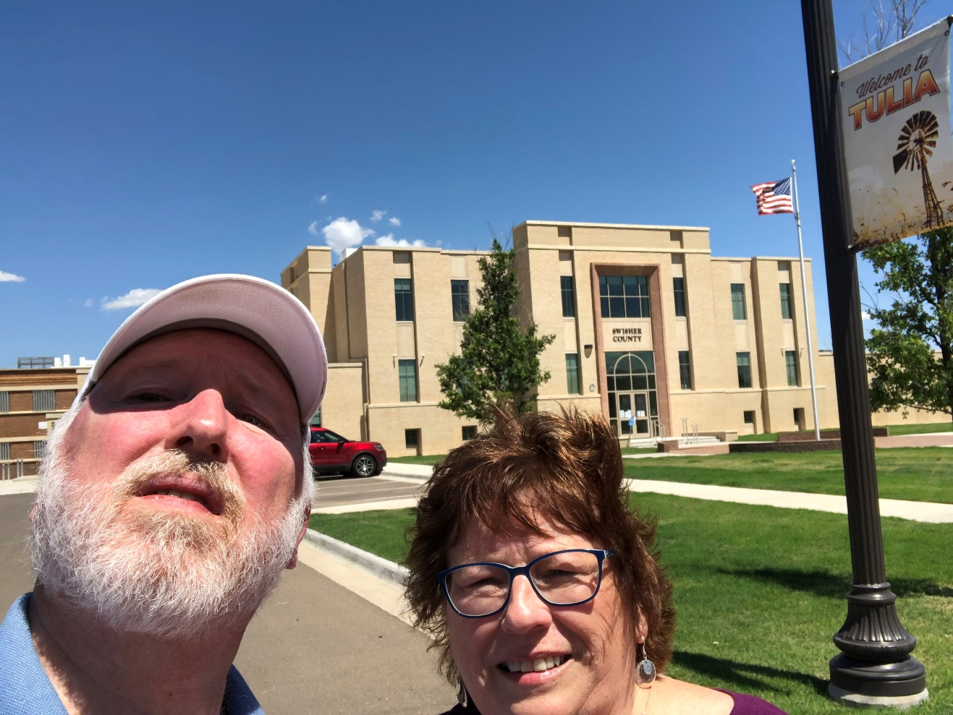
109 – Swisher County – Tulia, TX
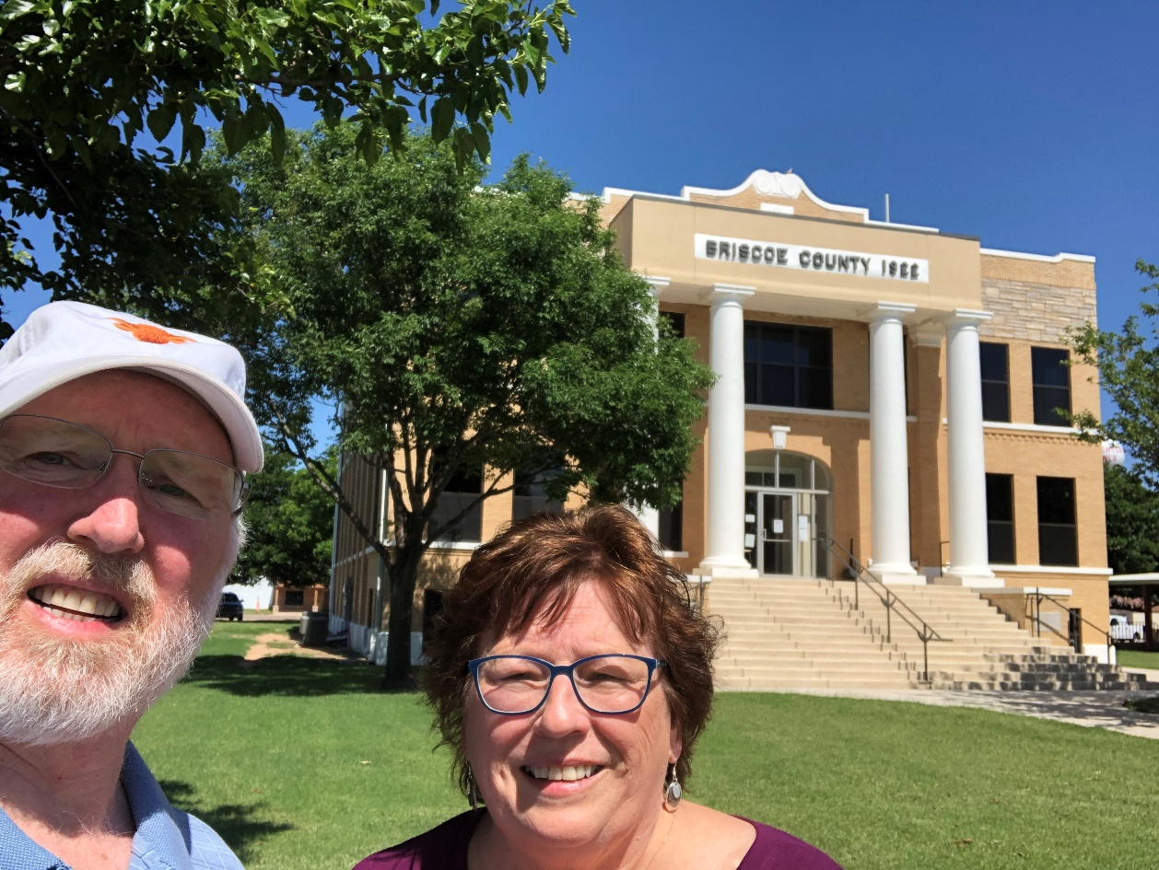
110 – Briscoe County – Silverton, TX
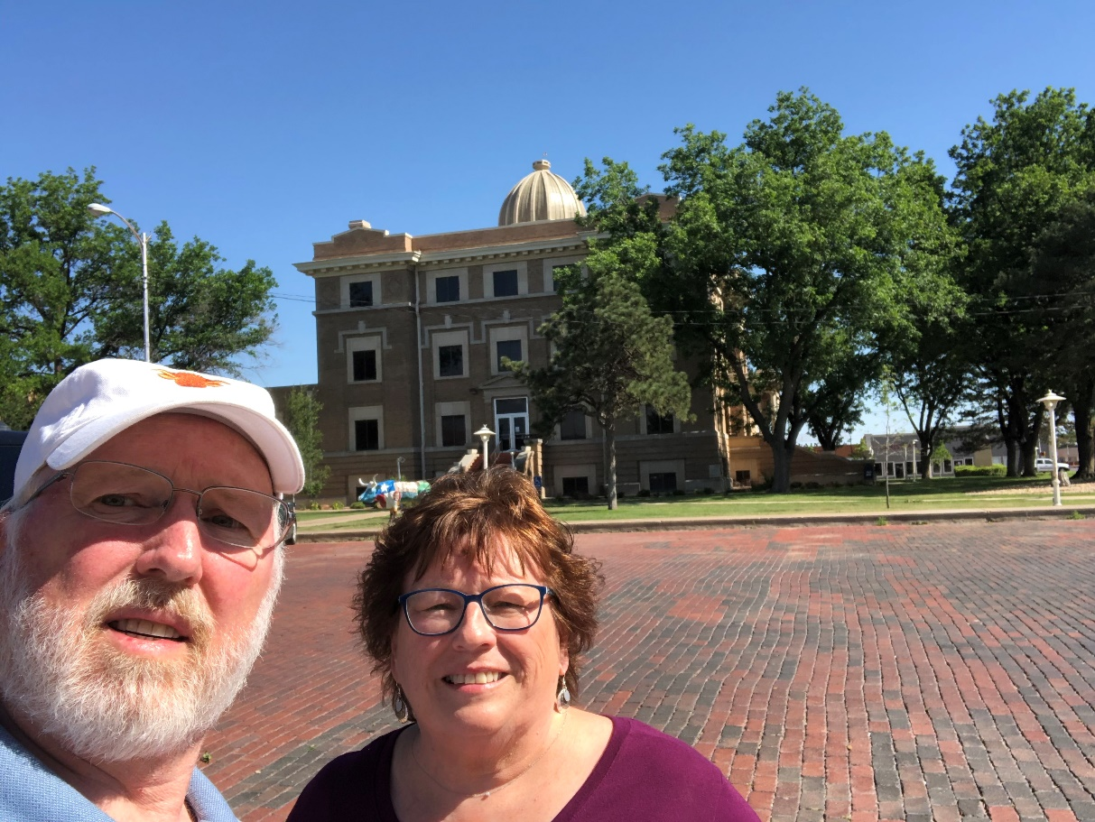
111 – Hale County – Plainview, TX
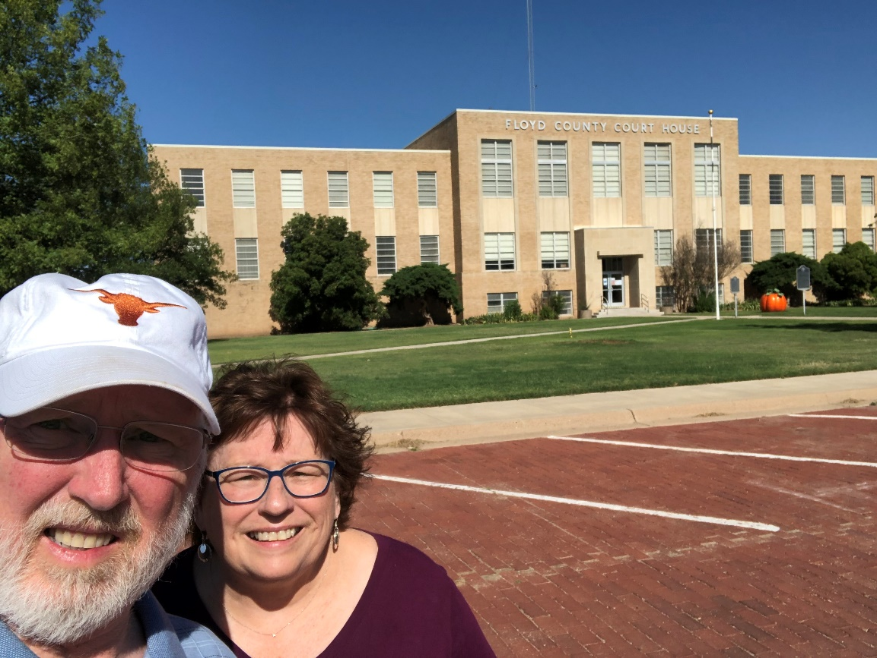
112 – Floyd County – Floydada, TX
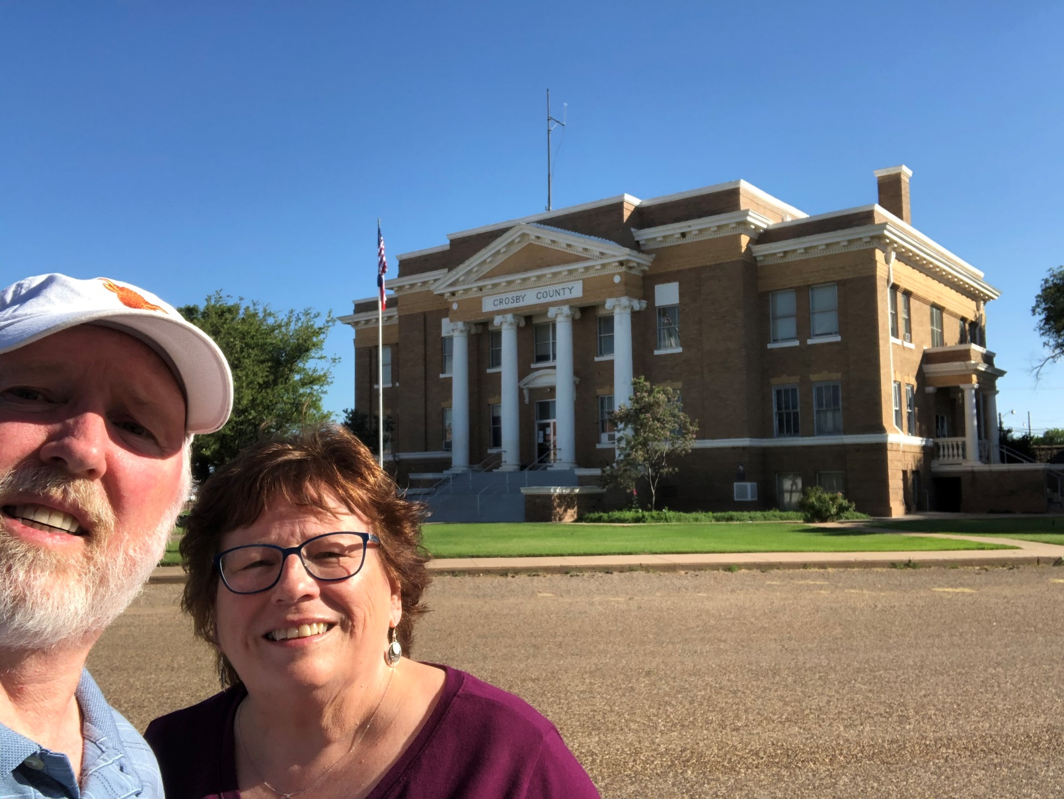
113 – Crosby County – Crosbyton, TX
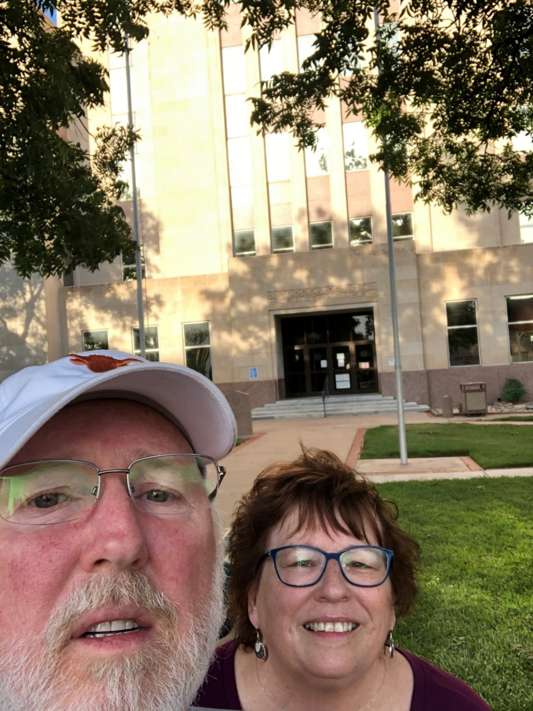
114 – Lubbock County – Lubbock, TX
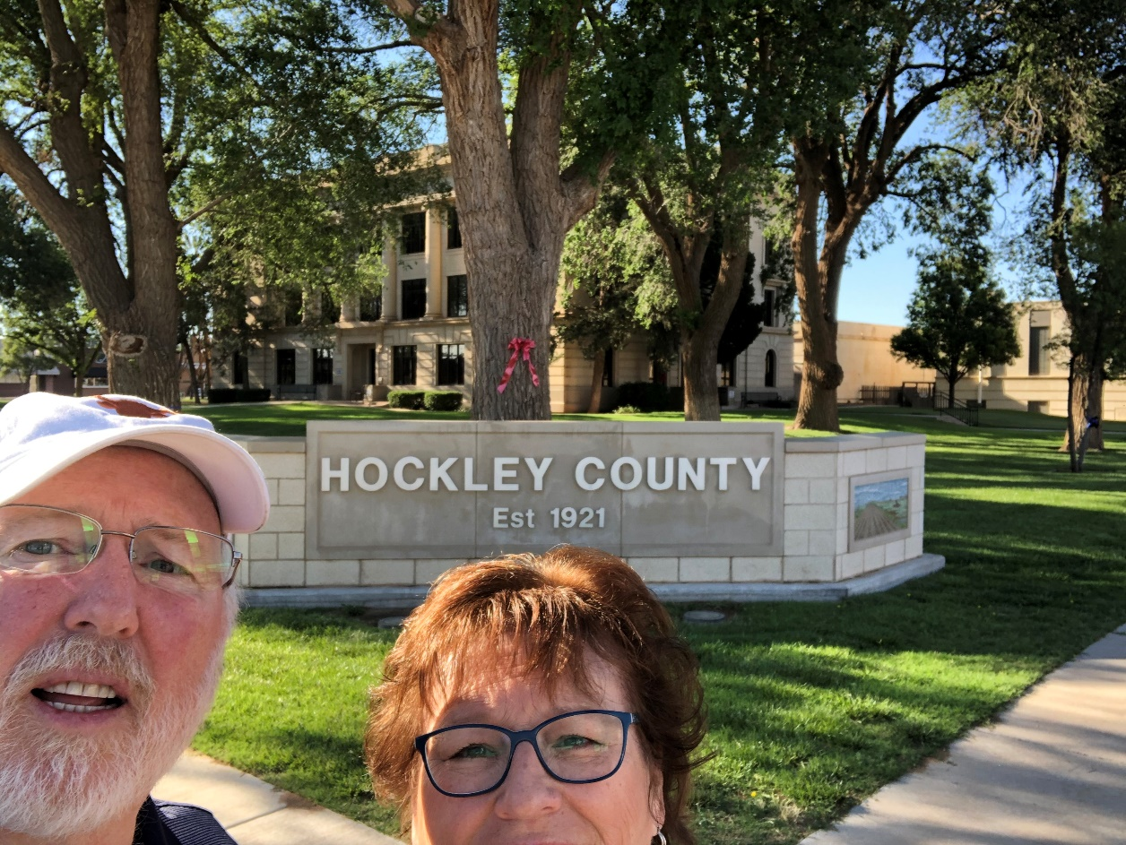
115 – Hockley County – Levelland, TX
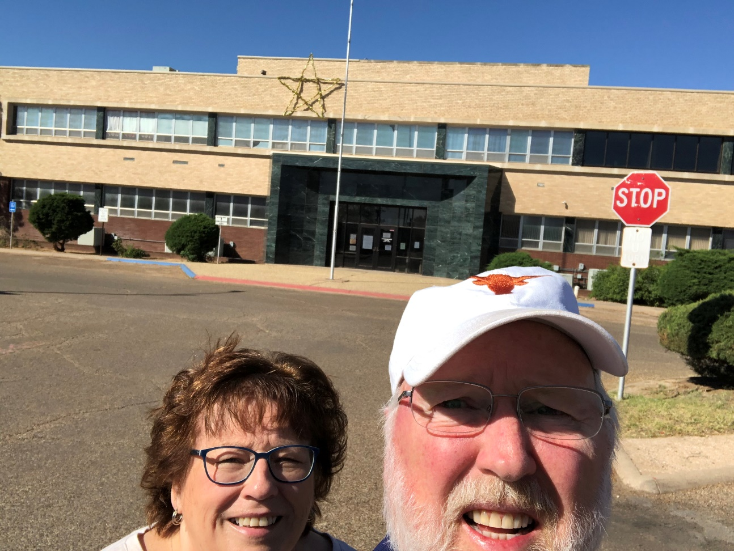
116 – Lamb County – Littlefield, TX
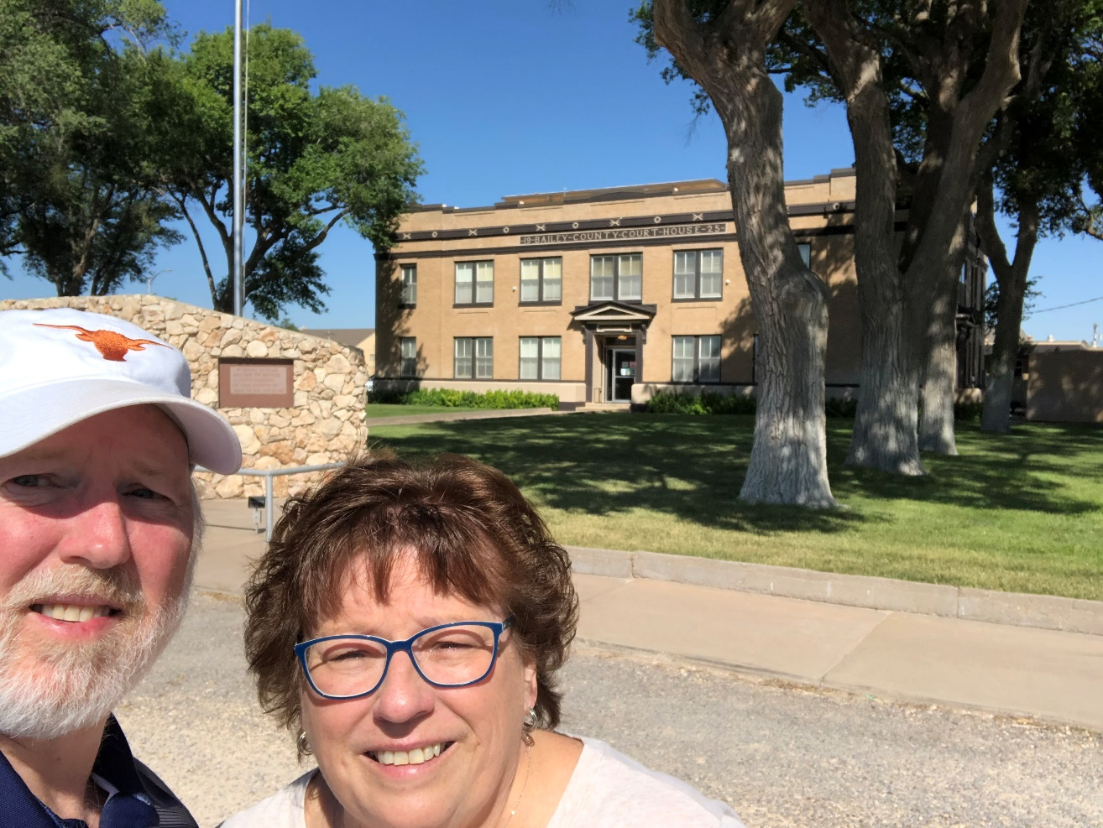
117 – Bailey County – Muleshoe, TX
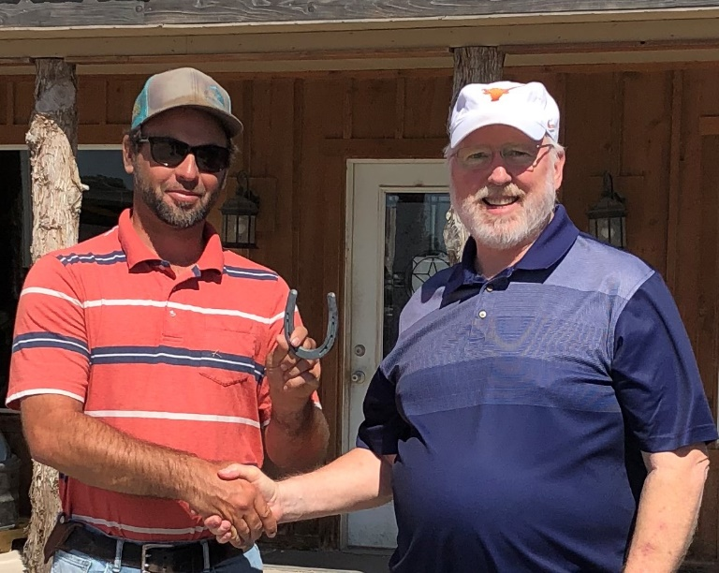
Mule Shoe from Muleshoe Grain & Feed from Arlyn Giesbrecht at Muleshoe Feed Barn.
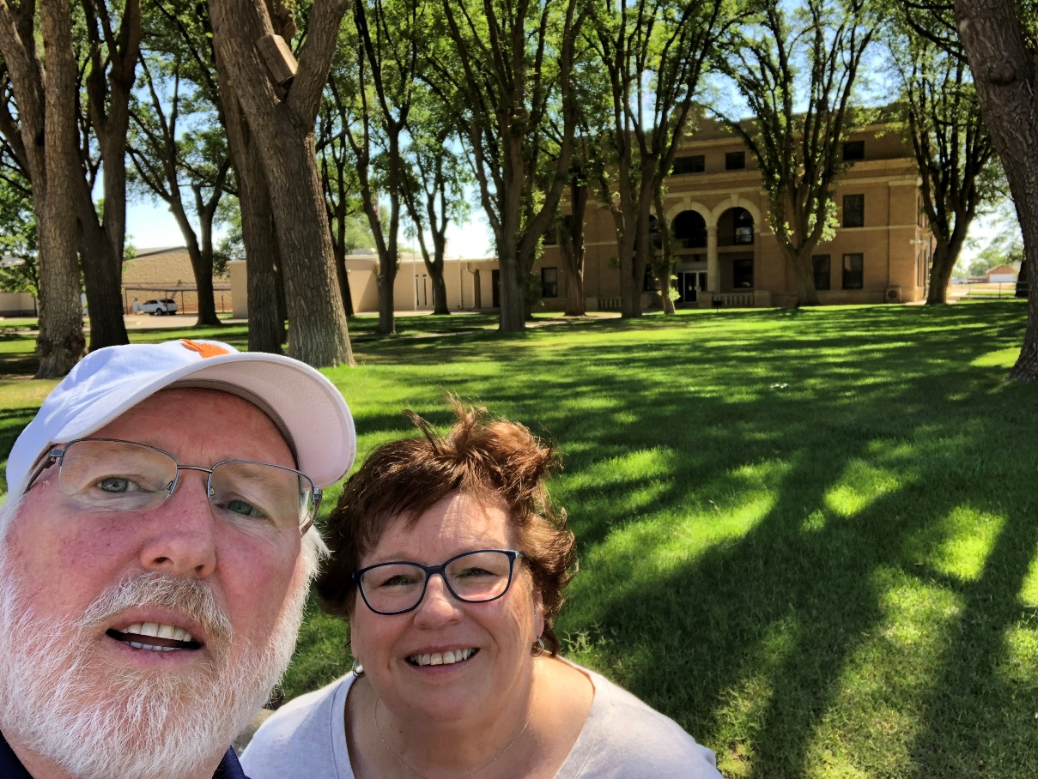
118 – Parmer County – Farwell, TX
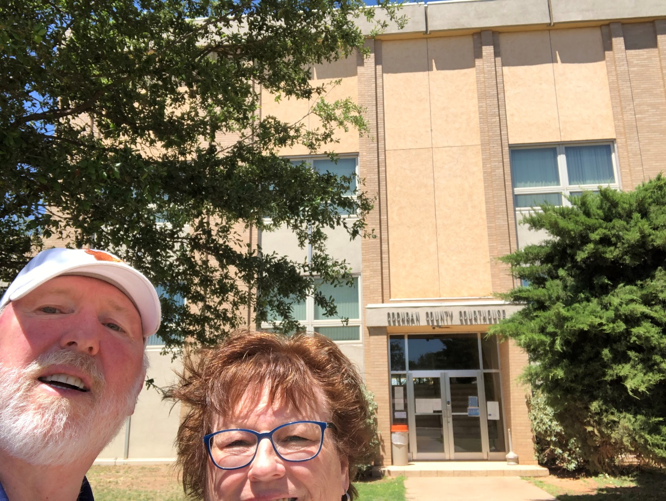
119 – Cochran County – Morton, TX
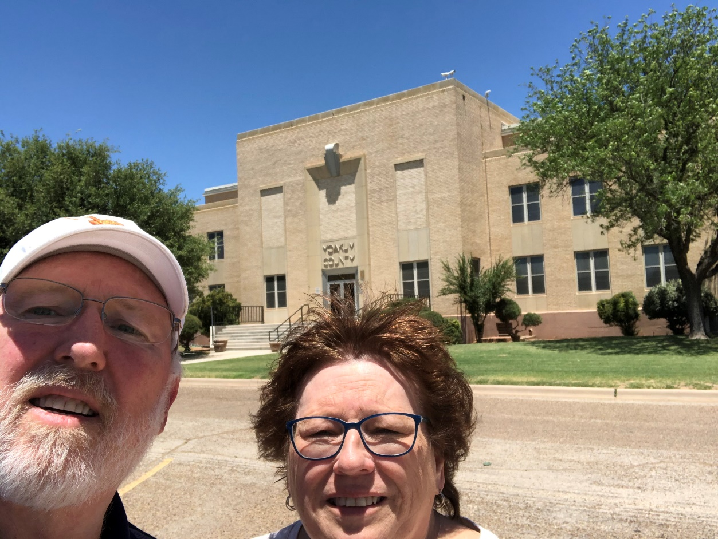
120 – Yoakum County – new – Plains, TX
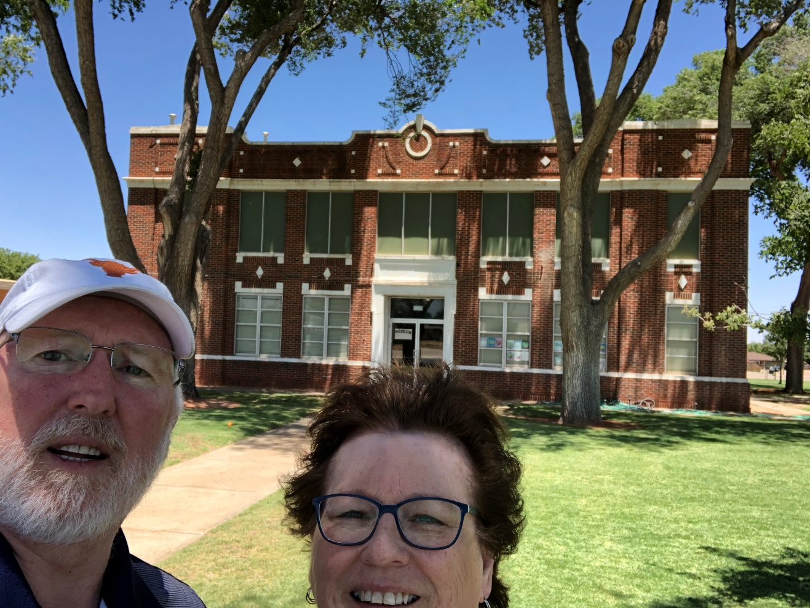
120 – Yoakum County – old – Plains, TX
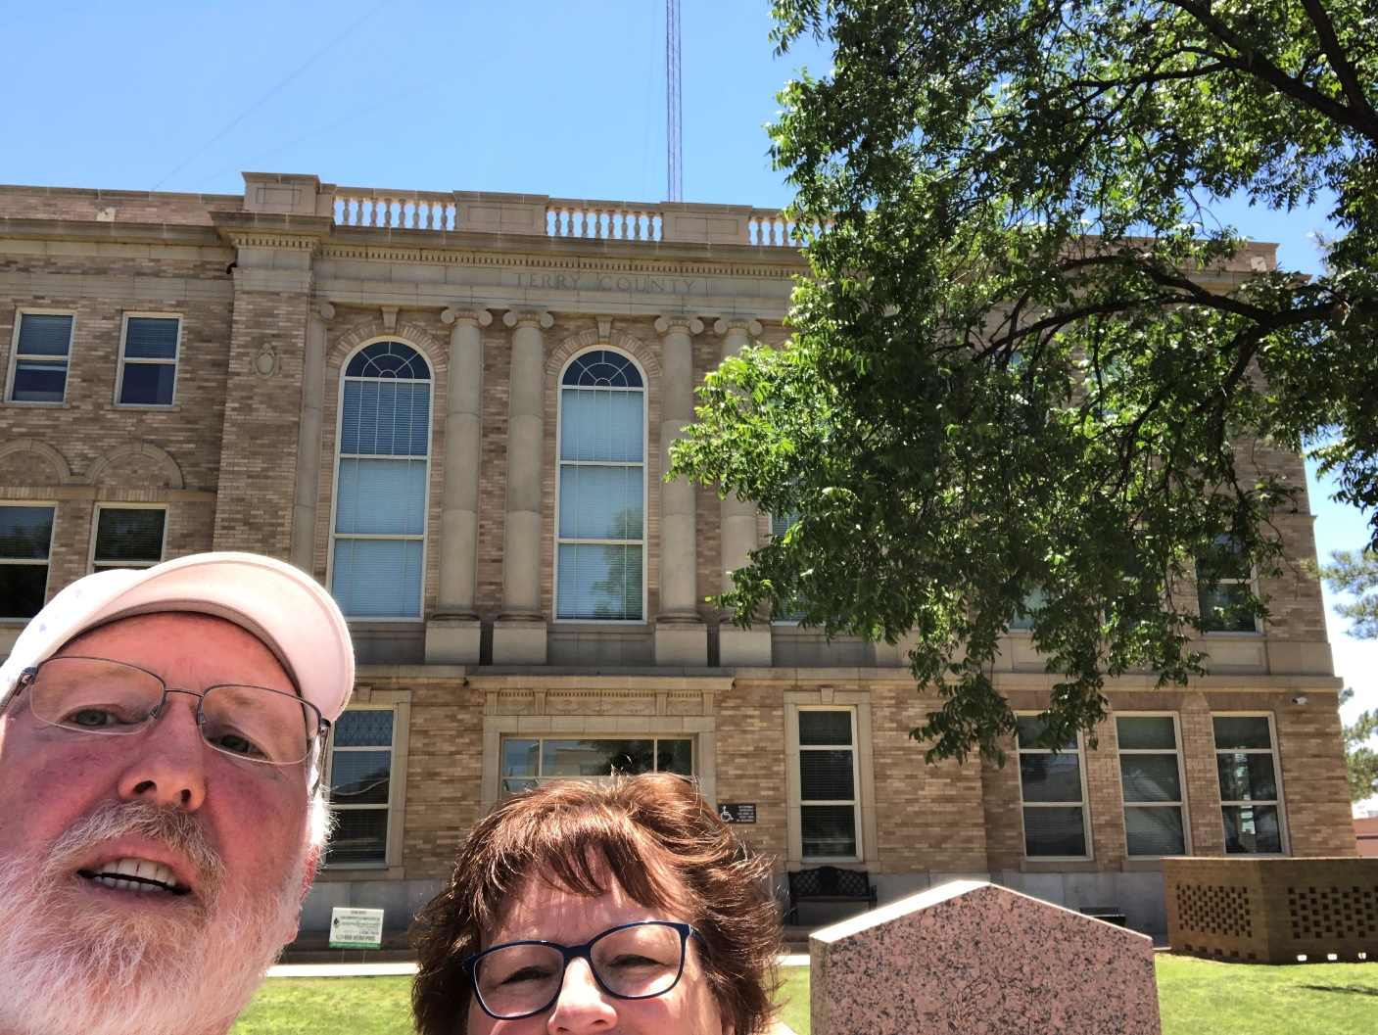
121 – Terry County – Brownfield, TX
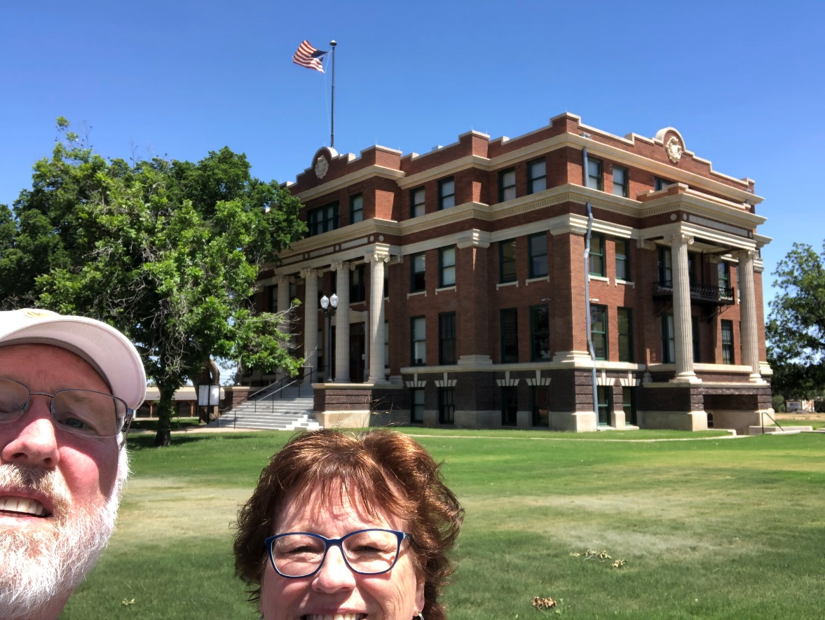
122 – Lynn County – Tahoka, TX
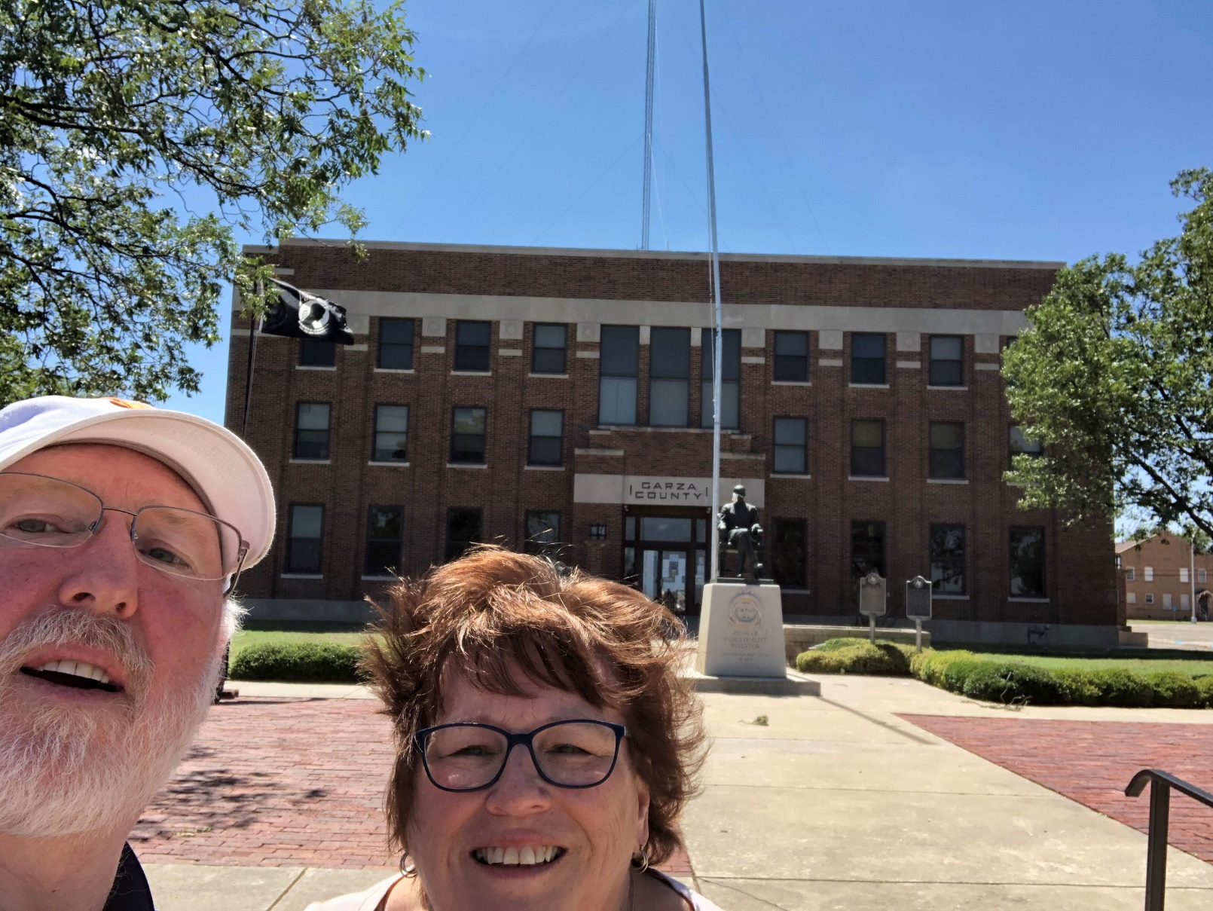
123 – Garza County – Post, TX
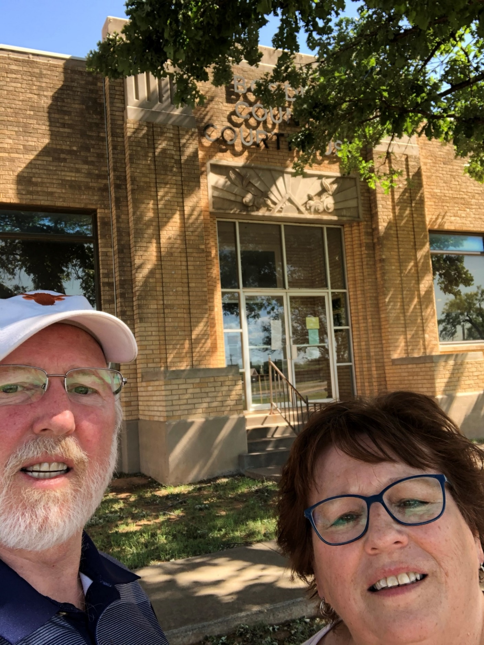
124 – Borden County – Gail, TX
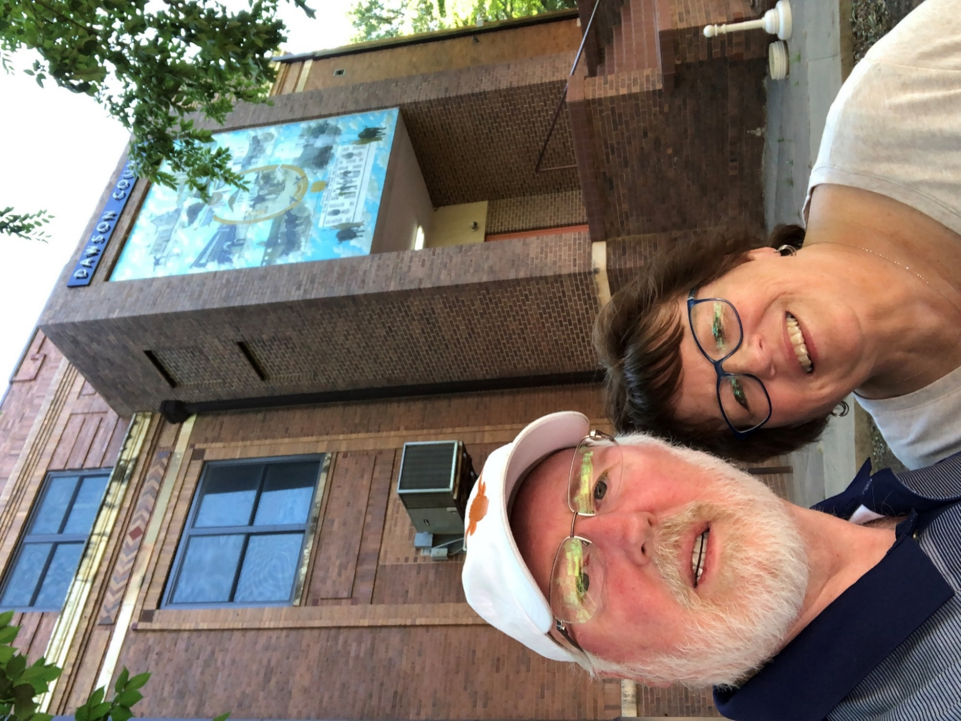
125 – Dawson County – Lamesa, TX
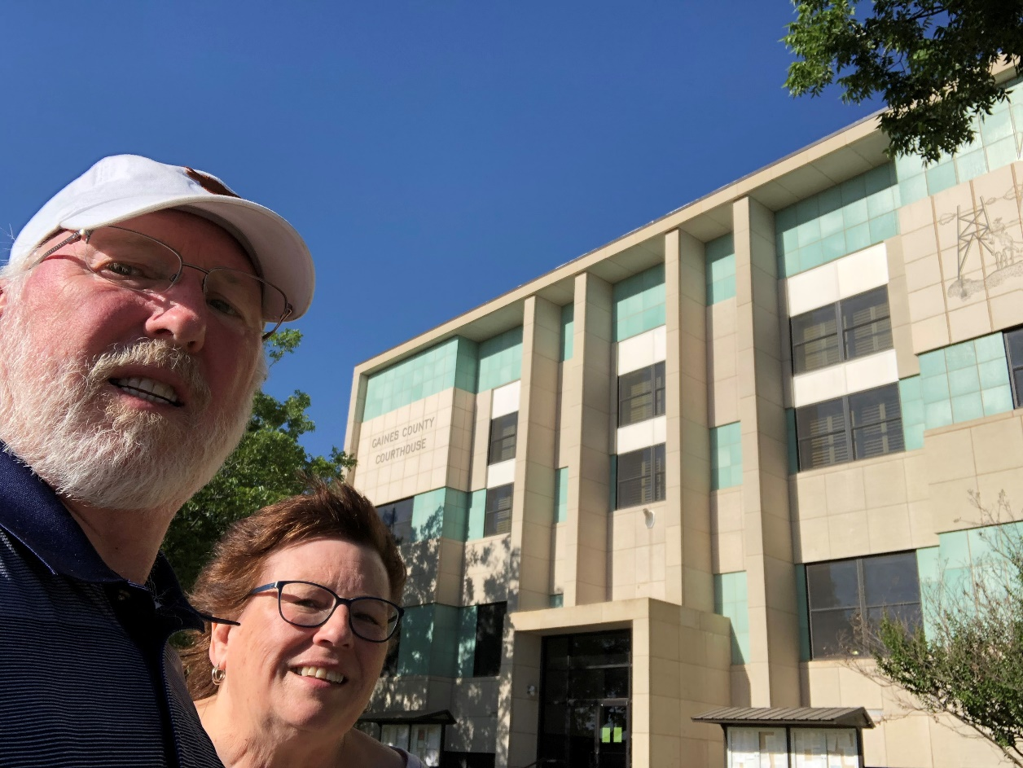
126 – Gaines County – Seminole, TX
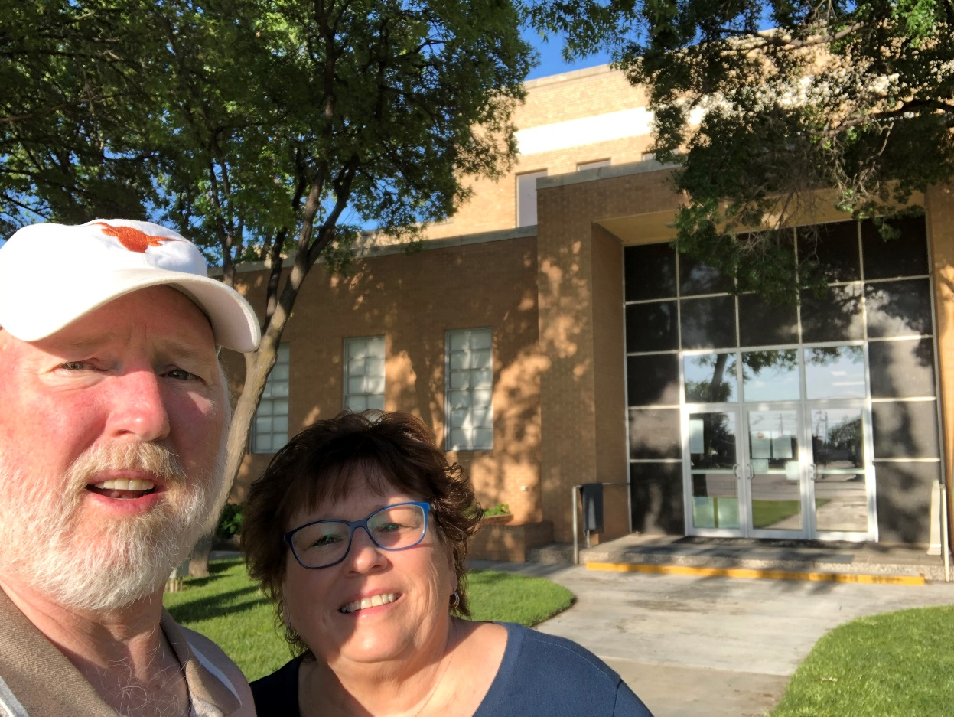
127 – Andrews County – Andrews, TX
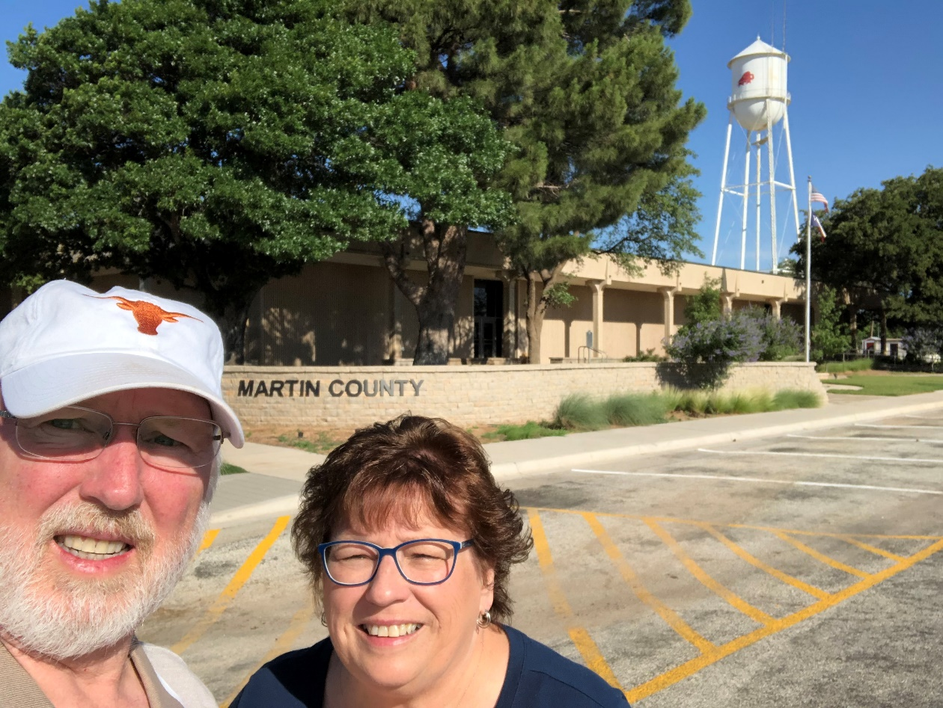
128 – Martin County – Stanton, TX
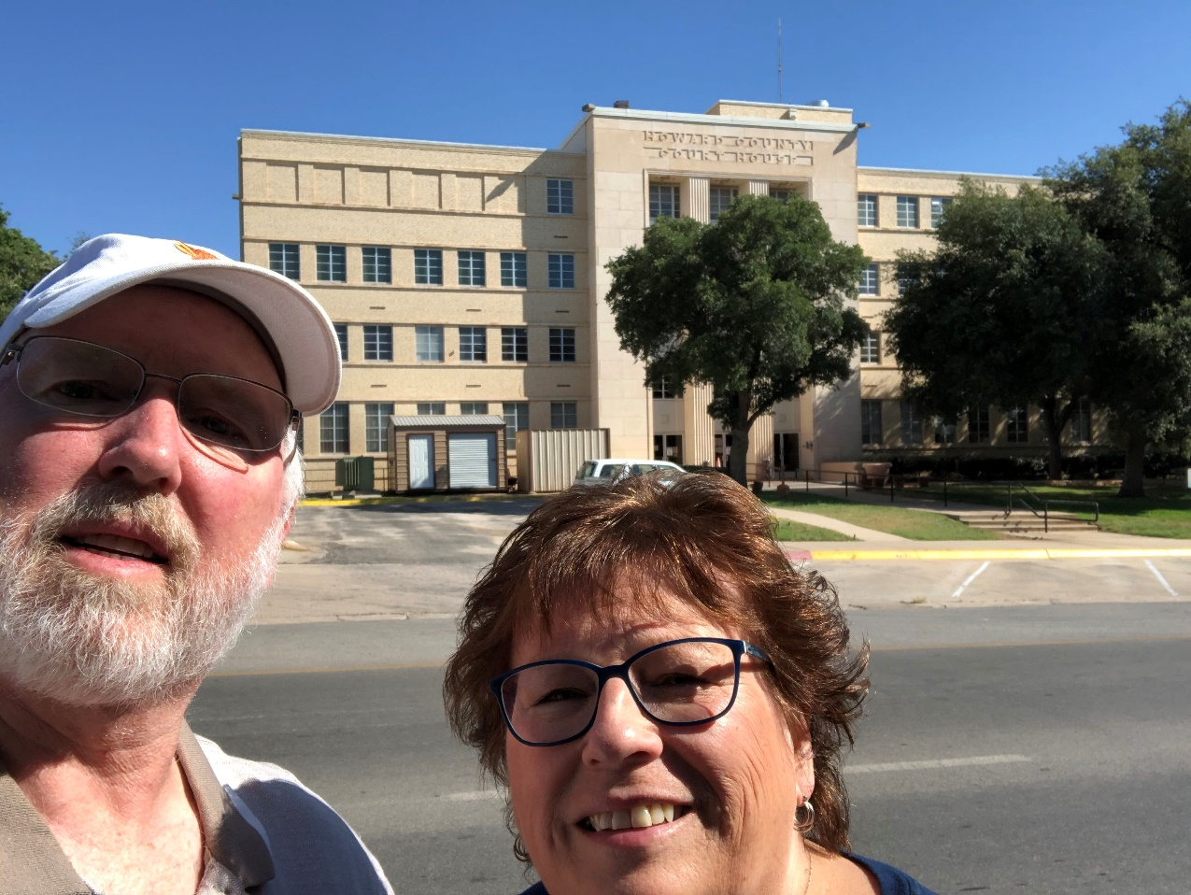
129 - Howard County – Big Spring, TX
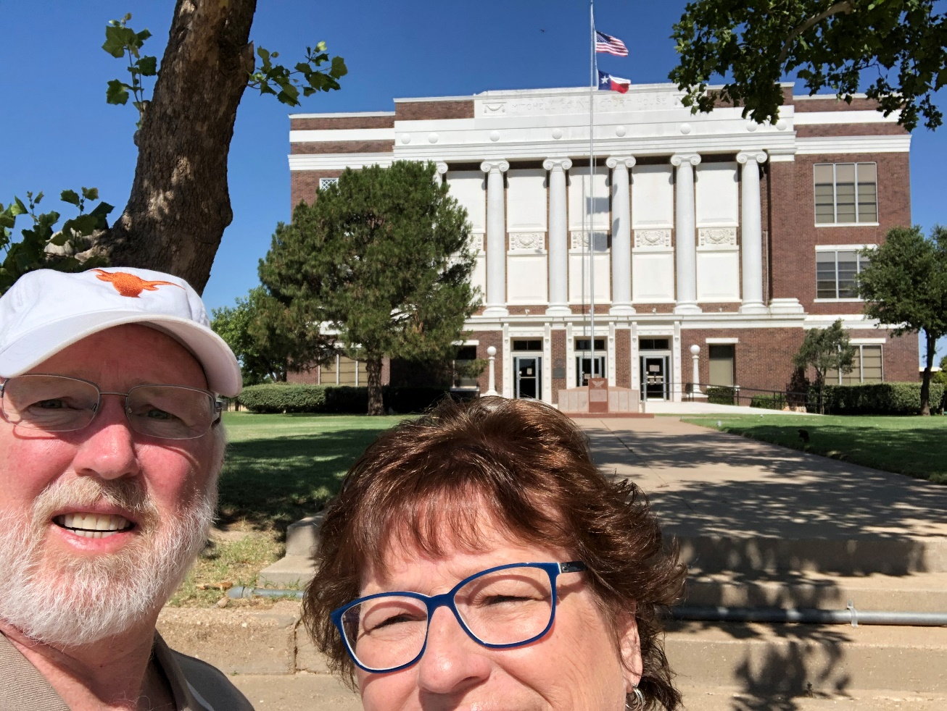
130 – Mitchell County – Colorado City, TX
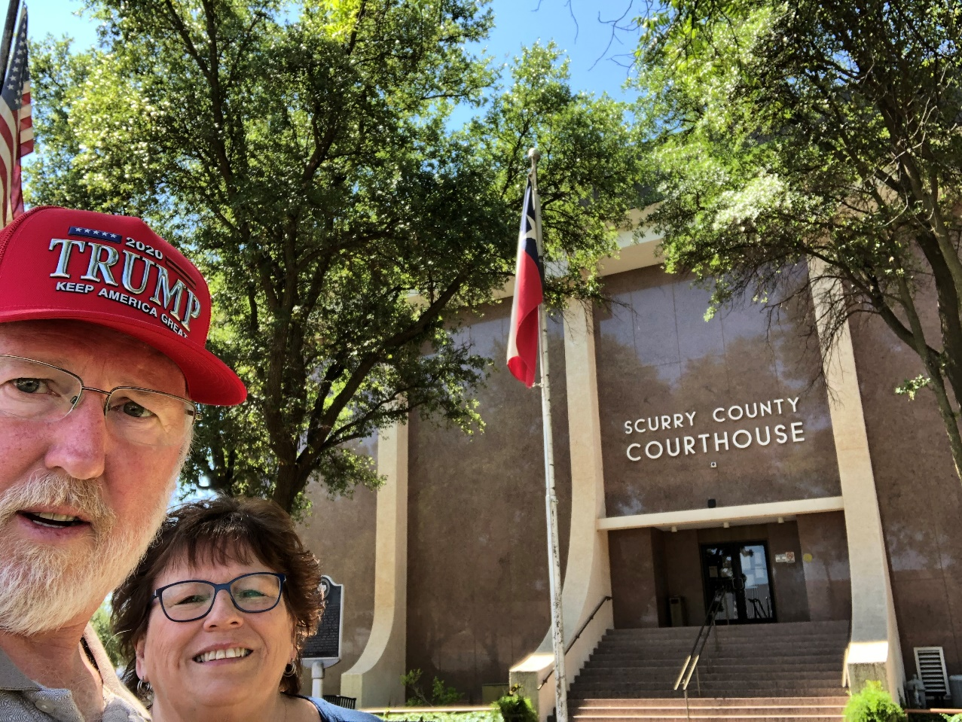
131 – Scurry County – Snyder, TX
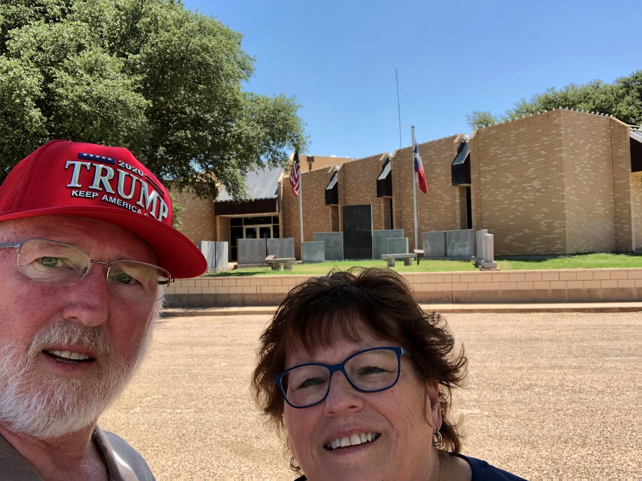
132 – Fisher County – Roby, TX
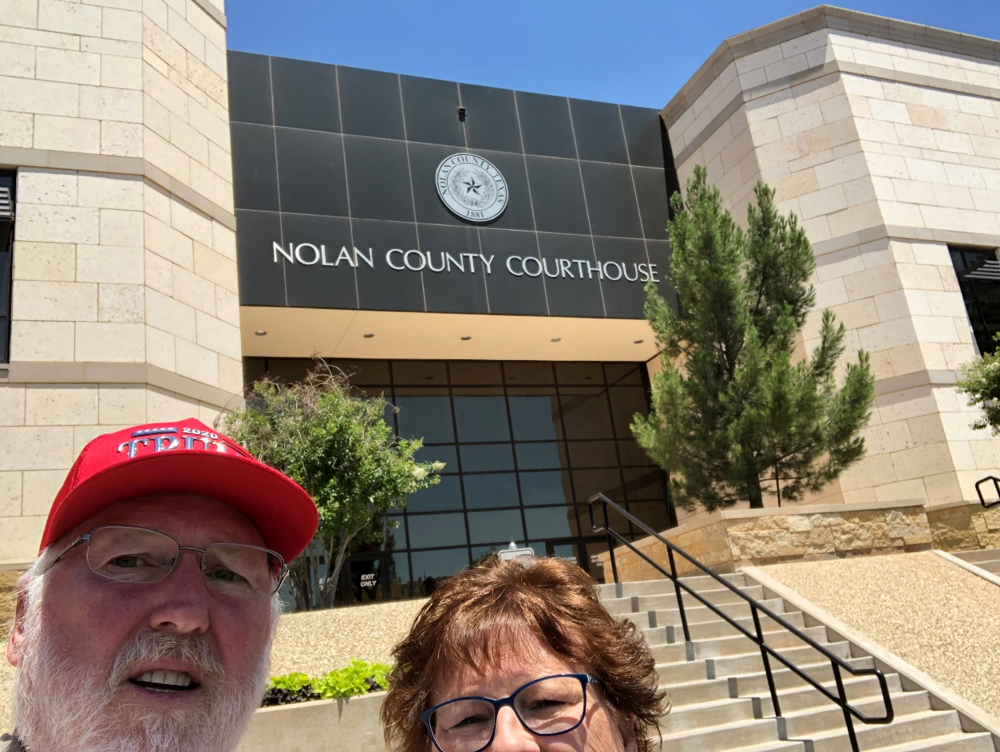
133 – Nolan County – Sweetwater, TX
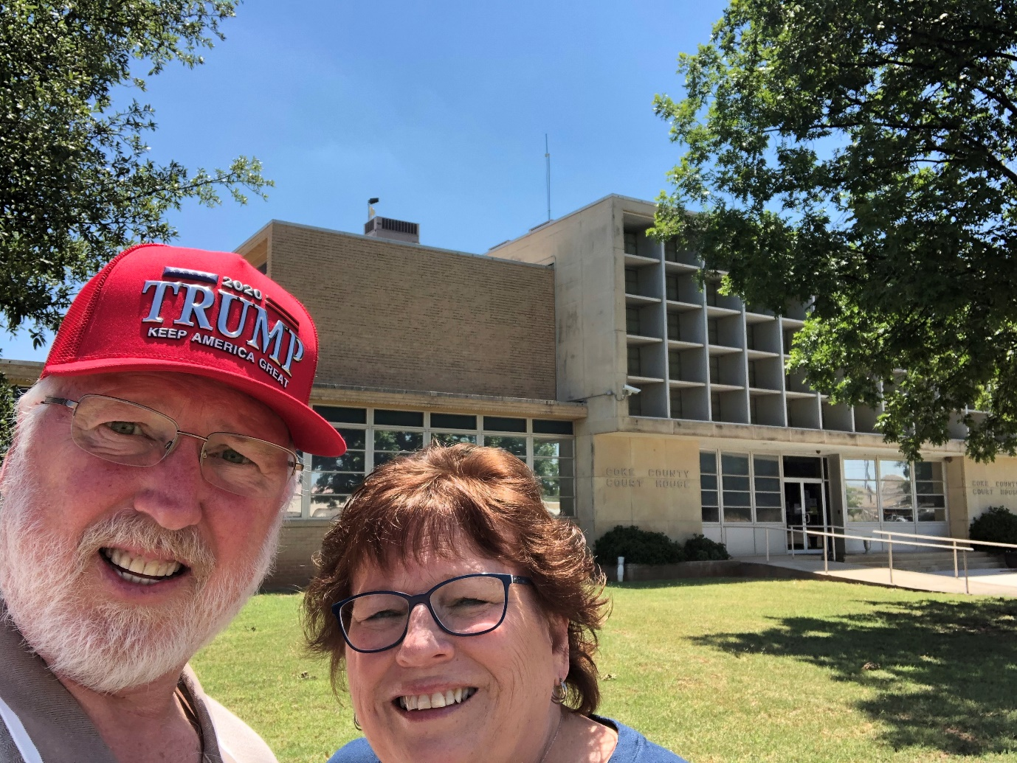
134 – Coke County – Robert Lee, TX
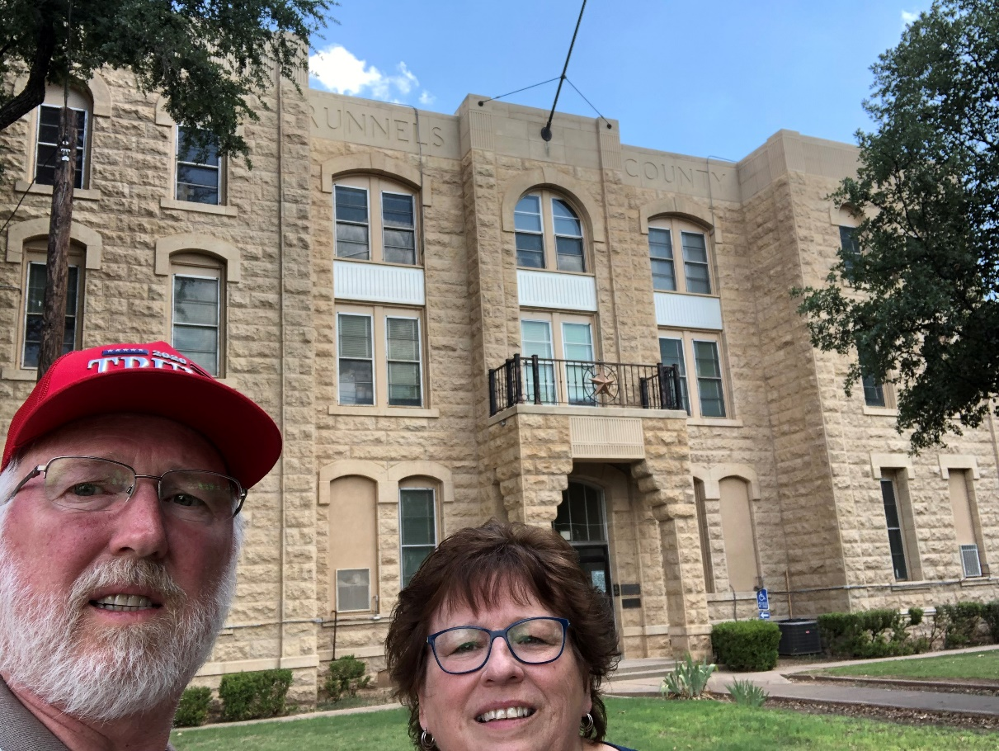
135 – Runnels County - Ballinger, TX

End of Trip

