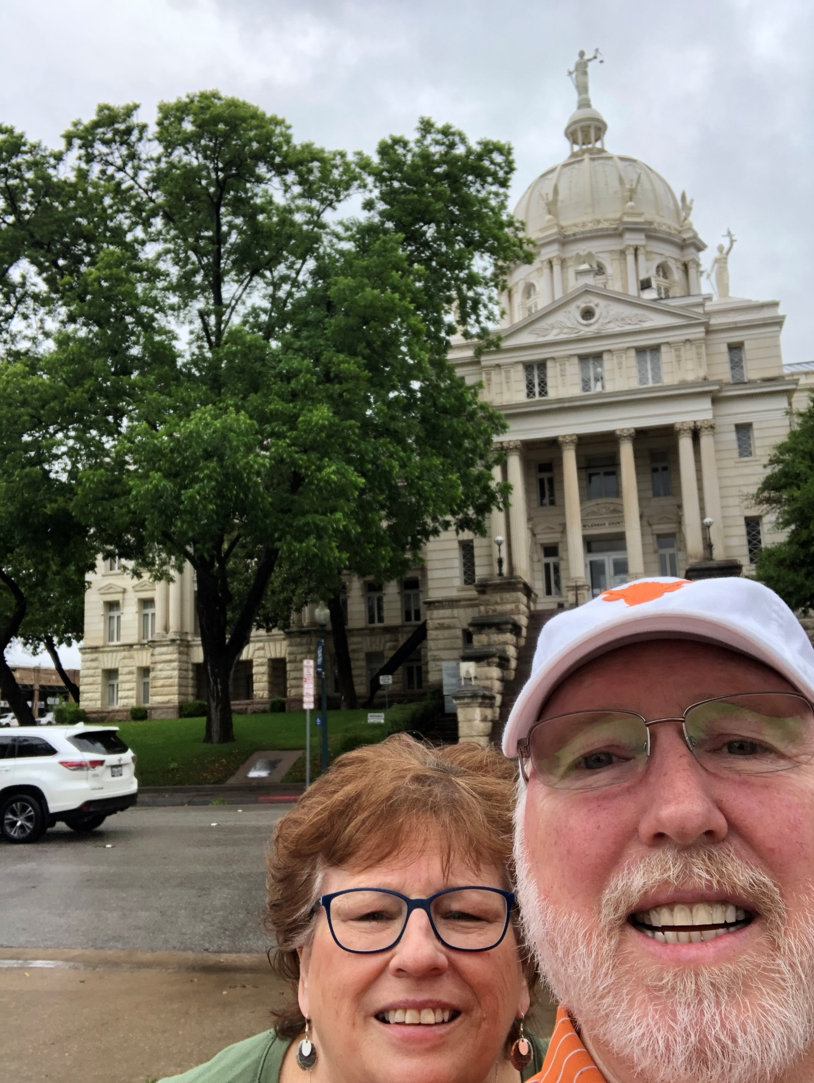
55 – McClennan County – Waco, TX
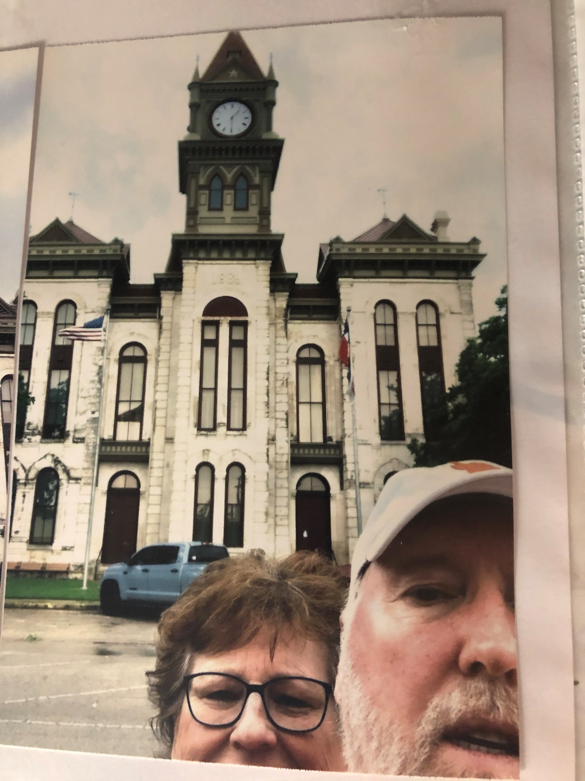
56 – Bosque County – Meridian, TX
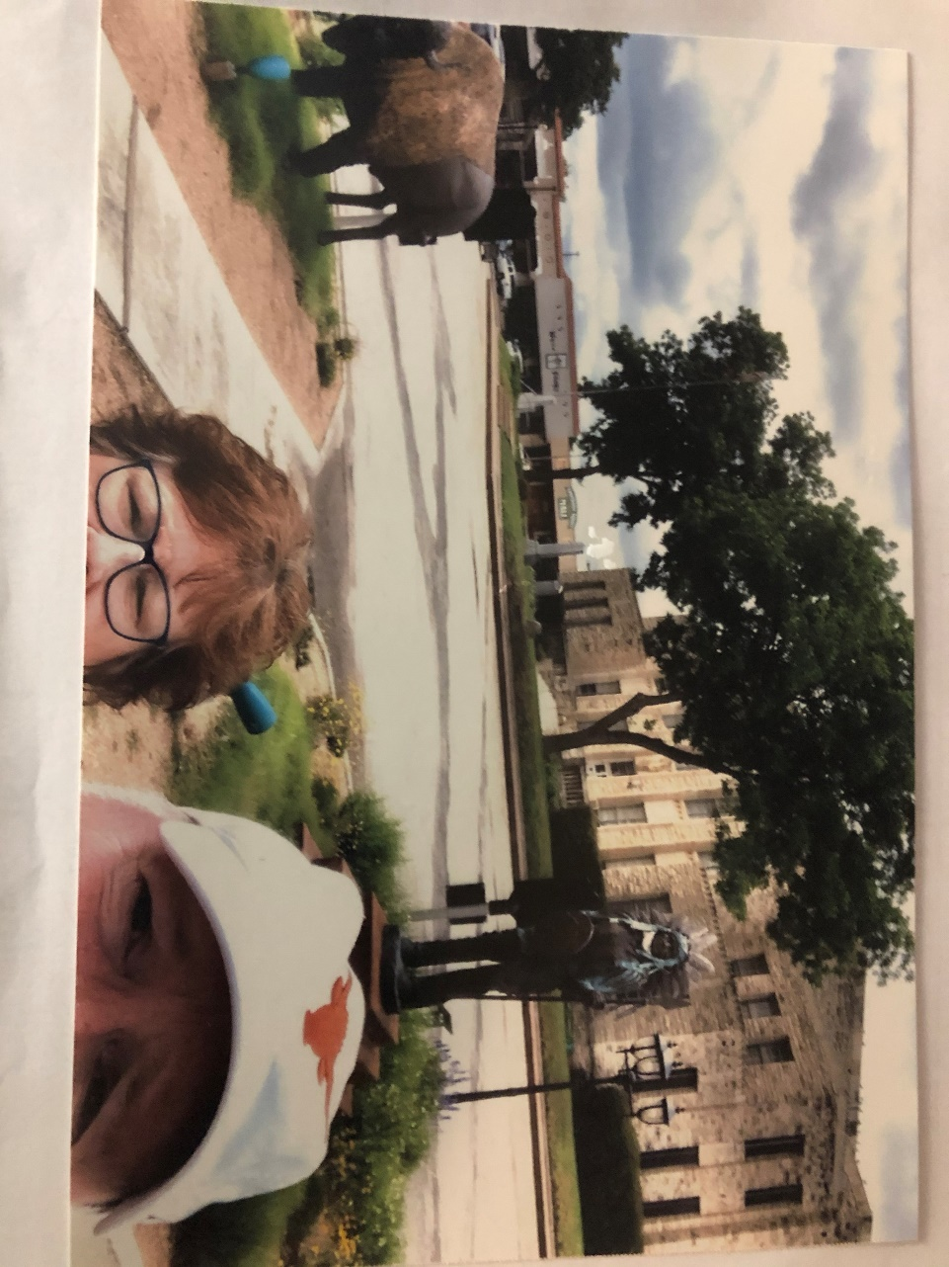
57 – Comanche County – Comanche, TX
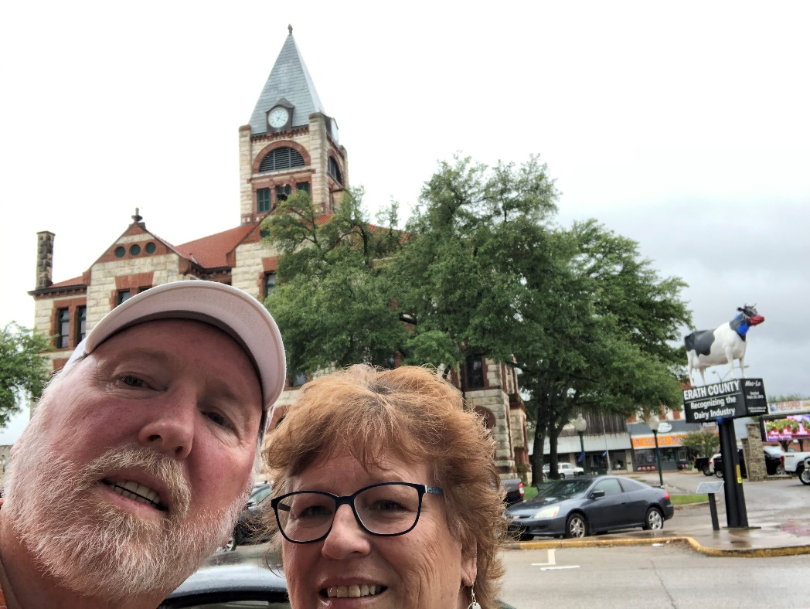
58 – Erath County – Stephenville, TX
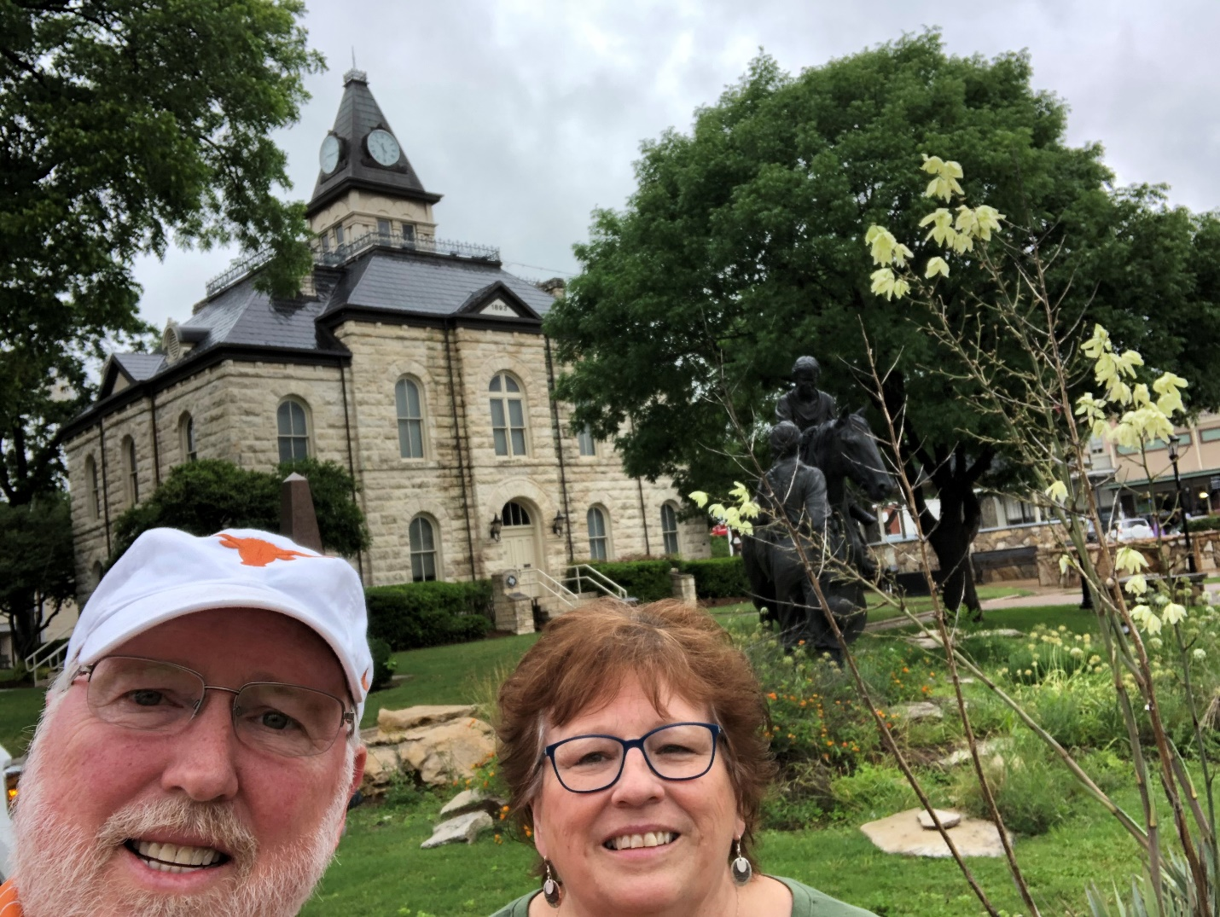
59 – Somervell County – Glen Rose, TX

End of Trip

